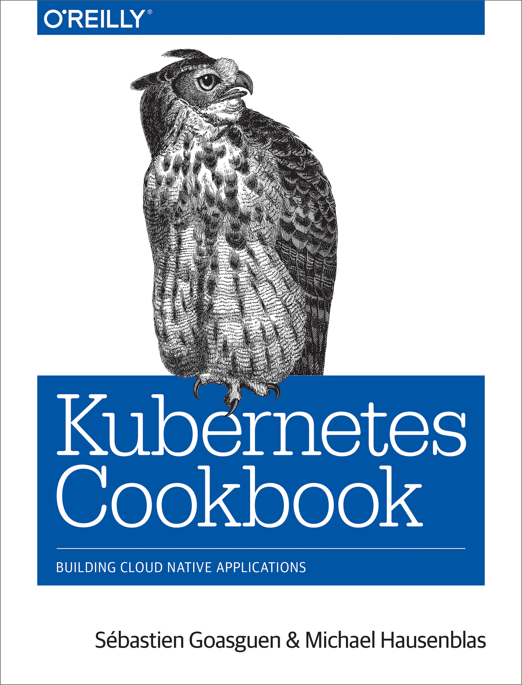

Table of Contents
Preface
Who Should Read This Book
Why We Wrote This Book
Navigating This Book
A Note on Kubernetes Releases
Technology You Need to Understand
Online Resources
Conventions Used in This Book
Using Code Examples
O’Reilly Safari
How to Contact Us
Acknowledgments
Getting Started with Kubernetes
1.1. Using Kubernetes Without Installation
1.2. Installing the Kubernetes CLI, kubectl
1.3. Installing Minikube to Run a Local Kubernetes Instance
1.4. Using Minikube Locally for Development
1.5. Starting Your First Application on Minikube
1.6. Accessing the Dashboard in Minikube
Creating a Kubernetes Cluster
2.1. Installing kubeadm to Create a Kubernetes Cluster
2.2. Bootstrapping a Kubernetes Cluster Using kubeadm
2.3. Downloading a Kubernetes Release from GitHub
2.4. Downloading Client and Server Binaries
2.5. Using a hyperkube Image to Run a Kubernetes Master Node with Docker
2.6. Writing a systemd Unit File to Run Kubernetes Components
2.7. Creating a Kubernetes Cluster on Google Kubernetes Engine (GKE)
2.8. Creating a Kubernetes Cluster on Azure Container Service (ACS)
Learning to Use the Kubernetes Client
3.1. Listing Resources
3.2. Deleting Resources
3.3. Watching Resource Changes with kubectl
3.4. Editing Resources with kubectl
3.5. Asking kubectl to Explain Resources and Fields
Creating and Modifying Fundamental Workloads
4.1. Creating a Deployment Using kubectl run
4.2. Creating Objects from File Manifests
4.3. Writing a Pod Manifest from Scratch
4.4. Launching a Deployment Using a Manifest
4.5. Updating a Deployment
Working with Services
5.1. Creating a Service to Expose Your Application
5.2. Verifying the DNS Entry of a Service
5.3. Changing the Type of a Service
5.4. Deploying an Ingress Controller on Minikube
5.5. Making Services Accessible from Outside the Cluster
Exploring the Kubernetes API and Key Metadata
6.1. Discovering API Endpoints of the Kubernetes API Server
6.2. Understanding the Structure of a Kubernetes Manifest
6.3. Creating Namespaces to Avoid Name Collisions
6.4. Setting Quotas Within a Namespace
6.5. Labeling an Object
6.6. Using Labels for Queries
6.7. Annotating a Resource with One Command
Managing Specialized Workloads
7.1. Running a Batch Job
7.2. Running a Task on a Schedule Within a Pod
7.3. Running Infrastructure Daemons per Node
7.4. Managing Stateful and Leader/Follower Apps
7.5. Influencing Pods’ Startup Behavior
Volumes and Configuration Data
8.1. Exchanging Data Between Containers via a Local Volume
8.2. Passing an API Access Key to a Pod Using a Secret
8.3. Providing Configuration Data to an Application
8.4. Using a Persistent Volume with Minikube
8.5. Understanding Data Persistency on Minikube
8.6. Dynamically Provisioning Persistent Storage on GKE
Scaling
9.1. Scaling a Deployment
9.2. Automatically Resizing a Cluster in GKE
9.3. Automatically Resizing a Cluster in AWS
9.4. Using Horizontal Pod Autoscaling on GKE
Security
10.1. Providing a Unique Identity for an Application
10.2. Listing and Viewing Access Control Information
10.3. Controlling Access to Resources
10.4. Securing Pods
Monitoring and Logging
11.1. Accessing the Logs of a Container
11.2. Recover from a Broken State with a Liveness Probe
11.3. Controlling Traffic Flow to a Pod Using a Readiness Probe
11.4. Adding Liveness and Readiness Probes to Your Deployments
11.5. Enabling Heapster on Minikube to Monitor Resources
11.6. Using Prometheus on Minikube
11.7. Using Elasticsearch–Fluentd–Kibana (EFK) on Minikube
Maintenance and Troubleshooting
12.1. Enabling Autocomplete for kubectl
12.2. Removing a Pod from a Service
12.3. Accessing a ClusterIP Service Outside the Cluster
12.4. Understanding and Parsing Resource Statuses
12.5. Debugging Pods
12.6. Getting a Detailed Snapshot of the Cluster State
12.7. Adding Kubernetes Worker Nodes
12.8. Draining Kubernetes Nodes for Maintenance
12.9. Managing etcd
Developing Kubernetes
13.1. Compiling from Source
13.2. Compiling a Specific Component
13.3. Using a Python Client to Interact with the Kubernetes API
13.4. Extending the API Using Custom Resource Definitions (CRDs)
The Ecosystem
14.1. Installing Helm, the Kubernetes Package Manager
14.2. Using Helm to Install Applications
14.3. Creating Your Own Chart to Package Your Application with Helm
14.4. Converting Your Docker Compose Files to Kubernetes Manifests
14.5. Creating a Kubernetes Cluster with kubicorn
14.6. Storing Encrypted Secrets in Version Control
14.7. Deploying Functions with kubeless
Resources
General
Tutorials and Examples
Index
Praise for Kubernetes Cookbook
The best infrastructure is the infrastructure you don’t see. The Kubernetes Cookbook helps move in that direction. This book provides concrete examples of how to get stuff done so you can get back to your real job. Along the way, you’ll build a skill set that helps you take your Kubernetes game to the next level.
Joe Beda
CTO and Founder of Heptio,
Kubernetes Founder
The Kubernetes Cookbook is a fantastic hands-on guide to building and running applications on Kubernetes. It is a great reference and a great way to help you learn to build cloud-native containerized applications.
Clayton Coleman
Red Hat
In this Cookbook, Sebastien and Michael collect together a number of useful recipes to get you going with Kubernetes, fast. They surface dozens of helpful hints and tips that will get readers hands-on with practical aspects of installing Kubernetes and using it to run applications.
Liz Rice
Chief Technology Evangelist,
Aqua Security
Kubernetes Cookbook

Building Cloud-Native Applications
Sébastien Goasguen and Michael Hausenblas
Kubernetes Cookbook
by Sébastien Goasguen and Michael Hausenblas
Copyright © 2018 Sebastien Goasguen and Michael Hausenblas. All rights reserved.
Printed in the United States of America.
Published by O’Reilly Media, Inc., 1005 Gravenstein Highway North, Sebastopol, CA 95472.
O’Reilly books may be purchased for educational, business, or sales promotional use. Online editions are also available for most titles (http://oreilly.com/safari). For more information, contact our corporate/institutional sales department: 800-998-9938 or corporate@oreilly.com.
- Editor: Angela Rufino
- Production Editor: Colleen Cole
- Copyeditor: Rachel Head
- Proofreader: Gillian McGarvey
- Indexer: Ellen Troutman
- Interior Designer: David Futato
- Cover Designer: Randy Comber
- Illustrator: Rebecca Demarest
- March 2018: First Edition

Revision History for the First Edition
- 2018-02-14: First Release
See http://oreilly.com/catalog/errata.csp?isbn=9781491979686 for release details.
The O’Reilly logo is a registered trademark of O’Reilly Media, Inc. Kubernetes Cookbook, the cover image, and related trade dress are trademarks of O’Reilly Media, Inc.
While the publisher and the authors have used good faith efforts to ensure that the information and instructions contained in this work are accurate, the publisher and the authors disclaim all responsibility for errors or omissions, including without limitation responsibility for damages resulting from the use of or reliance on this work. Use of the information and instructions contained in this work is at your own risk. If any code samples or other technology this work contains or describes is subject to open source licenses or the intellectual property rights of others, it is your responsibility to ensure that your use thereof complies with such licenses and/or rights.
978-1-491-97968-6
[LSI]
Dedication
For my boys, whose smiles, hugs, and spirits make me a better person.
For my wife with whom I am taking this journey through life.
Sébastien

For Saphira, Ranya, Iannis, and Anneliese.
Michael
Preface
Welcome to Kubernetes Cookbook, and thanks for choosing it! With this book, we want to help you solve concrete problems around Kubernetes. We’ve compiled over 80 recipes covering topics such as setting up a cluster, managing containerized workloads using Kubernetes API objects, using storage primitives, security configurations, and extending Kubernetes itself. Whether you are very new to Kubernetes or have been using it for a while, we hope that you’ll find something useful here to improve your experience and use of Kubernetes.

Who Should Read This Book
You’re a developer going cloud-native, or a sysadmin, or maybe you’ve even found yourself in one of the newfangled DevOps roles? This book will help you navigate your way successfully through the Kubernetes jungle, from development to production. These recipes are not organized in a linear progression of the basic Kubernetes concepts; however, each chapter contains recipes that utilize core Kubernetes concepts and API primitives.

Why We Wrote This Book
Both of us have been using and contributing to Kubernetes for a few years and have seen the many issues beginners and even more advanced users run into. We wanted to share the knowledge we’ve gathered running Kubernetes in production, as well as developing on and in Kubernetes—i.e., contributing to the core codebase or the ecosystem and writing applications that run on Kubernetes.

Navigating This Book
This cookbook contains 14 chapters. Each chapter is composed of recipes written in the standard O’Reilly recipe format (Problem, Solution, Discussion). You can read this book from front to back or skip to a specific chapter or recipe. Each recipe is independent of the others, and when an understanding of concepts from other recipes are needed, appropriate references are provided. The index is also an extremely powerful resource because sometimes a recipe is also showcasing a specific command and the index highlights these connections.

A Note on Kubernetes Releases
At the time of writing, Kubernetes 1.7 was the latest stable version, released at the end of June 2017, and this is the version we’re using throughout the book as the baseline.1 However, the solutions presented here should, in general, work for older releases, at least down to Kubernetes 1.4; we will call it out explicitly if this is not the case, mentioning the minimum required version.
The Kubernetes release cadence as of 2017 is such that every quarter a new (minor or dot) release is cut; for example, 1.6 was released in March, 1.7 in June, 1.8 in September, and 1.9 in December, as this book was entering production. The Kubernetes release versioning guidelines indicate that you can expect support for a feature for three minor releases at a time.2 This means that the stable API objects in the 1.7 release will be supported until at least March 2018. However, because the recipes in this book most often only use stable APIs, if you use a newer Kubernetes release, the recipes should still work.

Technology You Need to Understand
This intermediate-level book requires a minimal understanding of a few development and system administration concepts. Before diving into the book, you might want to review the following:
bash (Unix shell)
This is the default Unix shell on Linux and macOS. Familiarity with the Unix shell, such as for editing files, setting file permissions and user priveleges, moving files around the filesystem, and doing some basic shell programming, will be beneficial. For a general introduction, consult books such as Cameron Newham’s Learning the bash Shell or JP Vossen and Carl Albing’s bash Cookbook, both from O’Reilly.
Package management
The tools in this book often have multiple dependencies that need to be met by installing some packages. Knowledge of the package management system on your machine is therefore required. It could be apt on Ubuntu/Debian systems, yum on CentOS/RHEL systems, or port or brew on macOS. Whatever it is, make sure that you know how to install, upgrade, and remove packages.
Git
Git has established itself as the standard for distributed version control. If you are already familiar with CVS and SVN but have not yet used Git, you should. Version Control with Git by Jon Loeliger and Matthew McCullough (O’Reilly) is a good place to start. Together with Git, the GitHub website is a great resource to get started with a hosted repository of your own. To learn about GitHub, check out http://training.github.com and the associated interactive tutorial.
Python
In addition to programming with C/C++ or Java, we always encourage students to pick up a scripting language of their choice. Perl used to rule the world, while these days, Ruby and Go seem to be prevalent. Most examples in this book use Python, but there are a few examples with Ruby, and one even uses Clojure. O’Reilly offers an extensive collection of books on Python, including Introducing Python by Bill Lubanovic, Programming Python by Mark Lutz, and Python Cookbook by David Beazley and Brian K. Jones.
Go
Kubernetes is written in Go. Over the last couple of years, Go has established itself as the new programming language of choice in many startups and for many systems-related open source projects. This cookbook is not about Go programming, but it shows how to compile a few Go projects. Some minimal understanding of how to set up a Go workspace will be handy. If you want to know more, a good place to start is the O’Reilly video training course “Introduction to Go Programming”.

Online Resources
Kubernetes manifests, code examples, and other scripts used in this book are available on GitHub. You can clone this repository, go to the relevant chapter and recipe, and use the code as is:
$
git clone https://github.com/k8s-cookbook/recipes

Note
The examples in this repo are not meant to represent optimized setups to be used in production. They give you the basic minimum required to run the examples in the recipes.

Conventions Used in This Book
The following typographical conventions are used in this book:
Italic
Indicates new terms, URLs, email addresses, filenames, and file extensions.
Constant width
Used for program listings, as well as within paragraphs to refer to program elements such as variable or function names, databases, data types, environment variables, statements, and keywords. Also used for commands and command-line output.
Constant width bold
Shows commands or other text that should be typed literally by the user.
Constant width italic
Shows text that should be replaced with user-supplied values or by values determined by context.

Tip
This element signifies a tip or suggestion.

Note
This element signifies a general note.
Warning
This element indicates a warning or caution.

Using Code Examples

This book is here to help you get your job done. In general, if example code is offered with this book, you may use it in your programs and documentation. You do not need to contact us for permission unless you’re reproducing a significant portion of the code. For example, writing a program that uses several chunks of code from this book does not require permission. Selling or distributing a CD-ROM of examples from O’Reilly books does require permission. Answering a question by citing this book and quoting example code does not require permission. Incorporating a significant amount of example code from this book into your product’s documentation does require permission.
We appreciate, but do not require, attribution. An attribution usually includes the title, author, publisher, and ISBN. For example: “Kubernetes Cookbook by Sébastien Goasguen and Michael Hausenblas (O’Reilly). Copyright 2018 Sébastien Goasguen and Michael Hausenblas, 978-1-491-97968-6.”
If you feel your use of code examples falls outside fair use or the permission given above, feel free to contact us at permissions@oreilly.com.

O’Reilly Safari
Note
Safari (formerly Safari Books Online) is a membership-based training and reference platform for enterprise, government, educators, and individuals.
Members have access to thousands of books, training videos, Learning Paths, interactive tutorials, and curated playlists from over 250 publishers, including O’Reilly Media, Harvard Business Review, Prentice Hall Professional, Addison-Wesley Professional, Microsoft Press, Sams, Que, Peachpit Press, Adobe, Focal Press, Cisco Press, John Wiley & Sons, Syngress, Morgan Kaufmann, IBM Redbooks, Packt, Adobe Press, FT Press, Apress, Manning, New Riders, McGraw-Hill, Jones & Bartlett, and Course Technology, among others.
For more information, please visit http://oreilly.com/safari.

How to Contact Us
Please address comments and questions concerning this book to the publisher:
- O’Reilly Media, Inc.
- 1005 Gravenstein Highway North
- Sebastopol, CA 95472
- 800-998-9938 (in the United States or Canada)
- 707-829-0515 (international or local)
- 707-829-0104 (fax)
We have a web page for this book where we list errata, examples, and any additional information. You can access this page at http://bit.ly/kubernetes-cookbook.

To comment or ask technical questions about this book, send email to bookquestions@oreilly.com.
For more information about our books, courses, conferences, and news, see our website at http://www.oreilly.com.
Find us on Facebook: http://facebook.com/oreilly
Follow us on Twitter: http://twitter.com/oreillymedia
Watch us on YouTube: http://www.youtube.com/oreillymedia

Acknowledgments
Thank you to the entire Kubernetes community for developing such amazing software and for being a great bunch of people—open, kind, and always ready to help.
Writing this book turned out to be a much longer project than it should have been, but it is now finished and we are thankful to all the people who helped us. We are particularly in debt to the thorough reviews from Ihor Dvoretski, Liz Rice, and Ben Hall, who helped fix a good number of issues and suggested better organization and recipes that will help all readers.

1
“Kubernetes 1.7: Security Hardening, Stateful Application Updates and Extensibility”.
2
“Kubernetes API and Release Versioning”.
Chapter 1. Getting Started with Kubernetes
In this first chapter we present recipes that will help you get started with Kubernetes. We show you how to use Kubernetes without installing it and introduce components such as the command-line interface (CLI) and the dashboard, which allow you to interact with a cluster, as well as Minikube, an all-in-one solution you can run on your laptop.

1.1 Using Kubernetes Without Installation

Problem
You want to try Kubernetes without installing it.

Solution
To use Kubernetes without installing it, follow the interactive tutorial on the Kubernetes website.
You can also use the Kubernetes playground on Katacoda. Once you’re signed in with GitHub or one of the social media authentication methods, you will see the page depicted in Figure 1-1.
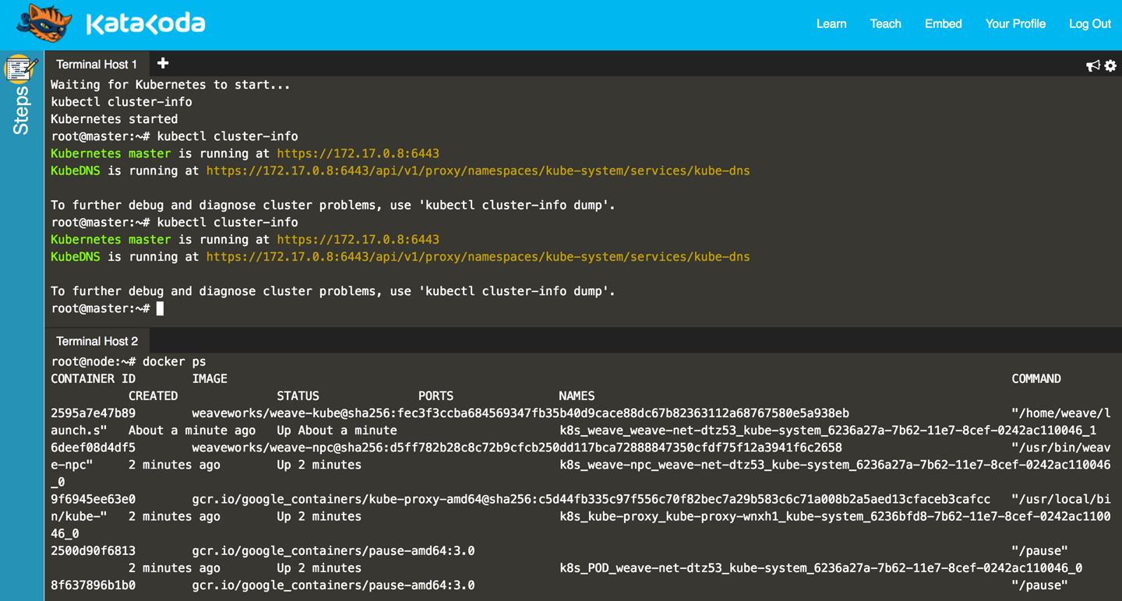
Figure 1-1. Screenshot of the Katacoda Kubernetes playground

Note that an environment you launch in the playground is only available for a limited time—currently one hour—but it’s free of charge and all you need is a browser.

1.2 Installing the Kubernetes CLI, kubectl

Problem
You want to install the Kubernetes command-line interface so you can interact with your Kubernetes cluster.

Solution
Install kubectl in one of the following ways:
- Download the source tarballs.
- Use a package manager.
- Build from source (see Recipe 13.1).
The documentation highlights a few mechanisms to get kubectl. The easiest is to download the latest official release. For example, on a Linux system, to get the latest stable version, enter:
$
curl -LO https://storage.googleapis.com/kubernetes-release/release/ \
$(curl -s https://storage.googleapis.com/kubernetes-release/ \
release/stable.txt) \
/bin/linux/amd64/kubectl
$
chmod +x ./kubectl
$
sudo mv ./kubectl /usr/local/bin/kubectl
Users of macOS can get kubectl simply via Homebrew:
$
brew install kubectl
Google Kubernetes Engine users (see Recipe 2.7) will get kubectl as part of the gcloud command installation. For example, on Sébastien’s local machine:
$
which kubectl
/Users/sebgoa/google-cloud-sdk/bin/kubectl
Also note that the latest versions of Minikube (see Recipe 1.3) packages kubectl and will install it in your $PATH if it is not found.
Before you move on from this recipe, make sure you have a working kubectl by listing its version. This command will also try to get the version of the default Kubernetes cluster:
$
kubectl version
Client Version: version.Info{Major:"1", \
Minor:"7", \
GitVersion:"v1.7.0", \
GitCommit:"fff5156...", \
GitTreeState:"clean", \
BuildDate:"2017-03-28T16:36:33Z", \
GoVersion:"go1.7.5", \
Compiler:"gc", \
Platform:"darwin/amd64"}
...

See Also
- Documentation on installing kubectl

1.3 Installing Minikube to Run a Local Kubernetes Instance

Problem
You want to use Kubernetes for testing or development or for training purposes on your local machine.

Solution
Use Minikube. Minikube is a tool that lets you use Kubernetes on your local machine without any installation except for the minikube binary. It takes advantage of your local hypervisor (e.g., VirtualBox, KVM) and launches a virtual machine that runs Kubernetes in a single node.
To install the Minikube CLI locally, you can get the latest release or build from source. To get the v0.18.0 release and install minikube on a Linux-based machine, do:
$
curl -Lo minikube https://storage.googleapis.com/minikube/releases/v0.18.0/ \
minikube-linux-amd64
$
chmod +x minikube
$
sudo mv minikube /usr/local/bin/
This will put the minikube binary in your path and make it accessible from everywhere.

Discussion
Once minikube is installed, you can verify the version that is running with the following command:
$
minikube version
minikube version: v0.18.0
You can start it with:
$
minikube start
Once the startup phase has finished, your Kubernetes client, kubectl, will have a minikube context and will automatically start using this context. Checking what nodes you have in your cluster will return the minikube hostname:
$
kubectl get nodes
NAME STATUS AGE
minikube Ready 5d

See Also
- Minikube documentation
- minikube source on GitHub

1.4 Using Minikube Locally for Development

Problem
You want to use Minikube locally for testing and development of your Kubernetes application. You have installed and started minikube (see Recipe 1.3) and want to know a few extra commands to simplify your development experience.

Solution
The Minikube CLI offers a few commands that make your life easier. The CLI has built-in help that you can use to discover the subcommands on your own—here’s a snippet:
$
minikube
...
Available Commands:
addons Modify minikube's kubernetes addons.
...
start Starts a local kubernetes cluster.
status Gets the status of a local kubernetes cluster.
stop Stops a running local kubernetes cluster.
version Print the version of minikube.
Aside from start, stop, and delete, you should become familiar with the ip, ssh, dashboard, and docker-env commands.

Tip
Minikube runs a Docker engine to be able to start containers. In order to access this Docker engine from your local machine using your local Docker client, you’ll need to set up the correct Docker environment with minikube docker-env.

Discussion
The minikube start command starts the virtual machine (VM) that will run Kubernetes locally. By default it will allocate 2 GB of RAM, so when you are done, do not forget to stop it with minikube stop. Also, you can give the VM more memory and CPUs as well as pick a certain Kubernetes version to run—for example:
$
minikube start --cpus=4 --memory=4000 --kubernetes-version=v1.7.2
For debugging the Docker daemon that is used inside Minikube, you might find minikube ssh handy; it will log you into the virtual machine. To get the IP address of the Minikube VM, use minikube ip. Finally, to launch the Kubernetes dashboard in your default browser, use minikube dashboard.

Tip
If for any reason your Minikube becomes unstable, or you want to start afresh, you can remove it with minikube stop and minikube delete. Then a minikube start will give you a fresh installation.

1.5 Starting Your First Application on Minikube

Problem
You’ve started Minikube (see Recipe 1.3), and now you want to launch your first application on Kubernetes.

Solution
As an example, you can start the Ghost microblogging platform on Minikube using two kubectl commands:
$
kubectl run ghost --image=ghost:0.9
$
kubectl expose deployments ghost --port=2368 --type=NodePort
Monitor the pod manually to see when it starts running and then use the minikube service command to open your browser automatically and access Ghost:
$
kubectl get pods
NAME READY STATUS RESTARTS AGE
ghost-8449997474-kn86m 1/1 Running 0 2h
$
minikube service ghost

Discussion
The kubectl run command is called a generator; it is a convenience command to create a Deployment object (see Recipe 4.4). The kubectl expose command is also a generator, a convenience command to create a Service object (see Recipe 5.1) that routes network traffic to the containers started by your deployment.

1.6 Accessing the Dashboard in Minikube

Problem
You are using Minikube and want to access the Kubernetes dashboard to start your first application from a graphical user interface.

Solution
You can open the Kubernetes dashboard from Minikube with:
$
minikube dashboard
Click on the plus sign (+) at the top right of the UI that opens in your browser, and you will see the page depicted in Figure 1-2.
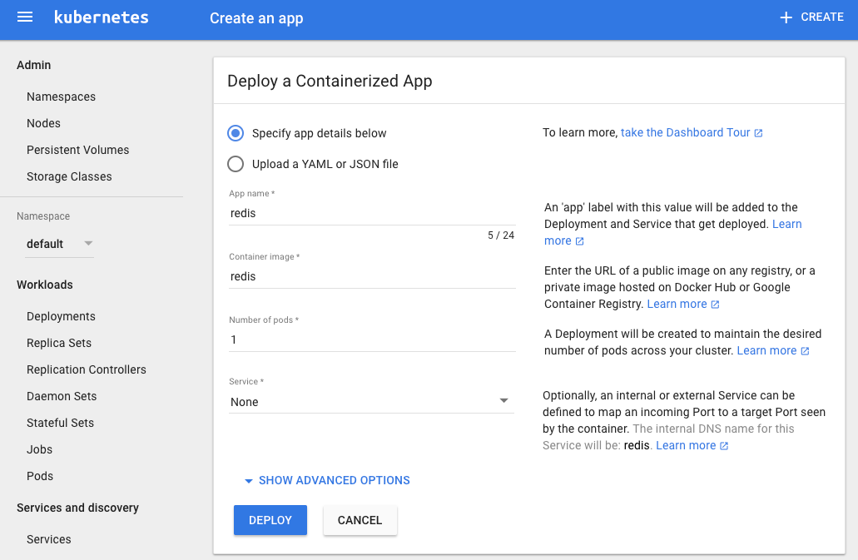
Figure 1-2. Snapshot of the dashboard application create view

Discussion
To create an application, click the Create button in the top-right corner, give the application a name, and specify the Docker image that you want to use. Then click the Deploy button and you will be presented with a new view that shows deployments and replica sets, and after a bit of time you will see a pod. These are some key API primitives we will deal with in greater detail in the rest of the book.
The snapshot in Figure 1-3 presents a typical dashboard view after having created a single application using the Redis container.
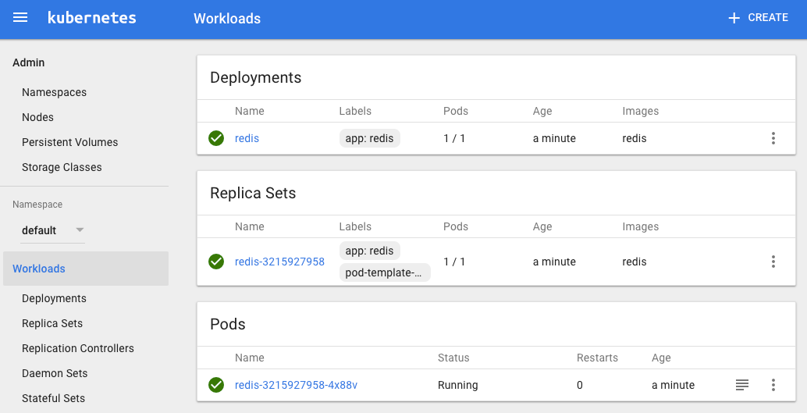
Figure 1-3. A dashboard overview with a Redis application

If you go back to a terminal session and use the command-line client, you will see the same thing:
$
kubectl get pods,rs,deployments
NAME READY STATUS RESTARTS AGE
po/redis-3215927958-4x88v 1/1 Running 0 24m
NAME DESIRED CURRENT READY AGE
rs/redis-3215927958 1 1 1 24m
NAME DESIRED CURRENT UP-TO-DATE AVAILABLE AGE
deploy/redis 1 1 1 1 24m
Your Redis pod will be running the Redis server, as the following logs show:
$
kubectl logs redis-3215927958-4x88v
...
_._
_.-``__ ''-._
_.-`` `. `_. ''-._ Redis 3.2.9 (00000000/0) 64 bit
.-`` .-```. ```\/ _.,_ ''-._
( ' , .-` | `, ) Running in standalone mode
|`-._`-...-` __...-.``-._|'` _.-'| Port: 6379
| `-._ `._ / _.-' | PID: 1
`-._ `-._ `-./ _.-' _.-'
|`-._`-._ `-.__.-' _.-'_.-'|
| `-._`-._ _.-'_.-' | http://redis.io
`-._ `-._`-.__.-'_.-' _.-'
|`-._`-._ `-.__.-' _.-'_.-'|
| `-._`-._ _.-'_.-' |
`-._ `-._`-.__.-'_.-' _.-'
`-._ `-.__.-' _.-'
`-._ _.-'
`-.__.-'
...
1:M 14 Jun 07:28:56.637 # Server started, Redis version 3.2.9
1:M 14 Jun 07:28:56.643 * The server is now ready to accept connections on
port 6379

Chapter 2. Creating a Kubernetes Cluster
In this chapter we discuss multiple ways to set up a full-blown Kubernetes cluster. We cover low-level, standardized tooling (kubeadm) that also serves as the basis for other installers and show you where to find the relevant binaries for the control plane, as well as for worker nodes. We discuss a containerized Kubernetes setup with hyperkube, demonstrate how to write systemd unit files to supervise Kubernetes components, and finally show how to set up clusters in Google Cloud and on Azure.

2.1 Installing kubeadm to Create a Kubernetes Cluster

Problem
You want to use kubeadm to bootstrap a Kubernetes cluster from scratch.

Solution
Download the kubeadm CLI tool from the Kubernetes package repository.
You will need kubeadm installed on all the servers that will be part of your Kubernetes cluster—not only the master, but also all the nodes.
For example, if you are using Ubuntu-based hosts, on each host do the following as root to set up the Kubernetes package repository:
#
apt-get update && apt-get install -y apt-transport-https
#
curl -s https://packages.cloud.google.com/apt/doc/apt-key.gpg | apt-key add -
#
cat <<EOF >/etc/apt/sources.list.d/kubernetes.list
deb http://apt.kubernetes.io/ kubernetes-xenial main
EOF
#
apt-get update
Now you can install the Docker engine and the various Kubernetes tools. You will need the following:
- The kubelet binary
- The kubeadm CLI
- The kubectl client
- kubernetes-cni, the Container Networking Interface (CNI) plug-in
Install them with:
#
apt-get install -y docker.io
#
apt-get install -y kubelet kubeadm kubectl kubernetes-cni

Discussion
Once all the binaries and tools are installed, you are ready to start bootstrapping your Kubernetes cluster. On your master node, initialize the cluster with:
#
kubeadm init
[kubeadm] WARNING: kubeadm is in beta, please do not use it for production
clusters.
[init] Using Kubernetes version: v1.7.8
[init] Using Authorization modes: [Node RBAC]
[preflight] Running pre-flight checks
...
At the end of the initialization, you will be given a command to execute on all your worker nodes (see Recipe 2.2). This command uses a token autogenerated by the initialization process.

See Also
- Using kubeadm to Create a Cluster

2.2 Bootstrapping a Kubernetes Cluster Using kubeadm

Problem
You have initialized your Kubernetes master node (see Recipe 2.1) and now need to add worker nodes to your cluster.

Solution
With the Kubernetes package repository configured and kubeadm installed as shown in Recipe 2.1, run the join command using the token given to you when running the init step on the master node:
$
kubeadm join --token
<token>
Head back to your master terminal session and you will see your nodes join:
$
kubectl get nodes

Discussion
The final step is to create a network that satisfies the Kubernetes networking requirements—especially the single IP address per pod. You can use any of the network add-ons.1 Weave Net,2 for example, can be installed on Kubernetes clusters v1.6.0 and above with a single kubectl command, like so:
$
export kubever=$(kubectl version | base64 | tr -d '\n')
$
kubectl apply -f "https://cloud.weave.works/k8s/net?k8s-version=$kubever"
This command will create daemon sets (see Recipe 7.3) running on all nodes in the cluster. These daemon sets use the host network and a CNI plug-in to configure the local node network. Once the network is in place, your cluster nodes will enter the READY state.
For other networking add-ons that you can use to create a pod network during the bootstrapping process with kubeadm, see the documentation.

See Also
- Documentation on creating a cluster with kubeadm

2.3 Downloading a Kubernetes Release from GitHub

Problem
You want to download an official Kubernetes release instead of compiling from source.

Solution
You can follow a manual process and go to the GitHub releases page. Choose the release, or potentially prerelease that you want to download. Then choose the source bundle you will need to compile, or download the kubernetes.tar.gz file.
Alternatively, you can check the latest release tags using the GitHub API, as shown here:
$
curl -s https://api.github.com/repos/kubernetes/kubernetes/releases | \
jq -r .[].assets[].browser_download_url
https://github.com/kubernetes/kubernetes/releases/download/v1.9.0/
kubernetes.tar.gz
https://github.com/kubernetes/kubernetes/releases/download/v1.9.0-beta.2/
kubernetes.tar.gz
https://github.com/kubernetes/kubernetes/releases/download/v1.8.5/
kubernetes.tar.gz
https://github.com/kubernetes/kubernetes/releases/download/v1.9.0-beta.1/
kubernetes.tar.gz
https://github.com/kubernetes/kubernetes/releases/download/v1.7.11/
kubernetes.tar.gz
...
Then download the kubernetes.tar.gz release package of your choice. For example, to get v1.7.11, do:
$
wget https://github.com/kubernetes/kubernetes/releases/download/ \
v1.7.11/kubernetes.tar.gz
If you want to compile Kubernetes from source, see Recipe 13.1.
Warning
Do not forget to verify the secure hash of the kubernetes.tar.gz archive. The SHA256 hash is listed on the GitHub release page. After downloading the archive locally, generate the hash and compare it. Even though the release is not signed with GPG, verifying the hash will check the integrity of the archive.

2.4 Downloading Client and Server Binaries

Problem
You have downloaded a release archive (see Recipe 2.3), but it does not contain the actual binaries.

Solution
To keep the size of the release archive small, it does not contain the release binaries. You need to download them separately. To do so, run the get-kube-binaries.sh script as shown here:
$
tar -xvf kubernetes.tar.gz
$
cd kubernetes/cluster
$
./get-kube-binaries.sh
Once complete, you will have the client binaries in client/bin:
$
tree ./client/bin
./client/bin
├── kubectl
└── kubefed
and the server binaries in server/kubernetes/server/bin:
$
tree server/kubernetes/server/bin
server/kubernetes/server/bin
├── cloud-controller-manager
├── kube-apiserver
...

Tip
If you want to skip downloading the release and quickly download the client and/or server binaries, you can get them directly from https://dl.k8s.io. For example, to get the v1.7.11 binaries for Linux, do:
$
wget https://dl.k8s.io/v1.7.11/ \
\kubernetes-client-linux-amd64.tar.gz
$
wget https://dl.k8s.io/v1.7.11/ \
kubernetes-server-linux-amd64.tar.gz

2.5 Using a hyperkube Image to Run a Kubernetes Master Node with Docker

Problem
You want to create a Kubernetes master node using a few Docker containers. Specifically, you want to run the API server, scheduler, controller, and etcd key/value store within containers.

Solution
You can use the hyperkube binary plus an etcd container. hyperkube is an all-in-one binary available as a Docker image. You can use it to start all the Kubernetes processes.
To create a Kubernetes cluster, you need a storage solution to keep the cluster state. In Kubernetes, this solution is a distributed key/value store called etcd; therefore, first you need to start an etcd instance. You can run it like this:
$
docker run -d \
--name=k8s \
-p 8080:8080 \
gcr.io/google_containers/etcd:3.1.10 \
etcd --data-dir /var/lib/data
Then you will start the API server using a so-called hyperkube image, which contains the API server binary. This image is available from the Google Container Registry (GCR) at gcr.io/google_containers/hyperkube:v1.7.11. We use a few settings to serve the API insecurely on a local port. Replace v1.7.11 with the latest version or the one you want to run:
$
docker run -d \
--net=container:k8s \
gcr.io/google_containers/hyperkube:v1.7.11/ \
apiserver --etcd-servers=http://127.0.0.1:2379 \
--service-cluster-ip-range=10.0.0.1/24 \
--insecure-bind-address=0.0.0.0 \
--insecure-port=8080 \
--admission-control=AlwaysAdmit
Finally, you can start the admission controller, which points to the API server:
$
docker run -d \
--net=container:k8s \
gcr.io/google_containers/hyperkube:v1.7.11/ \
controller-manager --master=127.0.0.1:8080
Notice that since etcd, the API server, and the controller-manager share the same network namespace, they can reach each other on 127.0.0.1 even though they are running in different containers.
To test that you have a working setup, use etcdctl in the etcd container and list what is in the /registry directory:
$
docker
exec
-ti
k8s
/bin/sh
#
export ETCDCTL_API=3
#
etcdctl get "/registry/api" --prefix=true
You can also reach your Kubernetes API server and start exploring the API:
$
curl
-s
curl
http://127.0.0.1:8080/api/v1
|
more
{
"kind"
:
"APIResourceList"
,
"groupVersion"
:
"v1"
,
"resources"
:
[
{
"name"
:
"bindings"
,
"singularName"
:
""
,
"namespaced"
:
true
,
"kind"
:
"Binding"
,
"verbs"
:
[
"create"
]
}
,
...
So far, you have not started the scheduler, nor have you set up nodes with the kubelet and the kube-proxy. This just shows you how you can run the Kubernetes API server by starting three local containers.

Tip
It is sometimes helpful to use the hyperkube Docker image to verify some of the configuration options of one of the Kubernetes binaries. For example, to check the help for the main /apiserver command, try:
$
docker run --rm -ti \
gcr.io/google_containers/hyperkube:v1.7.11 \
/apiserver --help

Discussion
Though this is a very useful way to start exploring the various Kubernetes components locally, it is not recommended for a production setup.

See Also
- hyperkube Docker images

2.6 Writing a systemd Unit File to Run Kubernetes Components

Problem
You have used Minikube (see Recipe 1.3) for learning and know how to bootstrap a Kubernetes cluster using kubeadm (see Recipe 2.2), but you would like to install a cluster from scratch. To do so, you need to run the Kubernetes components using systemd unit files. You are only looking for a basic examples to run the kubelet via systemd.

Solution
systemd3 is a system and services manager, sometimes referred to as an init system. It is now the default services manager on Ubuntu 16.04 and CentOS 7.
Checking how kubeadm does it is a very good way to figure out how to do it on your own. If you look closely at the kubeadm configuration, you will see that the kubelet running on every node in your cluster, including the master node, is managed by systemd.
Here is an example, which you can reproduce by logging into any nodes in a cluster built with kubeadm (see Recipe 2.2):
#
systemctl status kubelet
● kubelet.service - kubelet: The Kubernetes Node Agent
Loaded: loaded (/lib/systemd/system/kubelet.service; enabled; vendor preset:
enabled)
Drop-In: /etc/systemd/system/kubelet.service.d
└─10-kubeadm.conf
Active: active (running) since Tue 2017-06-13 08:29:33 UTC; 2 days ago
Docs: http://kubernetes.io/docs/
Main PID: 4205 (kubelet)
Tasks: 17
Memory: 47.9M
CPU: 2h 2min 47.666s
CGroup: /system.slice/kubelet.service
├─4205 /usr/bin/kubelet --kubeconfig=/etc/kubernetes/kubelet.conf \
| --require-kubeconfig=true \
| --pod-manifest-path=/etc/kubernetes/manifests \
| --allow-privileged=true \
| --network-plugin=cni \
| --cni-conf
└─4247 journalctl -k -f
This gives you a link to the systemd unit file in /lib/systemd/system/kubelet.service and its configuration in /etc/systemd/system/kubelet.service.d/10-kubeadm.conf.
The unit file is straightforward—it points to the kubelet binary installed in /usr/bin:
[
Unit
]
Description
=
kubelet: The Kubernetes Node Agent
Documentation
=
http://kubernetes.io/docs/
[
Service
]
ExecStart
=
/usr/bin/kubelet
Restart
=
always
StartLimitInterval
=
0
RestartSec
=
10
[
Install
]
WantedBy
=
multi-user.target
The configuration file tells you how the kubelet binary is started:
[
Service
]
Environment
=
"KUBELET_KUBECONFIG_ARGS=--kubeconfig=/etc/kubernetes/kubelet.conf
--require-kubeconfig=true"
Environment
=
"KUBELET_SYSTEM_PODS_ARGS=--pod-manifest-path=/etc/kubernetes/
manifests --allow-privileged=true"
Environment
=
"KUBELET_NETWORK_ARGS=--network-plugin=cni
--cni-conf-dir=/etc/cni/net.d --cni-bin-dir=/opt/cni/bin"
Environment
=
"KUBELET_DNS_ARGS=--cluster-dns=10.96.0.10
--cluster-domain=cluster.local"
Environment
=
"KUBELET_AUTHZ_ARGS=--authorization-mode=Webhook
--client-ca-file=/etc/kubernetes/pki/ca.crt"
ExecStart
=
ExecStart
=
/usr/bin/kubelet
$KUBELET_KUBECONFIG_ARGS
$KUBELET_SYSTEM_PODS_ARGS
$KUBELET_NETWORK_ARGS
$KUBELET_DNS_ARGS
$KUBELET_AUTHZ_ARGS
$KUBELET_EXTRA_ARGS
All the options specified, such as --kubeconfig, defined by the environment variable $KUBELET_CONFIG_ARGS, are startup options of the kubelet binary.

Discussion
The unit file just shown only deals with the kubelet. You can write your own unit files for all the other components of a Kubernetes cluster (i.e., API server, controller-manager, scheduler, proxy). Kubernetes the Hard Way has examples of unit files for each component.4
However, you only need to run the kubelet. Indeed, the configuration option --pod-manifest-path allows you to pass a directory where the kubelet will look for manifests that it will automatically start. With kubeadm, this directory is used to pass the manifests of the API server, scheduler, etcd, and controller-manager. Hence, Kubernetes manages itself and the only thing managed by systemd is the kubelet process.
To illustrate this, you can list the contents of the /etc/kubernetes/manifests directory in your kubeadm-based cluster:
#
ls -l /etc/kubernetes/manifests
total 16
-rw------- 1 root root 1071 Jun 13 08:29 etcd.yaml
-rw------- 1 root root 2086 Jun 13 08:29 kube-apiserver.yaml
-rw------- 1 root root 1437 Jun 13 08:29 kube-controller-manager.yaml
-rw------- 1 root root 857 Jun 13 08:29 kube-scheduler.yaml
Looking at the details of the etcd.yaml manifest, you can see that it is a Pod with a single container that runs etcd:
#
cat /etc/kubernetes/manifests/etcd.yaml
apiVersion
:
v1
kind
:
Pod
metadata
:
creationTimestamp
:
null
labels
:
component
:
etcd
tier
:
control-plane
name
:
etcd
namespace
:
kube-system
spec
:
containers
:
-
command
:
-
etcd
-
--listen-client-urls=http://127.0.0.1:2379
-
--advertise-client-urls=http://127.0.0.1:2379
-
--data-dir=/var/lib/etcd
image
:
gcr.io/google_containers/etcd-amd64:3.0.17
...

See Also
- kubelet configuration options

2.7 Creating a Kubernetes Cluster on Google Kubernetes Engine (GKE)

Problem
You want to create a Kubernetes cluster on Google Kubernetes Engine (GKE).

Solution
Using the gcloud command-line interface, create a Kubernetes cluster with the container clusters create command, like so:
$
gcloud container clusters create oreilly
By default this will create a Kubernetes cluster with three worker nodes. The master node is being managed by the GKE service and cannot be accessed.

Discussion
To use GKE, you will first need to do a few things:
- Create an account on the Google Cloud Platform with billing enabled.
- Create a project and enable the GKE service in it.
- Install the gcloud CLI on your machine.
To speed up the setup of gcloud, you can make use of the Google Cloud Shell, a pure online browser-based solution.
Once your cluster is created, you can list it as shown here:
$
gcloud container clusters list
NAME ZONE MASTER_VERSION MASTER_IP ... STATUS
oreilly europe-west1-b 1.7.8-gke.0 35.187.80.94 ... RUNNING

Note
The gcloud CLI allows you to resize your cluster, update it, and upgrade it:
...
COMMANDS
...
resize
Resizes an existing cluster for running containers.
update
Update cluster settings for an existing container cluster.
upgrade
Upgrade the Kubernetes version of an existing container
cluster.
Once you are done using your cluster, do not forget to delete it to avoid being charged:
$
gcloud container clusters delete oreilly

See Also
- GKE Quickstart
- Google Cloud Shell Quickstart

2.8 Creating a Kubernetes Cluster on Azure Container Service (ACS)

Problem
You want to create a Kubernetes cluster on Azure Container Service (ACS).

Solution
To carry out the following steps, you will need to sign up for a (free) Azure account and install the Azure CLI (az) version 2.0.
First, make sure that you have the correct az CLI version installed and then log in:
$
az --version | grep ^azure-cli
azure-cli (2.0.13)
$
az login
To sign in, use a web browser to open the page https://aka.ms/devicelogin and
enter the code XXXXXXXXX to authenticate.
[
{
"cloudName": "AzureCloud",
"id": "****************************",
"isDefault": true,
"name": "Free Trial",
"state": "Enabled",
"tenantId": "*****************************",
"user": {
"name": "******@hotmail.com",
"type": "user"
}
}
]
As preparation, create an Azure resource group (the equivalent of a project in Google Cloud) called k8s. This resource group will hold all your resources, such as VMs and networking components, and makes it easy to clean up and tear down later on:
$
az group create --name k8s --location northeurope
{
"id": "/subscriptions/************************/resourceGroups/k8s",
"location": "northeurope",
"managedBy": null,
"name": "k8s",
"properties": {
"provisioningState": "Succeeded"
},
"tags": null
}

Tip
If you’re unsure what region to use for the --location argument, execute az account list-locations and pick one near you.
Now that you have the resource group k8s set up, you can create the cluster with one worker node (agent in Azure terminology), like so:
$
az acs create --orchestrator-type kubernetes \
--resource-group k8s \
--name k8scb \
--agent-count 1 \
--generate-ssh-keys
waiting for AAD role to propagate.done
{
...
"provisioningState": "Succeeded",
"template": null,
"templateLink": null,
"timestamp": "2017-08-13T19:02:58.149409+00:00"
},
"resourceGroup": "k8s"
}
Note that the az acs create command might take up to 10 minutes to complete.
Warning
With the Azure free account you don’t have enough quota to create a default (three-agent) Kubernetes cluster, so you will see something like the following if you try it:
Operation results in exceeding quota limits of Core.
Maximum allowed: 4, Current in use: 0, Additional
requested: 8.
To work around this, either create a smaller cluster (for example, with --agent-count 1) or use a paid subscription instead.
As a result, in the Azure portal you should now see something like Figure 2-1. Start by finding the k8s resource group and then navigate your way through the Deployments tab.
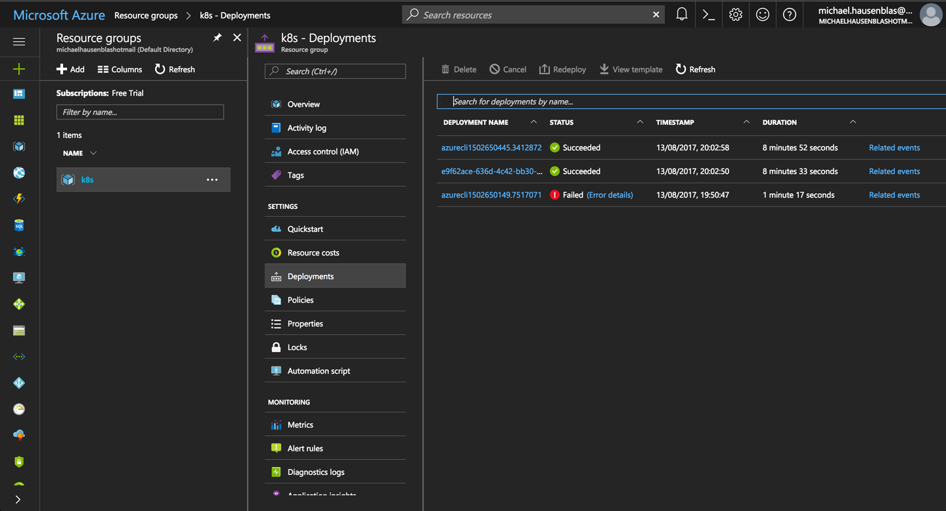
Figure 2-1. Screenshot of the Azure Portal, showing ACS deployments in the k8s resource group

You’re now in a position to connect to the cluster:
$
az acs kubernetes get-credentials --resource-group=k8s --name=k8scb
You can now poke around in the environment and verify the setup:
$
kubectl cluster-info
Kubernetes master is running at https://k8scb-k8s-143f1emgmt.northeurope.cloudapp
.azure.com
Heapster is running at https://k8scb-k8s-143f1emgmt.northeurope.cloudapp.azure
.com/api/v1/namespaces/kube-system/services/heapster/proxy
KubeDNS is running at https://k8scb-k8s-143f1emgmt.northeurope.cloudapp.azure
.com/api/v1/namespaces/kube-system/services/kube-dns/proxy
kubernetes-dashboard is running at https://k8scb-k8s-143f1emgmt.northeurope
.cloudapp.azure.com/api/v1/namespaces/kube-system/services/kubernetes-dashboard
/proxy
tiller-deploy is running at https://k8scb-k8s-143f1emgmt.northeurope.cloudapp
.azure.com/api/v1/namespaces/kube-system/services/tiller-deploy/proxy
To further debug and diagnose cluster problems, use 'kubectl cluster-info dump'.
$
kubectl get nodes
NAME STATUS AGE VERSION
k8s-agent-1a7972f2-0 Ready 7m v1.7.8
k8s-master-1a7972f2-0 Ready,SchedulingDisabled 7m v1.7.8
And indeed, as you can see from the output that there is one agent (worker) node and one master node.
When you’re done discovering ACS, don’t forget to shut down the cluster and remove all the resources by deleting the resource group k8s:
$
az group delete --name k8s --yes --no-wait
Although the az group delete command returns immediately, it can take up to 10 minutes for all the resources—such as VMs, virtual networks, or disks—to be removed and the resource group actually destroyed. You might want to check in the Azure portal to make sure everything went according to plan.

Tip
If you don’t want to or cannot install the Azure CLI, you can use the Azure Cloud Shell from within your browser instead to carry out the preceding steps to install the Kubernetes cluster.

See Also
- “Deploy Kubernetes cluster for Linux containers” in the Microsoft Azure documentation

1
Kubernetes, “Installing Addons”.
2
Weaveworks, “Integrating Kubernetes via the Addon”.
3
freedesktop.org, “systemd”.
4
Kubernetes the Hard Way, “Bootstrapping the Kubernetes Control Plane”.
Chapter 3. Learning to Use the Kubernetes Client
This chapter gathers recipes around the basic usage of the Kubernetes command-line interface (CLI), kubectl. See Chapter 1 for how to install the CLI tool; for advanced use cases, see Chapter 6, where we show how to use the Kubernetes API.

3.1 Listing Resources

Problem
You want to list Kubernetes resources of a certain kind.

Solution
Use the get verb of kubectl along with the resource type. To list all pods:
$
kubectl get pods
To list all services and deployments:
$
kubectl get services,deployments
To list a specific deployment:
$
kubectl get deployment myfirstk8sapp
To list all resources:
$
kubectl get all
Note that kubectl get is a very basic but extremely useful command to get a quick overview what is going on in the cluster—it’s essentially the equivalent to ps on Unix.

Tip
Many resources have short names you can use with kubectl, sparing your time and sanity. Here are some examples:
- configmaps (aka cm)
- daemonsets (aka ds)
- deployments (aka deploy)
- endpoints (aka ep)
- events (aka ev)
- horizontalpodautoscalers (aka hpa)
- ingresses (aka ing)
- namespaces (aka ns)
- nodes (aka no)
- persistentvolumeclaims (aka pvc)
- persistentvolumes (aka pv)
- pods (aka po)
- replicasets (aka rs)
- replicationcontrollers (aka rc)
- resourcequotas (aka quota)
- serviceaccounts (aka sa)
- services (aka svc)

3.2 Deleting Resources

Problem
You no longer need resources and want to get rid of them.

Solution
Use the delete verb of kubectl along with the type and name of the resource you wish to delete.
To delete all resources in the namespace my-app, do:
$
kubectl get ns
NAME STATUS AGE
default Active 2d
kube-public Active 2d
kube-system Active 2d
my-app Active 20m
$
kubectl delete ns my-app
namespace "my-app" deleted
If you’re wondering how to create a namespace, see Recipe 6.3.
You can also delete specific resources and/or influence the process by which they are destroyed. To delete services and deployments labeled with app=niceone, do:
$
kubectl delete svc,deploy -l app=niceone
To force deletion of a pod, do:
$
kubectl delete pod hangingpod --grace-period=0 --force
To delete all pods in the namespace test, do:
$
kubectl delete pods --all --namespace test

Discussion
Do not delete supervised objects such as pods controlled by a deployment directly. Rather, kill their supervisors or use dedicated operations to get rid of the managed resources. For example, if you scale a deployment to zero replicas (see Recipe 9.1), then you effectively delete all the pods it looks after.
Another aspect to take into account is cascading versus direct deletion—for example, when you delete a custom resource definition (CRD) as shown in Recipe 13.4, all its dependent objects are deleted too. To learn more about how to influence the cascading deletion policy, read Garbage Collection in the Kubernetes docs.

3.3 Watching Resource Changes with kubectl

Problem
You want to watch the changes to Kubernetes objects in an interactive manner in the terminal.

Solution
The kubectl command has a --watch option that gives you this behavior. For example, to watch pods:
$
kubectl get pods --watch
Note that this is a blocking and autoupdating command, akin to top.

Discussion
The --watch option is useful, but sometimes not very reliable, in terms of refreshing the screen correctly. Alternatively, you can use the watch command, as in:
$
watch kubectl get pods

3.4 Editing Resources with kubectl

Problem
You want to update the property of a Kubernetes resource.

Solution
Use the edit verb of kubectl along with the resource type:
$
kubectl run nginx --image=nginx
$
kubectl edit deploy/nginx
Now edit the nginx deployment in your editor—for example, change replicas to 2. Once you save, you’ll see something like:
deployment "nginx" edited

Discussion
If you have editor issues, use EDITOR=vi. Also be aware that not all changes trigger a deployment.
Some triggers have shortcuts, for example, if you want to change the image version a deployment uses, simply use kubectl set image, which updates the existing container images of resources (valid for deployments, replica sets/replication controllers, daemon sets, jobs, and simple pods).

3.5 Asking kubectl to Explain Resources and Fields

Problem
You want to gain a deeper understanding of a certain resource—for example, service—and/or understand what exactly a certain field in a Kubernetes manifest means, including default values and if it’s required or optional.

Solution
Use the explain verb of kubectl:
$
kubectl explain svc
DESCRIPTION:
Service is a named abstraction of software service (for example, mysql)
consisting of local port (for example 3306) that the proxy listens on, and the
selector that determines which pods will answer requests sent through the proxy.
FIELDS:
status <Object>
Most recently observed status of the service. Populated by the system.
Read-only. More info: https://git.k8s.io/community/contributors/devel/
api-conventions.md#spec-and-status/
apiVersion <string>
APIVersion defines the versioned schema of this representation of an
object. Servers should convert recognized schemas to the latest internal
value, and may reject unrecognized values. More info:
https://git.k8s.io/community/contributors/devel/api-conventions.md#resources
kind <string>
Kind is a string value representing the REST resource this object
represents. Servers may infer this from the endpoint the client submits
requests to. Cannot be updated. In CamelCase. More info:
https://git.k8s.io/community/contributors/devel/api-conventions
.md#types-kinds
metadata <Object>
Standard object's metadata. More info:
https://git.k8s.io/community/contributors/devel/api-conventions.md#metadata
spec <Object>
Spec defines the behavior of a service. https://git.k8s.io/community/
contributors/devel/api-conventions.md#spec-and-status/
$
kubectl explain svc.spec.externalIPs
FIELD: externalIPs <[]string>
DESCRIPTION:
externalIPs is a list of IP addresses for which nodes in the cluster will
also accept traffic for this service. These IPs are not managed by
Kubernetes. The user is responsible for ensuring that traffic arrives at a
node with this IP. A common example is external load-balancers that are not
part of the Kubernetes system.

Discussion
The kubectl explain command1 pulls the descriptions of resources and fields from the Swagger/OpenAPI definitions,2 exposed by the API server.

See Also
- Ross Kukulinski’s blog post, “kubectl explain — #HeptioProTip”

1
Kubernetes, “Kubectl Reference Docs: Explain”.
2
Kubernetes, “The Kubernetes API”.
Chapter 4. Creating and Modifying Fundamental Workloads
In this chapter, we present recipes that show you how to manage fundamental Kubernetes workload types: pods and deployments. We show how to create deployments and pods via CLI commands and from a YAML manifest, and explain how to scale and update a deployment.

4.1 Creating a Deployment Using kubectl run

Problem
You want to quickly launch a long-running application such as a web server.

Solution
Use the kubectl run command, a generator that creates a deployment manifest on the fly. For example, to create a deployment that runs the Ghost microblogging platform do the following:
$
kubectl run ghost --image=ghost:0.9
$
kubectl get deploy/ghost
NAME DESIRED CURRENT UP-TO-DATE AVAILABLE AGE
ghost 1 1 1 0 16s

Discussion
The kubectl run command can take a number of arguments to configure additional parameters of the deployments. For example, you can do the following:
- Set environment variables with --env
- Define container ports with --port
- Define a command to run using --command
- Automatically create an associated service with --expose
- Define the number of pods using --replicas
Typical usages are as follows. To launch Ghost serving on port 2368 and create a service along with it, enter:
$
kubectl run ghost --image=ghost:0.9 --port=2368 --expose
To launch MySQL with the root password set, enter:
$
kubectl run mysql --image=mysql:5.5 --env=MYSQL_ROOT_PASSWORD=root
To launch a busybox container and execute the command sleep 3600 on start, enter:
$
kubectl run myshell --image=busybox --command -- sh -c "sleep 3600"
See also kubectl run --help for more details about the available arguments.

4.2 Creating Objects from File Manifests

Problem
Rather than creating an object via a generator such as kubectl run, you want to explicitly state its properties and then create it.

Solution
Use kubectl create like so:
$
kubectl create -f
<manifest>
In Recipe 6.3 you’ll see how to create a namespace using a YAML manifest. This is one of the simplest examples as the manifest is very short. It can be written in YAML or JSON—for example, with a YAML manifest file myns.yaml like so:
apiVersion
:
v1
kind
:
namespace
metadata
:
name
:
myns
You can create this object with kubectl create -f myns.yaml.

Discussion
You can point kubectl create to a URL instead, or a filename in your local filesystem. For example, to create the frontend for the canonical Guestbook application, get the URL of the raw YAML that defines the application in a single manifest and enter:
$
kubectl create -f https://raw.githubusercontent.com/kubernetes/kubernetes/ \
master/examples/guestbook/frontend-deployment.yaml

4.3 Writing a Pod Manifest from Scratch

Problem
You want to write a pod manifest from scratch and not use a generator such as kubectl run.

Solution
A Pod is an /api/v1 object and, like any other Kubernetes object, its manifest file contains the following fields:
- apiVersion, which specifies the API version
- kind, which indicates the type of the object
- metadata, which provides some metadata about the object
- spec, which provides the object specification
The pod manifest contains an array of containers and an optional array of volumes (see Chapter 8). In its simplest form, with a single container and no volume, it looks as follows:
apiVersion
:
v1
kind
:
Pod
metadata
:
name
:
oreilly
spec
:
containers
:
-
name
:
oreilly
image
:
nginx
Save this YAML manifest in a file called oreilly.yaml and then use kubectl to create it:
$
kubectl create -f oreilly.yaml

Discussion
The API specification of a pod is much richer than what is shown in the Solution, which is the most basic functioning pod. For example, a pod can contain multiple containers, as shown here:
apiVersion
:
v1
kind
:
Pod
metadata
:
name
:
oreilly
spec
:
containers
:
-
name
:
oreilly
image
:
nginx
-
name
:
safari
image
:
redis
A pod can also contain volume definitions to load data in the containers (see Recipe 8.1), as well as probes to check the health of the containerized application (see Recipe 11.2 and Recipe 11.3).
A description of the thinking behind many of the specification fields and a link to the full API object specification is detailed in the documentation.

Note
Unless for very specific reasons, never create a pod on its own. Use a Deployment object (see Recipe 4.4) to supervise pods—it will watch over the pods through another object called a ReplicaSet.

See Also
- Kubernetes Pods reference documentation.
- ReplicaSet documentation

4.4 Launching a Deployment Using a Manifest

Problem
You want to have full control over how a (long-running) app is launched and supervised.

Solution
Write a manifest using the Deployment object in it. For the basics, see also Recipe 4.3.
Let’s say you have manifest file called fancyapp.yaml with the following content:
apiVersion
:
extensions/v1beta1
kind
:
Deployment
metadata
:
name
:
fancyapp
spec
:
replicas
:
5
template
:
metadata
:
labels
:
app
:
fancy
env
:
development
spec
:
containers
:
-
name
:
sise
image
:
mhausenblas/simpleservice:0.5.0
ports
:
-
containerPort
:
9876
env
:
-
name
:
SIMPLE_SERVICE_VERSION
value
:
"0.9"
As you can see, there are a couple of things you might want to do explicitly when launching the app:
- Set the number of pods (replicas), or identical copies, that should be launched and supervised.
- Label it, such as with env=development (see also Recipe 6.5 and Recipe 6.6).
- Set environment variables, such as SIMPLE_SERVICE_VERSION.
Now let’s have a look at what the deployment entails:
$
kubectl create -f fancyapp.yaml
deployment "fancyapp" created
$
kubectl get deploy
NAME DESIRED CURRENT UP-TO-DATE AVAILABLE AGE
fancyapp 5 5 5 0 8s
$
kubectl get rs
NAME DESIRED CURRENT READY AGE
fancyapp-1223770997 5 5 0 13s
$
kubectl get po
NAME READY STATUS RESTARTS AGE
fancyapp-1223770997-18msl 0/1 ContainerCreating 0 15s
fancyapp-1223770997-1zdg4 0/1 ContainerCreating 0 15s
fancyapp-1223770997-6rqn2 0/1 ContainerCreating 0 15s
fancyapp-1223770997-7bnbh 0/1 ContainerCreating 0 15s
fancyapp-1223770997-qxg4v 0/1 ContainerCreating 0 15s
And if we repeat this a few seconds later:
$
kubectl get po
NAME READY STATUS RESTARTS AGE
fancyapp-1223770997-18msl 1/1 Running 0 1m
fancyapp-1223770997-1zdg4 1/1 Running 0 1m
fancyapp-1223770997-6rqn2 1/1 Running 0 1m
fancyapp-1223770997-7bnbh 1/1 Running 0 1m
fancyapp-1223770997-qxg4v 1/1 Running 0 1m
Warning
When you want to get rid of a deployment, and with it the replica sets and pods it supervises, execute a command like kubectl delete deploy/fancyapp. Do not try to delete individual pods, as they will be recreated by the deployment. This is something that often confuses beginners.
Deployments allow you to scale the app (see Recipe 9.1) as well as roll out a new version or roll back to a previous version. They are, in general, good for stateless apps that require pods with identical characteristics.

Discussion
A deployment is a supervisor for pods and replica sets (RSs), giving you fine-grained control over how and when a new pod version is rolled out or rolled back to a previous state. The RSs and pods that a deployment supervises are generally of no interest to you unless, for example, you need to debug a pod (see Recipe 12.5). Figure 4-1 illustrates how you can move back and forth between deployment revisions.
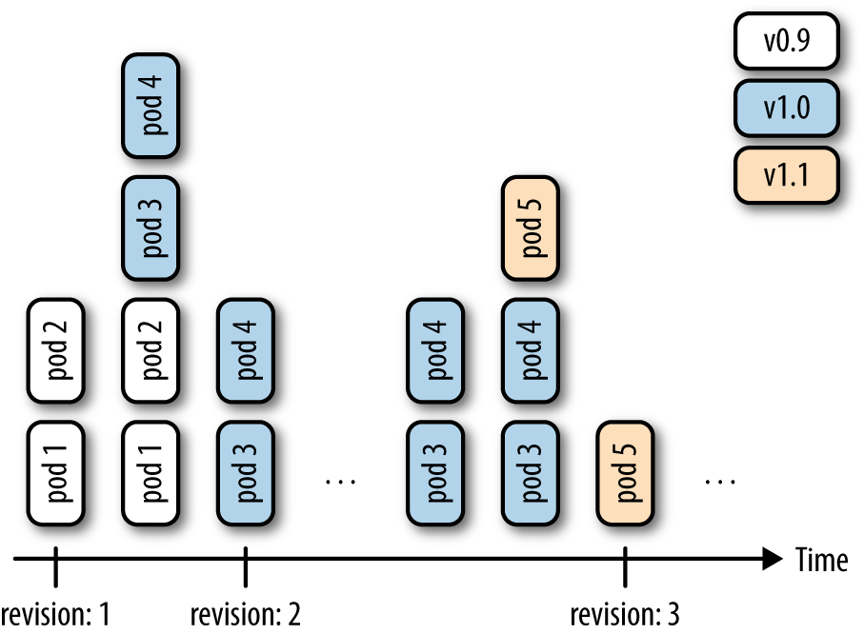
Figure 4-1. Deployment revisions

Note that RS will, going forward, replace the original replication controller (RC), so it’s a good thing to start thinking in terms of RSs rather than RCs. For now, the only difference is that RSs support set-based labels/querying, but we can expect that there will be more features added to the RS and the RC will eventually be deprecated.
Finally, to generate the manifest, you can use the kubectl create command and the --dry-run option. It will allow you to generate the manifest in YAML or JSON format and save the manifest for later use. For example, to create the manifest of a deployment called fancy-app using the Docker image nginx, issue the following command:
$
kubectl create deployment fancyapp --image nginx -o json --dry-run
{
"kind": "Deployment",
"apiVersion": "extensions/v1beta1",
"metadata": {
"name": "fancy-app",
"creationTimestamp": null,
"labels": {
"app": "fancy-app"
}
},
...

See Also
- Kubernetes Deployments in documentation

4.5 Updating a Deployment

Problem
You have a deployment and want to roll out a new version of your app.

Solution
Update your deployment and let the default update strategy, RollingUpdate, automatically handle the rollout.
For example, suppose you create a new container image and want to update the deployment based on it:
$
kubectl run sise --image=mhausenblas/simpleservice:0.4.0
deployment "sise" created
$
kubectl set image deployment sise mhausenblas/simpleservice:0.5.0
deployment "sise" image updated
$
kubectl rollout status deployment sise
deployment "sise" successfully rolled out
$
kubectl rollout history deployment sise
deployments "sise"
REVISION CHANGE-CAUSE
1 <none>
2 <none>
You’ve now successfully rolled out a new revision of your deployment where only the container image used has changed. All other properties of the deployment, such as the number of replicas, stay unchanged. But what if you want to update other aspects of the deployment, such as changing environment variables? You can use a number of kubectl commands to update the deployment. For example, to add a port definition to the current deployment, you can use kubectl edit:
$
kubectl edit deploy sise
This command will open the current deployment in your default editor, or, when set and exported, in the editor specified by the environment variable KUBE_EDITOR.
Say you want to add the following port definition:
...
ports
:
-
containerPort
:
9876
...
The result of the editing process (in this case, with KUBE_EDITOR set to vi) is shown in Figure 4-2.
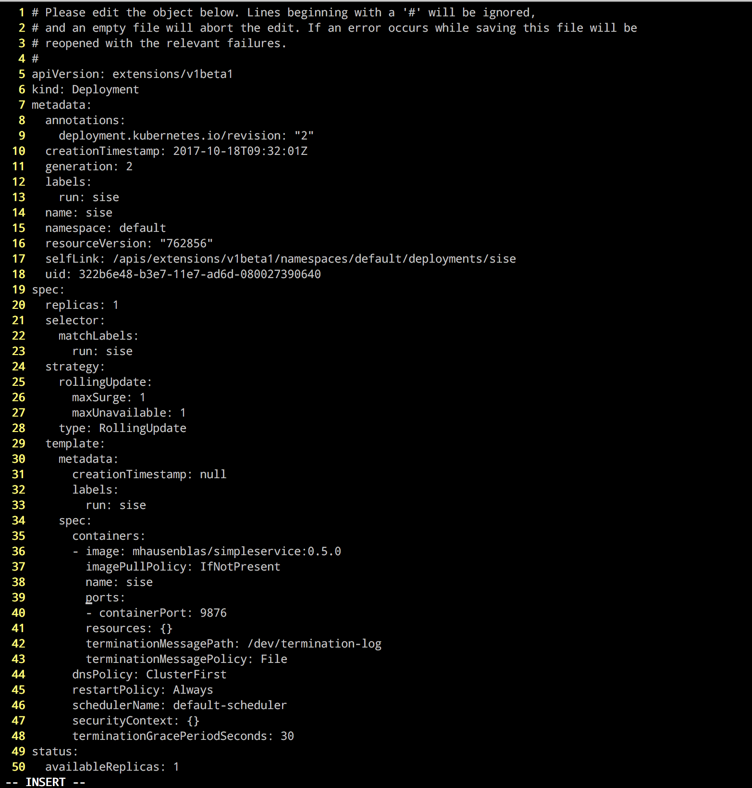
Figure 4-2. Editing a deployment

Once you save and exit the editor, Kubernetes kicks off a new deployment, now with the port defined. Let’s verify that:
$
kubectl rollout history deployment sise
deployments "sise"
REVISION CHANGE-CAUSE
1 <none>
2 <none>
3 <none>
Indeed, we see that revision 3 has been rolled out with the changes we introduced with kubectl edit. The reason the CHANGE-CAUSE column is empty is that you didn’t use kubectl create with the --record option. If you want to see what triggered a revision, add this option.
As mentioned earlier, there are more kubectl commands that you can use to update your deployment:
- Use kubectl apply to update a deployment (or create it if it doesn’t exist) from a manifest file—for example, kubectl apply -f simpleservice.yaml.
- Use kubectl replace to replace a deployment from a manifest file—for example, kubectl replace -f simpleservice.yaml. Note that unlike apply, in order to use replace, the deployment must already exist.
- Use kubectl patch to update a specific key—for example:
kubectl patch deployment sise -p '{"spec": {"template":
{"spec": {"containers":
[{"name": "sise", "image": "mhausenblas/simpleservice:0.5.0"}]}}}}'
What if you make a mistake or experience issues with the new version of the deployment? Luckily, Kubernetes makes it really easy to roll back to a known good state using the kubectl rollout undo command. For example, suppose the last edit was a mistake and you want to roll back to revision 2. You can do this with the following command:
$
kubectl rollout undo deployment sise ‐‐to‐revision=2
You can then verify that the port definition has been removed with kubectl get deploy/sise -o yaml.

Note
The rollout of a deployment is only triggered if parts of the pod template (that is, keys below .spec.template) are changed, such as environment variables, ports, or the container image. Changes to aspects of the deployments, such as the replica count, do not trigger a new deployment.

Chapter 5. Working with Services
In this chapter, we discuss how pods communicate within the cluster, how applications discover each other, and how to expose pods so that they can be accessed from outside of the cluster.
The primitive we will be using here is called a Kubernetes service, as depicted in Figure 5-1.
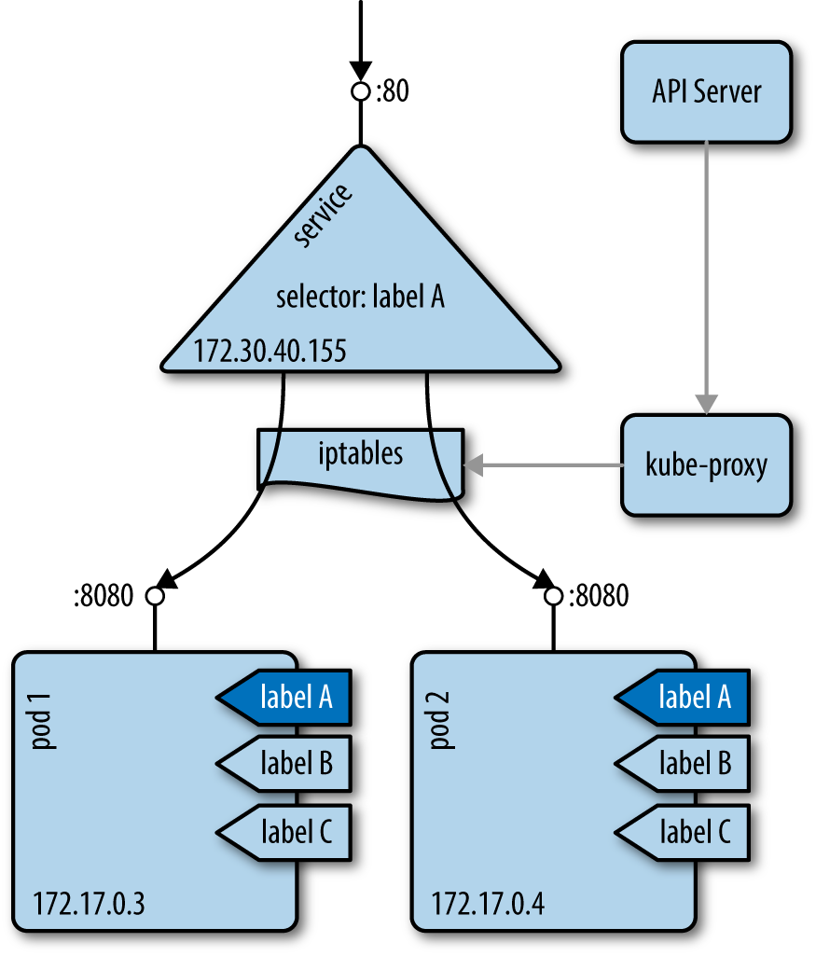
Figure 5-1. The Kubernetes service concept

A service provides a stable virtual IP (VIP) address for a set of pods. Though pods may come and go, services allow clients to reliably discover and connect to the containers running in the pods by using the VIP. The “virtual” in VIP means it’s not an actual IP address connected to a network interface; its purpose is purely to forward traffic to one or more pods. Keeping the mapping between the VIP and the pods up to date is the job of kube-proxy, a process that runs on every node on the cluster. This kube-proxy process queries the API server to learn about new services in the cluster and updates the node’s iptables rules (iptables) accordingly, to provide the necessary routing information.

5.1 Creating a Service to Expose Your Application

Problem
You want to provide a stable and reliable way to discover and access your application within the cluster.

Solution
Create a Kubernetes service for the pods that make up your application.
Assuming you created an nginx deployment with kubectl run nginx --image nginx, you can automatically create a Service object using the kubectl expose command, like so:
$
kubectl expose deploy/nginx --port 80
service "nginx" exposed
$
kubectl describe svc/nginx
Name: nginx
Namespace: default
Labels: run=nginx
Annotations: <none>
Selector: run=nginx
Type: ClusterIP
IP: 10.0.0.143
Port: <unset> 80/TCP
Endpoints: 172.17.0.5:80,172.17.0.7:80
Session Affinity: None
Events: <none>
You will then see the object appear when you list all services:
$
kubectl get svc | grep nginx
NAME TYPE CLUSTER-IP EXTERNAL-IP PORT(S) AGE
nginx ClusterIP 10.109.24.56 <none> 80/TCP 2s

Discussion
To access this service via your browser, run a proxy in a separate terminal, like so:
$
kubectl proxy
Starting to serve on 127.0.0.1:8001
Then open your browser with:
$
open http://localhost:8001/api/v1/proxy/namespaces/default/services/nginx/
If you wanted to write a Service object by hand for the same nginx deployment, you would write the following YAML file:
apiVersion
:
v1
kind
:
Service
metadata
:
name
:
nginx
spec
:
selector
:
run
:
nginx
ports
:
-
port
:
80
The one thing to pay attention to in this YAML file is the selector, which is used to select all the pods that make up this microservice abstraction. Kubernetes uses the Service object to dynamically configure the iptables on all the nodes to be able to send the network traffic to the containers that make up the microservice. The selection is done as a label query (see Recipe 6.6) and results in a list of endpoints.

Tip
If your service does not seem to be working properly, check the labels used in the selector and verify that a set of endpoints is being populated with kubectl get endpoints. If not, this most likely means that your selector is not finding any matching pods.

Note
Pod supervisors, such as deployments or replication controllers, operate orthogonally to services. Both supervisors and services find the pods they’re looking after by using labels, but they have different jobs to do: supervisors monitor the health of and restart pods, and services make them accessible in a reliable way.

See Also
- Kubernetes Services documentation
- Kubernetes tutorial “Using a Service to Expose Your App”

5.2 Verifying the DNS Entry of a Service

Problem
You have created a service (see Recipe 5.1) and want to verify that your DNS registration is working properly.

Solution
By default Kubernetes uses ClusterIP as the service type, and that exposes the service on a cluster-internal IP. If the DNS cluster add-on is available and working properly, you can access the service via a fully qualified domain name (FQDN) in the form of $SERVICENAME.$NAMESPACE.svc.cluster.local.
To verify that this is working as expected, get an interactive shell within a container in your cluster. The easiest way to do this is to use kubectl run with the busybox image, like so:
$
kubectl run busybox --image busybox -it -- /bin/sh
If you don't see a command prompt, try pressing enter.
/ # nslookup nginx
Server: 10.96.0.10
Address 1: 10.96.0.10 kube-dns.kube-system.svc.cluster.local
Name: nginx
Address 1: 10.109.24.56 nginx.default.svc.cluster.local
The IP address returned for the service should correspond to its cluster IP.

5.3 Changing the Type of a Service

Problem
You have an existing service, say of type ClusterIP, as discussed in Recipe 5.2 and you want to change its type so that you can expose your application as a NodePort or via a cloud provider load balancer using the LoadBalancer service type.

Solution
Use the kubectl edit command along with your preferred editor to change the service type. Suppose you have a manifest file called simple-nginx-svc.yaml with this content:
kind
:
Service
apiVersion
:
v1
metadata
:
name
:
webserver
spec
:
ports
:
-
port
:
80
selector
:
app
:
nginx
Create the webserver service and query for it:
$
kubectl create -f simple-nginx-svc.yaml
$
kubectl get svc/webserver
NAME CLUSTER-IP EXTERNAL-IP PORT(S) AGE
webserver 10.0.0.39 <none> 80/TCP 56s
Next, change the service type to, say, NodePort, like so:
$
kubectl edit svc/webserver
This command will download the current spec the API server has of the service and open it in your default editor, resulting in something like what’s shown in Figure 5-2 (EDITOR=vi is set here).
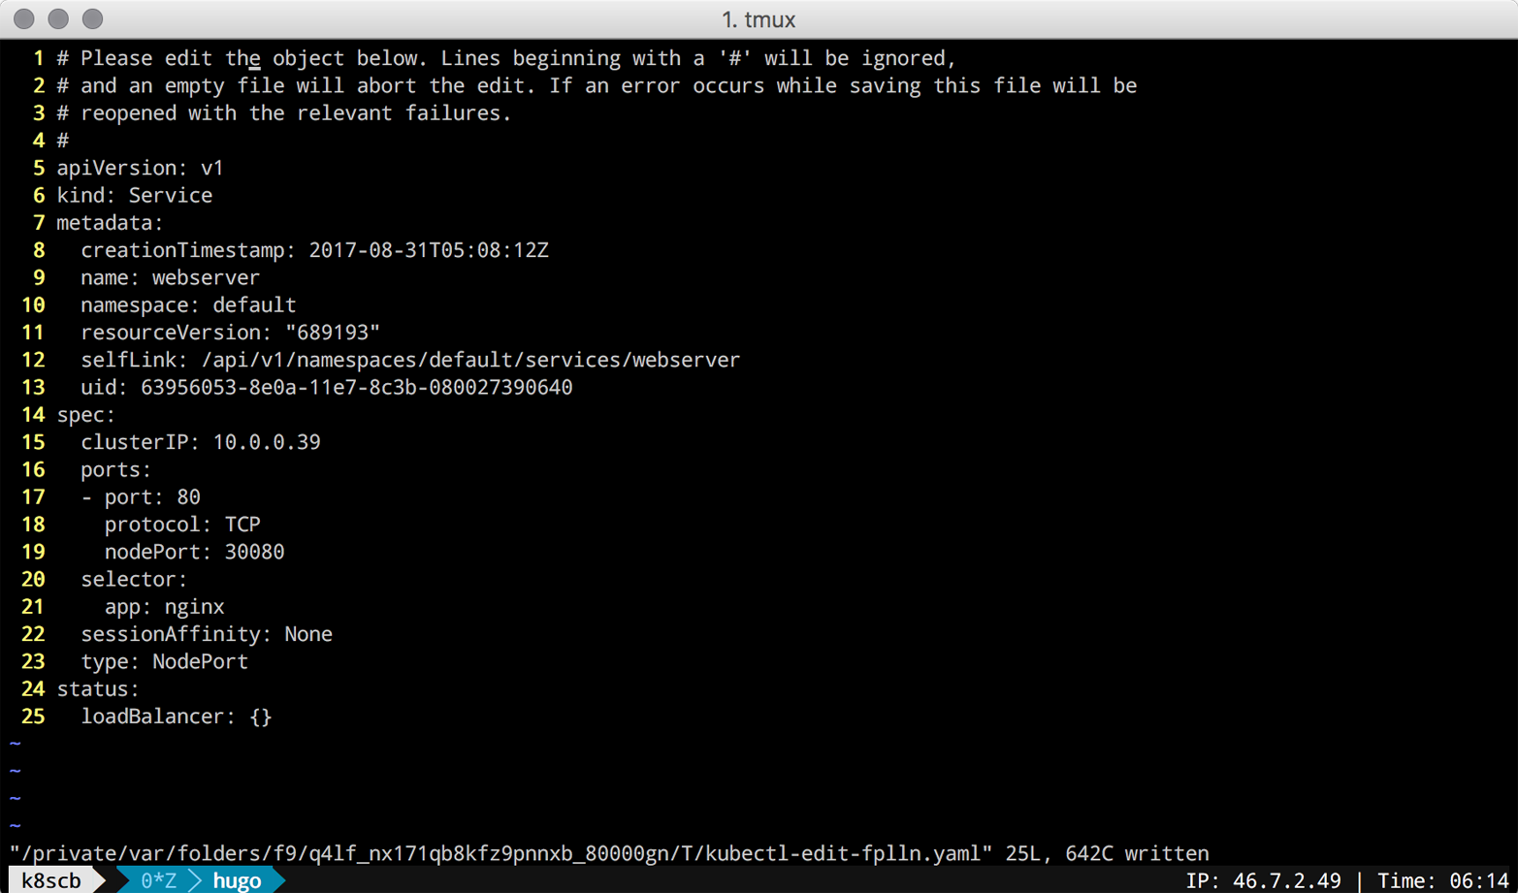
Figure 5-2. Screenshot of editing service using kubectl edit

Once you’ve saved the edits (changing type to NodePort and containerPort to nodePort), you can verify the updated service, like so:
$
kubectl get svc/webserver
NAME CLUSTER-IP EXTERNAL-IP PORT(S) AGE
webserver 10.0.0.39 <nodes> 80:30080/TCP 7m
$
kubectl get svc/webserver -o yaml
apiVersion: v1
kind: Service
metadata:
creationTimestamp: 2017-08-31T05:08:12Z
name: webserver
namespace: default
resourceVersion: "689727"
selfLink: /api/v1/namespaces/default/services/webserver
uid: 63956053-8e0a-11e7-8c3b-080027390640
spec:
clusterIP: 10.0.0.39
externalTrafficPolicy: Cluster
ports:
- nodePort: 30080
port: 80
protocol: TCP
targetPort: 80
selector:
app: nginx
sessionAffinity: None
type: NodePort
status:
loadBalancer: {}
Note that you can change the service type to whatever suits your use case; however, be aware of the implications of certain types, like LoadBalancer, which may trigger the provisioning of public cloud infrastructure components that can be costly if used without awareness and/or monitoring.

5.4 Deploying an Ingress Controller on Minikube

Problem
You want to deploy an ingress controller on Minikube to learn about Ingress objects. Ingress objects are of interest to you because you want to provide access to your applications running in Kubernetes from outside your Kubernetes cluster; however, you do not want to create a NodePort- or LoadBalancer-type service.

Solution
For Ingress objects (discussed in Recipe 5.5) to take effect and provide a route from outside the cluster to your pods, you need to deploy an ingress controller.
On Minikube, enable the ingress add-on like so:
$
minikube addons enable ingress
Once done, you should see ingress appear as enabled in the list of Minikube add-ons. Check that this is the case with:
$
minikube addons list | grep ingress
- ingress: enabled
After a minute or less, two new pods will start in your kube-system namespace:
$
kubectl get pods -n kube-system
NAME READY STATUS RESTARTS AGE
default-http-backend-6tv69 1/1 Running 1 1d
...
nginx-ingress-controller-95dqr 1/1 Running 1 1d
...
You are now ready to create Ingress objects.

See Also
- Ingress documentation
- Nginx-based ingress controller

5.5 Making Services Accessible from Outside the Cluster

Problem
You want to access a Kubernetes service from outside of the cluster.

Solution
Use an ingress controller (see Recipe 5.4), which is configured by creating Ingress objects. The following shows the manifest of an Ingress rule that configures a path to an nginx service:
$
cat nginx-ingress.yaml
kind: Ingress
apiVersion: extensions/v1beta1
metadata:
name: nginx-public
annotations:
ingress.kubernetes.io/rewrite-target: /
spec:
rules:
- host:
http:
paths:
- path: /web
backend:
serviceName: nginx
servicePort: 80
$
kubectl create -f nginx-ingress.yaml
Now you can see the Ingress object created for nginx in your Kubernetes dashboard (Figure 5-3).
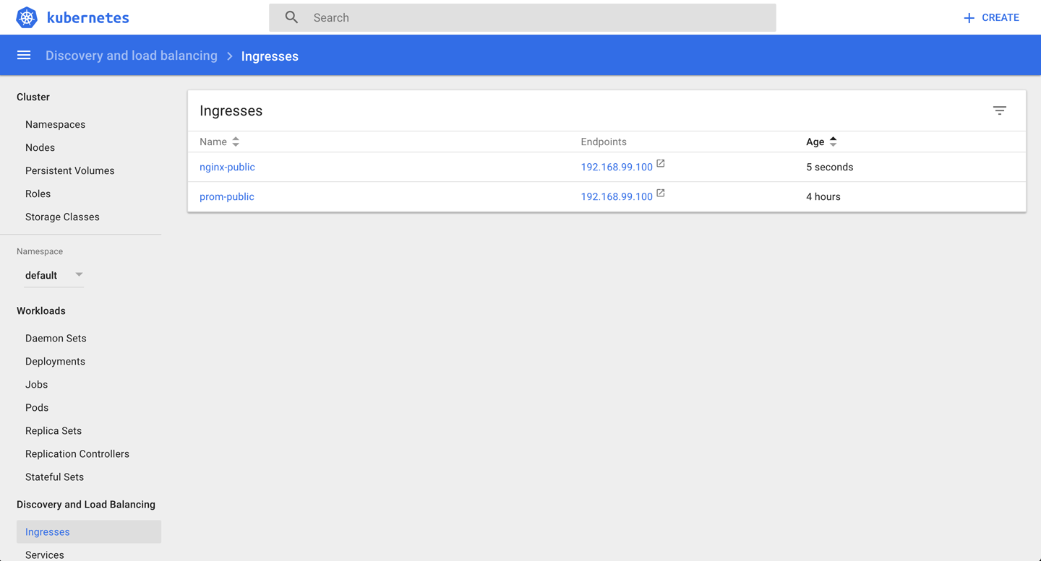
Figure 5-3. Screenshot of the nginx ingress object

From the Kubernetes dashboard, you can see that nginx will be available via the IP address 192.168.99.100, and the manifest file defines that it should be exposed via the path /web. Based on this information, you can access nginx from outside the cluster now as follows:
$
curl -k https://192.168.99.100/web
<!DOCTYPE html>
<html>
<head>
<title>Welcome to nginx!</title>
<style>
body {
width: 35em;
margin: 0 auto;
font-family: Tahoma, Verdana, Arial, sans-serif;
}
</style>
</head>
<body>
<h1>Welcome to nginx!</h1>
<p>If you see this page, the nginx web server is successfully installed and
working. Further configuration is required.</p>
<p>For online documentation and support please refer to
<a href="http://nginx.org/">nginx.org</a>.<br/>
Commercial support is available at
<a href="http://nginx.com/">nginx.com</a>.</p>
<p><em>Thank you for using nginx.</em></p>
</body>
</html>

Discussion
In general, ingress works as depicted in Figure 5-4: the ingress controller listens to the /ingresses endpoint of the API server, learning about new rules. It then configures the routes so that external traffic lands at a specific (cluster-internal) service—service1 on port 9876 in our example.
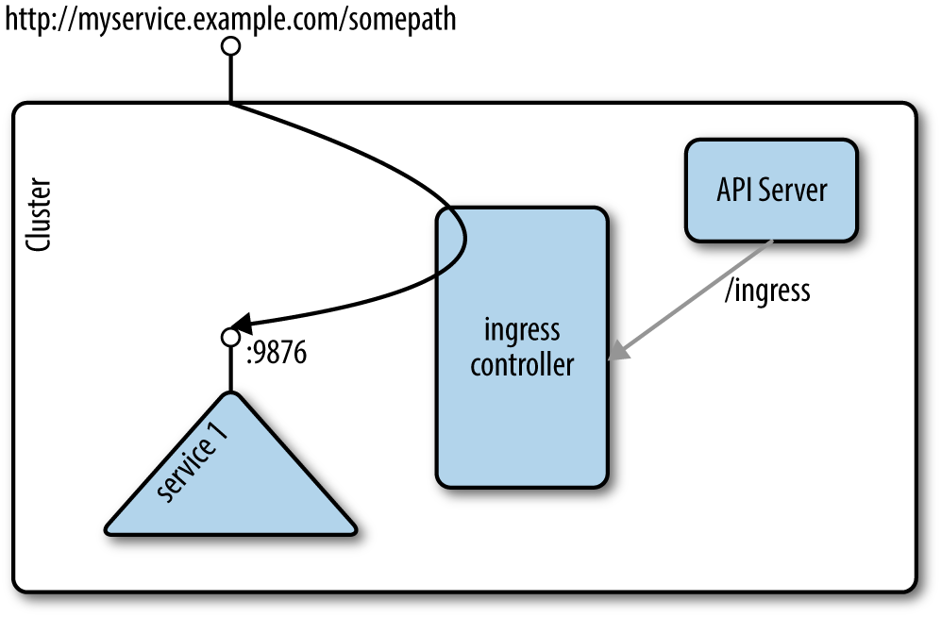
Figure 5-4. Ingress concept

Note
This recipe uses Minishift, where an ingress controller add-on is readily available. Usually, you’ll need to set up an ingress controller yourself; see for example the instructions on GitHub.

See Also
- The kubernetes/ingress-nginx repo on GitHub
- Milos Gajdos’s blog post “Kubernetes Services and Ingress Under X-ray”
- Daemonza’s blog post “Kubernetes nginx-ingress-controller”

Chapter 6. Exploring the Kubernetes API and Key Metadata
In this chapter, we present recipes that address the basic interaction with Kubernetes objects as well as the API. Every object in Kubernetes, no matter if namespaced like a deployment or cluster-wide like a node, has certain fields available—for example, metadata, spec, and status.1 The spec describes the desired state for an object (the specification), and the status captures the actual state of the object, managed by the Kubernetes API server.

6.1 Discovering API Endpoints of the Kubernetes API Server

Problem
You want to discover the various API endpoints available on the Kubernetes API server.

Solution
If you have access to the API server via an unauthenticated private port, you can directly issue HTTP requests to the API server and explore the various endpoints. For example, with Minikube, you can ssh inside the virtual machine (minikube ssh) and reach the API server on port 8080, as shown here:
$
curl localhost:8080/api/v1
...
{
"name": "pods",
"namespaced": true,
"kind": "Pod",
"verbs": [
"create",
"delete",
"deletecollection",
"get",
"list",
"patch",
"proxy",
"update",
"watch"
],
"shortNames": [
"po"
]
},
...
In this listing you see an example of an object of kind Pod as well as the allowed operations on this subject, such as get and delete.

Tip
Alternatively, if you don’t have direct access to the machine the Kubernetes API server is running on, you can use kubectl to proxy the API locally. This will allow you to reach the API server locally, but using an authenticated session:
$
kubectl proxy --port=8001 --api-prefix=/
And then in another window, do this:
$
curl localhost:8001/foobar
The use of the /foobar API path allows you to list all the API endpoints. Note that both --port and --api-prefix are optional.

Discussion
When discovering the API endpoints, you will see different ones, like:
- /api/v1
- /apis/apps
- /apis/authentication.k8s.io
- /apis/authorization.k8s.io
- /apis/autoscaling
- /apis/batch
Each of these endpoints corresponds to an API group. Within a group, API objects are versioned (e.g., v1beta1, v1beta2) to indicate the maturity of the objects. Pods, services, config maps, and secrets, for example, are all part of the /api/v1 API group, whereas deployments are part of the /apis/extensions/v1beta1 API group.
The group an object is part of is what is referred to as the apiVersion in the object specification, available via the API reference.

See Also
- Kubernetes API Overview
- Kubernetes API Conventions

6.2 Understanding the Structure of a Kubernetes Manifest

Problem
While Kubernetes has a few convenience generators with kubectl run and kubectl create, you need to learn how to write Kubernetes manifests, expressing Kubernetes object specifications. To do this, you need to understand the general structure of manifests.

Solution
In Recipe 6.1, you learned about the various API groups and how to discover which group a particular object is in.
All API resources are either objects or lists. All resources have a kind and an apiVersion. In addition, every object kind must have metadata. The metadata contains the name of the object, the namespace it is in (see Recipe 6.3), and potentially some labels (see Recipe 6.6) and annotations (see Recipe 6.7).
A pod, for example, will be of kind Pod and apiVersion v1, and the beginning of a simple manifest written in YAML will look like this:
apiVersion
:
v1
kind
:
Pod
metadata
:
name
:
mypod
...
To complete a manifest, most objects will have a spec and, once created, will also return a status:
apiVersion
:
v1
kind
:
Pod
metadata
:
name
:
mypod
spec
:
...
status
:
...

See Also
- Understanding Kubernetes Objects

6.3 Creating Namespaces to Avoid Name Collisions

Problem
You want to create two objects with the same name but want to avoid naming collisions.

Solution
Create namespaces and place your objects in different ones.
If you don’t specify anything, objects will get created in the default namespace. Try creating a second namespace called my-app, as shown here, and list the existing namespaces. You will see the default namespace, two other namespaces that were created on startup (kube-system and kube-public), and the my-app namespace you just created:
$
kubectl create namespace my-app
namespace "my-app" created
$
kubectl get ns
NAME STATUS AGE
default Active 30s
my-app Active 1s
kube-public Active 29s
kube-system Active 30s

Note
Alternatively, you can write a manifest to create your namespace. If you save the following manifest as app.yaml, you can then create the namespace with the kubectl create -f app.yaml command:
apiVersion: v1
kind: Namespace
metadata:
name: my-app

Discussion
Attempting to start two objects with the same name in the same namespace (e.g., default) leads to a collision, and an error is returned by the Kubernetes API server. However, if you start the second object in a different namespace, the API server will create it:
$
kubectl run foobar --image=ghost:0.9
deployment "foobar" created
$
kubectl run foobar --image=nginx:1.13
Error from server (AlreadyExists): deployments.extensions "foobar" already exists
$
kubectl run foobar --image=nginx:1.13 --namespace foobar
deployment "foobar" created
This is because many API objects in Kubernetes are namespaced. The namespace they belong to is defined as part of the object’s metadata.

Note
The kube-system namespace is reserved for administrators, whereas the kube-public namespace is meant to store public objects available to any users of the cluster.

6.4 Setting Quotas Within a Namespace

Problem
You want to limit the resources available in a namespace—for example, the overall number of pods that can run in the namespace.

Solution
Use a ResourceQuota object to specify the limitations on a namespace basis:
$
cat resource-quota-pods.yaml
apiVersion: v1
kind: ResourceQuota
metadata:
name: podquota
spec:
hard:
pods: "10"
$
kubectl create namespace my-app
$
kubectl create -f resource-quota-pods.yaml --namespace=my-app
$
kubectl describe resourcequota podquota --namespace=my-app
Name: podquota
Namespace: my-app
Resource Used Hard
-------- ---- ----
pods 0 10

Discussion
You can set a number of quotas on a per-namespace basis, including but not limited to pods, secrets, and config maps.

See Also
- Configure Quotas for API Objects

6.5 Labeling an Object

Problem
You want to label an object in order to find it later on. The label can be used for further end-user queries (see Recipe 6.6) or in the context of system automation.

Solution
Use the kubectl label command. For example, to label a pod named foobar with the key/value pair tier=frontend, do this:
$
kubectl label pods foobar tier=frontend

Tip
Check the complete help for the command (kubectl label --help). You can use it to find out how to remove labels, overwrite existing ones, and even label all resources in a namespace.

Discussion
In Kubernetes, you use labels to organize objects in a flexible, nonhierarchical manner. A label is a key/value pair without any predefined meaning for Kubernetes. In other words, the content of the key/value pair is not interpreted by the system. You can use labels to express membership (e.g., object X belongs to department ABC), environments (e.g., this service runs in production), or really anything you need to organize your objects. Note that labels do have restrictions concerning their length and allowed values.2

6.6 Using Labels for Queries

Problem
You want to query objects efficiently.

Solution
Use the kubectl get --selector command. For example, given the following pods:
$
kubectl get pods --show-labels
NAME READY ... LABELS
cockroachdb-0 1/1 ... app=cockroachdb,
cockroachdb-1 1/1 ... app=cockroachdb,
cockroachdb-2 1/1 ... app=cockroachdb,
jump-1247516000-sz87w 1/1 ... pod-template-hash=1247516000,run=jump
nginx-4217019353-462mb 1/1 ... pod-template-hash=4217019353,run=nginx
nginx-4217019353-z3g8d 1/1 ... pod-template-hash=4217019353,run=nginx
prom-2436944326-pr60g 1/1 ... app=prom,pod-template-hash=2436944326
You can select the pods that belong to the CockroachDB app (app=cockroachdb):
$
kubectl get pods --selector app=cockroachdb
NAME READY STATUS RESTARTS AGE
cockroachdb-0 1/1 Running 0 17h
cockroachdb-1 1/1 Running 0 17h
cockroachdb-2 1/1 Running 0 17h

Discussion
Labels are part of an object’s metadata. Any object in Kubernetes can be labeled. Labels are also used by Kubernetes itself for pod selection by deployments (see Recipe 4.1) and services (see Chapter 5).
Labels can be added manually with the kubectl label command (see Recipe 6.5), or you can define labels in an object manifest, like so:
apiVersion
:
v1
kind
:
Pod
metadata
:
name
:
foobar
labels
:
tier
:
frontend
...
Once labels are present, you can list them with kubectl get, noting the following:
- -l is the short form of --selector and will query objects with a specified key=value pair.
- --show-labels will show all the labels of each object returned.
- -L will add a column to the results returned with the value of the specified label.
- Many object kinds support set-based querying, meaning you can state a query in a form like “must be labelled with X and/or Y.” For example, kubectl get pods -l 'env in (production, development)' would give you pods that are in either the production or development environment.
With two pods running, one with label run=barfoo and the other with label run=foobar, you would get outputs similar to the following:
$
kubectl get pods --show-labels
NAME READY ... LABELS
barfoo-76081199-h3gwx 1/1 ... pod-template-hash=76081199,run=barfoo
foobar-1123019601-6x9w1 1/1 ... pod-template-hash=1123019601,run=foobar
$
kubectl get pods -Lrun
NAME READY ... RUN
barfoo-76081199-h3gwx 1/1 ... barfoo
foobar-1123019601-6x9w1 1/1 ... foobar
$
kubectl get pods -l run=foobar
NAME READY ...
foobar-1123019601-6x9w1 1/1 ...

See Also
- Kubernetes Labels documentation

6.7 Annotating a Resource with One Command

Problem
You want to annotate a resource with a generic, nonidentifying key/value pair, possibly using nonhuman readable data.

Solution
Use the kubectl annotate command:
$
kubectl annotate pods foobar \
description='something that you can use for automation'

Discussion
Annotations tend to be used for added automation of Kubernetes. For example, when you create a deployment with the kubectl run command and you forget to use the --record option, you will notice that the change-cause column in your rollout history (see Recipe 4.5) is empty. As of Kubernetes v1.6.0, to start recording the commands that cause changes to the deployment, you can annotate it with the kubernetes.io/change-cause key. Given a deployment foobar, you might annotate it with:
$
kubectl annotate deployment foobar \
kubernetes.io/change-cause="Reason for creating a new revision"
Subsequent changes to the deployment will be recorded.

1
Kubernetes, “Understanding Kubernetes Objects”.
2
Kubernetes, “Labels and Selectors: Syntax and character set”.
Chapter 7. Managing Specialized Workloads
In Chapter 4, we explored how to launch applications that are supposed to run forever, such as a web server or an app server. In this chapter, we will discuss workloads that are somewhat more specialized—for example, ones that launch terminating processes such as batch jobs, run pods on certain nodes, or manage stateful and noncloud native apps.

7.1 Running a Batch Job

Problem
You want to run a process that runs for a certain time to completion, such as a batch conversion, backup operation, or database schema upgrade.

Solution
Use a Kubernetes job resource to launch and supervise the pod(s) that will carry out the batch process.1
First, define the Kubernetes manifest for the job in a file called counter-batch-job.yaml:
apiVersion
:
batch/v1
kind
:
Job
metadata
:
name
:
counter
spec
:
template
:
metadata
:
name
:
counter
spec
:
containers
:
-
name
:
counter
image
:
busybox
command
:
-
"sh"
-
"-c"
-
"for
i
in
1
2
3
;
do
echo
$i
;
done"
restartPolicy
:
Never
Then launch the job and have a look at its status:
$
kubectl create -f counter-batch-job.yaml
job "counter" created
$
kubectl get jobs
NAME DESIRED SUCCESSFUL AGE
counter 1 1 22s
$
kubectl describe jobs/counter
Name: counter
Namespace: default
Selector: controller-uid=634b9015-7f58-11e7-b58a-080027390640
Labels: controller-uid=634b9015-7f58-11e7-b58a-080027390640
job-name=counter
Annotations: <none>
Parallelism: 1
Completions: 1
Start Time: Sat, 12 Aug 2017 13:18:45 +0100
Pods Statuses: 0 Running / 1 Succeeded / 0 Failed
Pod Template:
Labels: controller-uid=634b9015-7f58-11e7-b58a-080027390640
job-name=counter
Containers:
counter:
Image: busybox
Port: <none>
Command:
sh
-c
for i in 1 2 3 ; do echo $i ; done
Environment: <none>
Mounts: <none>
Volumes: <none>
Events:
FirstSeen ... ... ... Type Reason Message
--------- ... ... ... ------ ------ -------
31s ... ... ... Normal SuccessfulCreate Created pod: counter-0pt20
Finally, you want to verify that it actually carried out the task (counting from 1 to 3):
$
kubectl logs jobs/counter
1
2
3
Indeed, as you can see, the counter job counted as expected.
If you don’t need the job anymore, use kubectl delete jobs/counter to remove it.

7.2 Running a Task on a Schedule Within a Pod

Problem
You want to run a task on a specific schedule within a pod managed by Kubernetes.

Solution
Use Kubernetes CronJob objects. The CronJob object is a derivative of the more generic Job object (see Recipe 7.1).
You can periodically schedule a job by writing a manifest similar to the one shown here. In the spec, you see a schedule section that follows the crontab format. The template section describes the pod that will run and the command that will get executed (it prints the current date and time every hour to stdout):
apiVersion
:
batch/v2alpha1
kind
:
CronJob
metadata
:
name
:
hourly-date
spec
:
schedule
:
"0
*
*
*
*"
jobTemplate
:
spec
:
template
:
spec
:
containers
:
-
name
:
date
image
:
busybox
command
:
-
"sh"
-
"-c"
-
"date"
restartPolicy
:
OnFailure

See Also
- CronJob documentation

7.3 Running Infrastructure Daemons per Node

Problem
You want to launch an infrastructure daemon—for example, a log collector or monitoring agent—making sure that exactly one pod runs per node.

Solution
Use a DaemonSet to launch and supervise the daemon process. For example, to launch a Fluentd agent on each node in your cluster, create a file named fluentd-daemonset.yaml with the following content:
kind
:
DaemonSet
apiVersion
:
extensions/v1beta1
metadata
:
name
:
fluentd
spec
:
template
:
metadata
:
labels
:
app
:
fluentd
name
:
fluentd
spec
:
containers
:
-
name
:
fluentd
image
:
gcr.io/google_containers/fluentd-elasticsearch:1.3
env
:
-
name
:
FLUENTD_ARGS
value
:
-qq
volumeMounts
:
-
name
:
varlog
mountPath
:
/varlog
-
name
:
containers
mountPath
:
/var/lib/docker/containers
volumes
:
-
hostPath
:
path
:
/var/log
name
:
varlog
-
hostPath
:
path
:
/var/lib/docker/containers
name
:
containers
Now launch the DaemonSet, like so:
$
kubectl create -f fluentd-daemonset.yaml
daemonset "fluentd" created
$
kubectl get ds
NAME DESIRED CURRENT READY UP-TO-DATE AVAILABLE NODE-SELECTOR AGE
fluentd 1 1 1 1 1 <none> 17s
$
kubectl describe ds/fluentd
Name: fluentd
Selector: app=fluentd
Node-Selector: <none>
Labels: app=fluentd
Annotations: <none>
Desired Number of Nodes Scheduled: 1
Current Number of Nodes Scheduled: 1
Number of Nodes Scheduled with Up-to-date Pods: 1
Number of Nodes Scheduled with Available Pods: 1
Number of Nodes Misscheduled: 0
Pods Status: 1 Running / 0 Waiting / 0 Succeeded / 0 Failed
...

Discussion
Note that in the preceding output, because the command is executed on Minikube, you only see one pod running as there’s only one node in this setup. If you had 15 nodes in your cluster, you’d have 15 pods overall with 1 pod per node running. You can also restrict the daemon to certain nodes using the nodeSelector section in the spec of the DaemonSet manifest.

7.4 Managing Stateful and Leader/Follower Apps

Problem
You want to run an app that requires that its pods have distinct, potentially different characteristics, such as a database where you have a leader handling reads and writes and several followers that only serve reads. You can’t use deployments because they only supervise identical pods, and you need a supervisor that can deal with pods that are more like pets than cattle.

Solution
Use a StatefulSet, which enables workloads with unique network names, graceful deployment/scaling/termination, or persistent storage. For example, to run the popular scalable datastore CockroachDB, you can use the provided example,2 which contains at its core the following StatefulSet:
apiVersion
:
apps/v1beta1
kind
:
StatefulSet
metadata
:
name
:
cockroachdb
spec
:
serviceName
:
"cockroachdb"
replicas
:
3
template
:
metadata
:
labels
:
app
:
cockroachdb
spec
:
initContainers
:
-
name
:
bootstrap
image
:
cockroachdb/cockroach-k8s-init:0.2
imagePullPolicy
:
IfNotPresent
args
:
-
"-on-start=/on-start.sh"
-
"-service=cockroachdb"
env
:
-
name
:
POD_NAMESPACE
valueFrom
:
fieldRef
:
fieldPath
:
metadata.namespace
volumeMounts
:
-
name
:
datadir
mountPath
:
"/cockroach/cockroach-data"
affinity
:
podAntiAffinity
:
preferredDuringSchedulingIgnoredDuringExecution
:
-
weight
:
100
podAffinityTerm
:
labelSelector
:
matchExpressions
:
-
key
:
app
operator
:
In
values
:
-
cockroachdb
topologyKey
:
kubernetes.io/hostname
containers
:
-
name
:
cockroachdb
image
:
cockroachdb/cockroach:v1.0.3
imagePullPolicy
:
IfNotPresent
ports
:
-
containerPort
:
26257
name
:
grpc
-
containerPort
:
8080
name
:
http
volumeMounts
:
-
name
:
datadir
mountPath
:
/cockroach/cockroach-data
command
:
-
"/bin/bash"
-
"-ecx"
-
|
if [ ! "$(hostname)" == "cockroachdb-0" ] || \
[ -e "/cockroach/cockroach-data/cluster_exists_marker" ]
then
CRARGS+=("--join" "cockroachdb-public")
fi
exec /cockroach/cockroach ${CRARGS[*]}
terminationGracePeriodSeconds
:
60
volumes
:
-
name
:
datadir
persistentVolumeClaim
:
claimName
:
datadir
volumeClaimTemplates
:
-
metadata
:
name
:
datadir
annotations
:
volume.alpha.kubernetes.io/storage-class
:
anything
spec
:
accessModes
:
-
"ReadWriteOnce"
resources
:
requests
:
storage
:
1Gi
To launch it, do this:
$
curl -s -o cockroachdb-statefulset.yaml \
https://raw.githubusercontent.com/kubernetes/kubernetes/master/ \
examples/cockroachdb/cockroachdb-statefulset.yaml
$
curl -s -o crex.sh \
https://raw.githubusercontent.com/kubernetes/kubernetes/master/ \
examples/cockroachdb/minikube.sh
$
./crex.sh
+ kubectl delete statefulsets,persistentvolumes,persistentvolumeclaims,services...
...
+ kubectl create -f -
persistentvolumeclaim "datadir-cockroachdb-3" created
+ kubectl create -f cockroachdb-statefulset.yaml
service "cockroachdb-public" created
service "cockroachdb" created
poddisruptionbudget "cockroachdb-budget" created
statefulset "cockroachdb" created
Now you can see the StatefulSet object created along with the pods in the Kubernetes dashboard (Figure 7-1).
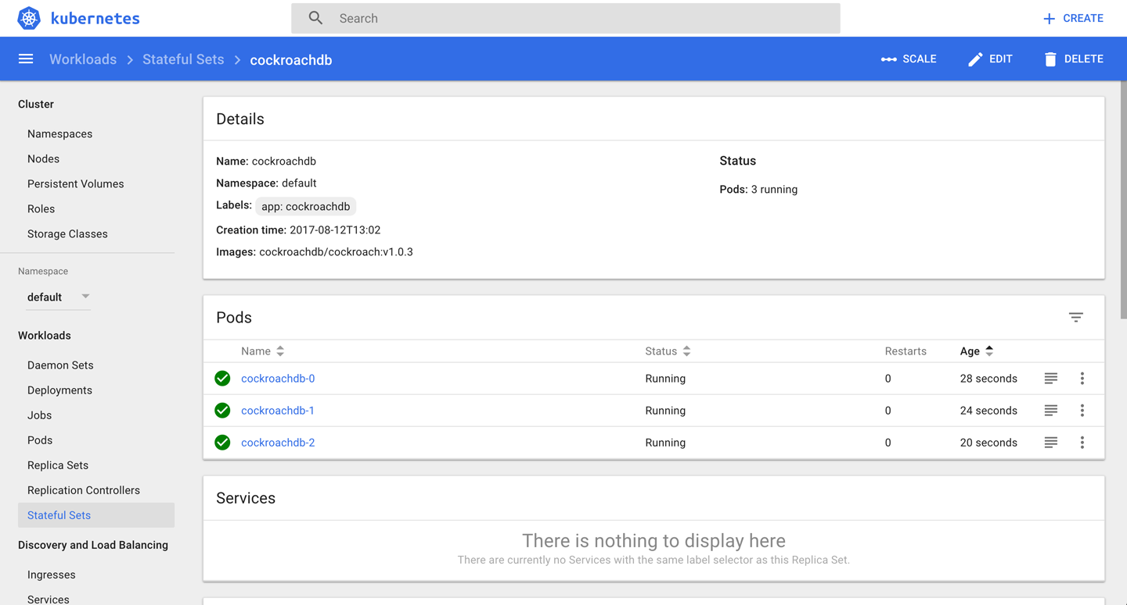
Figure 7-1. Screenshot of a StatefulSet

Discussion
Originally, what is now known in Kubernetes as a StatefulSet was called a PetSet. This should give you an idea of what the motivation was. In Kubernetes 1.7, the StatefulSet became a beta feature, which means that the API is not going to change anymore; only UX fixes are to be expected. A StatefulSet is a controller that provides unique identities to the pods it is supervising. Note that, as a safety measure, deleting a StatefulSet will not delete the volumes associated with it.
Another use case for a StatefulSet, found quite often in the wild, is to run an app that was not written with Kubernetes in mind. Such apps are sometimes called legacy apps, from a Kubernetes perspective. We will refer to these apps as non-cloud-native apps going forward. Using StatefulSet is a good way to supervise such an app.

See Also
- StatefulSet Basics
- Run a Replicated Stateful Application
- Example: Deploying Cassandra with Stateful Sets
- Kubernetes Redis as Stateful Set with Sentinel
- Oleg Chunikhin’s article “How to Run a MongoDb Replica Set on Kubernetes PetSet or StatefulSet”
- The Hacker News discussion on StatefulSets

7.5 Influencing Pods’ Startup Behavior

Problem
Your pod depends on some other service being available in order to function properly.

Solution
Use init containers to influence the startup behavior of a pod.
Imagine you want to launch an nginx web server that depends on a backend service to serve content. You therefore want to make sure that the nginx pod only starts up once the backend service is up and running.
First, create the backend service the web server depends on:
$
kubectl run backend --image=mhausenblas/simpleservice:0.5.0
deployment "backend" created
$
kubectl expose deployment backend --port=80 --target-port=9876
Then you can use the following manifest, nginx-init-container.yaml, to launch the nginx instance and make sure it starts up only when the backend deployment serves data:
kind
:
Deployment
apiVersion
:
apps/v1beta1
metadata
:
name
:
nginx
spec
:
replicas
:
1
template
:
metadata
:
labels
:
app
:
nginx
spec
:
containers
:
-
name
:
webserver
image
:
nginx
ports
:
-
containerPort
:
80
initContainers
:
-
name
:
checkbackend
image
:
busybox
command
:
[
'sh'
,
'-c'
,
'until
nslookup
backend.default.svc;
do
echo
"Waiting
for
backend
to
come
up";
sleep
3;
done;
echo
"Backend
is
up,
ready
to
launch
web
server"'
]
Now you can launch the nginx deployment and verify whether the init container has done its job by looking at the logs of the pod it is supervising:
$
kubectl create -f nginx-init-container.yaml
deployment "nginx" created
$
kubectl get po
NAME READY STATUS RESTARTS AGE
backend-853383893-2g0gs 1/1 Running 0 43m
nginx-2101406530-jwghn 1/1 Running 0 10m
$
kubectl logs nginx-2101406530-jwghn -c checkbackend
Server: 10.0.0.10
Address 1: 10.0.0.10 kube-dns.kube-system.svc.cluster.local
Name: backend.default.svc
Address 1: 10.0.0.46 backend.default.svc.cluster.local
Backend is up, ready to launch web server
As you can see, the command in the init container indeed worked as planned.

1
Kubernetes, “Jobs - Run to Completion”.
2
Kubernetes cockroachdb example on GitHub, cockroachdb-statefulset.yaml.
Chapter 8. Volumes and Configuration Data
A volume in Kubernetes is a directory accessible to all containers running in a pod, with the additional guarantee that the data is preserved across restarts of individual containers.
Depending on what is backing the volume and potentially additional semantics present, we differentiate the types of volumes:
- Node-local volumes, such as emptyDir or hostPath
- Generic networked volumes, such as nfs, glusterfs, or cephfs
- Cloud provider–specific volumes, such as awsElasticBlockStore, azureDisk, or gcePersistentDisk
- Special-purpose volumes, such as secret or gitRepo
Which volume type you choose depends entirely on your use case. For example, for a temporary scratch space, an emptyDir would be fine, but when you need to make sure your data survives node failures you’ll want to look into networked volumes, or cloud-provider–specific ones if you run Kubernetes in a public cloud setting.

8.1 Exchanging Data Between Containers via a Local Volume

Problem
You have two or more containers running in a pod and want to be able to exchange data via filesystem operations.

Solution
Use a local volume of type emptyDir.
The starting point is the following pod manifest, exchangedata.yaml, which has two containers (c1 and c2) that each mount the local volume xchange into their filesystem, using different mount points:
apiVersion
:
v1
kind
:
Pod
metadata
:
name
:
sharevol
spec
:
containers
:
-
name
:
c1
image
:
centos:7
command
:
-
"bin/bash"
-
"-c"
-
"sleep
10000"
volumeMounts
:
-
name
:
xchange
mountPath
:
"/tmp/xchange"
-
name
:
c2
image
:
centos:7
command
:
-
"bin/bash"
-
"-c"
-
"sleep
10000"
volumeMounts
:
-
name
:
xchange
mountPath
:
"/tmp/data"
volumes
:
-
name
:
xchange
emptyDir
:
{}
Now you can launch the pod, exec into it, create data from one container, and read it out from the other one:
$
kubectl create -f exchangedata.yaml
pod "sharevol" created
$
kubectl exec sharevol -c c1 -i -t -- bash
[root@sharevol /]# mount | grep xchange
/dev/vda1 on /tmp/xchange type ext4 (rw,relatime,data=ordered)
[root@sharevol /]# echo 'some data' > /tmp/xchange/data
[root@sharevol /]# exit
$
kubectl exec sharevol -c c2 -i -t -- bash
[root@sharevol /]# mount | grep /tmp/data
/dev/vda1 on /tmp/data type ext4 (rw,relatime,data=ordered)
[root@sharevol /]# cat /tmp/data/data
some data

Discussion
A local volume is backed by the node the pod and its containers are running on. If the node goes down or you have to carry out maintenance on the node (see Recipe 12.8), then the local volume is gone and all the data is lost.
There are some use cases where local volumes are fine—for example, for some scratch space or when the canonical state is obtained from somewhere else, such as an S3 bucket—but in general you’ll want to use a volume backed by networked storage (see Recipe 8.6).

See Also
- Kubernetes Volumes documentation

8.2 Passing an API Access Key to a Pod Using a Secret

Problem
As an admin, you want to provide your developers with an API access key in a secure way; that is, without sharing it in clear text in your Kubernetes manifests.

Solution
Use a local volume of type secret.
Let’s say you want to give your developers access to an external service that is accessible via the passphrase open sesame.
First, create a text file called passphrase that holds the passphrase:
$
echo -n "open sesame" > ./passphrase
Next, create the secret, using the passphrase file:
$
kubectl create secret generic pp --from-file=./passphrase
secret "pp" created
$
kubectl describe secrets/pp
Name: pp
Namespace: default
Labels: <none>
Annotations: <none>
Type: Opaque
Data
====
passphrase: 11 bytes
From an admin point of view, you’re all set now and it’s time for your developers to consume the secret. So let’s switch hats and assume you’re a developer and want to use the passphrase from within a pod.
You would consume the secret, for example, by mounting it as a volume into your pod and then reading it out as a normal file. Create the pod and mount the volume now:
apiVersion
:
v1
kind
:
Pod
metadata
:
name
:
ppconsumer
spec
:
containers
:
-
name
:
shell
image
:
busybox
command
:
-
"sh"
-
"-c"
-
"mount
|
grep
access
&&
sleep
3600"
volumeMounts
:
-
name
:
passphrase
mountPath
:
"/tmp/access"
readOnly
:
true
volumes
:
-
name
:
passphrase
secret
:
secretName
:
pp
Now launch the pod and have a look at its logs, where you would expect to see the pp secret file mounted as /tmp/access/passphrase:
$
kubectl create -f ppconsumer.yaml
pod "ppconsumer" created
$
kubectl logs ppconsumer
tmpfs on /tmp/access type tmpfs (ro,relatime)
To access the passphrase from within the running container, simply read out the passphrase file in /tmp/access, like so:
$
kubectl exec ppconsumer -i -t -- sh
/ # cat /tmp/access/passphrase
open sesame

Discussion
Secrets exist in the context of a namespace, so you need to take that into account when setting them up and/or consuming them.
You can access a secret from a container running in a pod via one of the following:
- A volume (as shown in the Solution, where the content is stored in a tmpfs volume)
- An environment variable
Also, note that the size of a secret is limited to 1 MB.
In addition to user-defined secrets, Kubernetes automatically creates secrets for service accounts to access the API. For example, with Prometheus installed (see Recipe 11.6), you’d see something like Figure 8-1 in the Kubernetes dashboard.
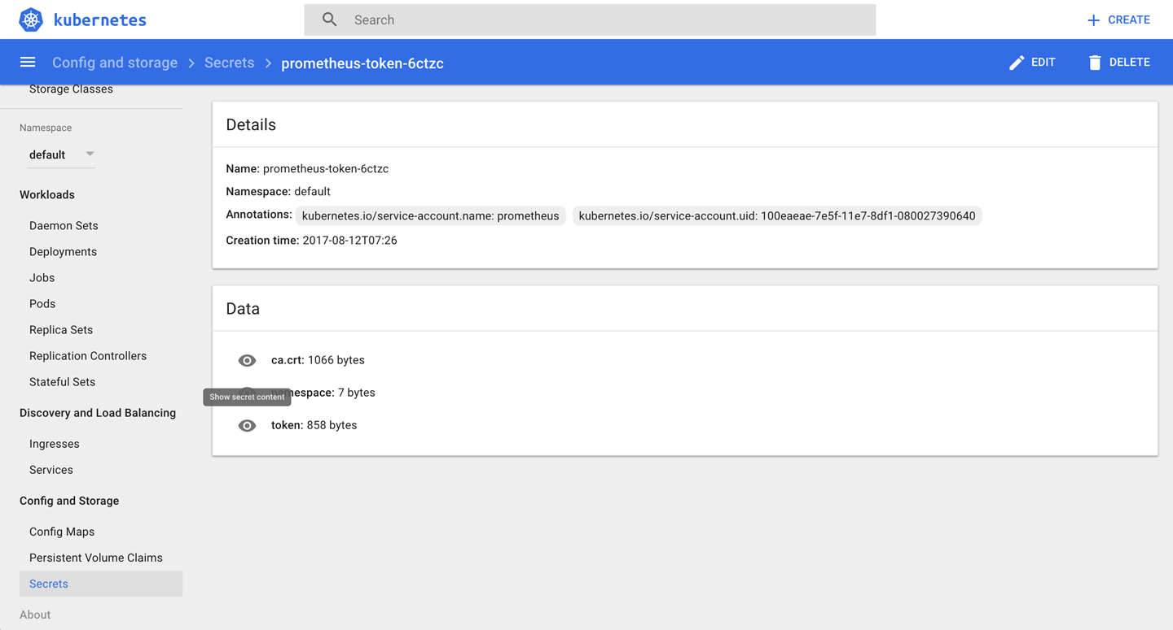
Figure 8-1. Screenshot of the Prometheus service account secret

Tip
kubectl create secret deals with three types of secrets and, depending on your use case, you might want to choose different ones:
- The docker-registry type is for use with a Docker registry.
- The generic type is what we used in the Solution; it creates a secret from a local file, directory, or literal value (you need to base64-encode it yourself).
- With tls you can create, for example, a secure SSL certificate for ingress.
kubectl describe doesn’t show the content of the secret in the plain text. This avoids “over-the-shoulder” password grabs. You can, however, easily decode it manually since it’s not encrypted—only base64-encoded:
$
kubectl get secret pp -o yaml | \
grep passphrase | \
cut -d":" -f 2 | \
awk '{$1=$1};1' | \
base64 --decode
open sesame
In this command, the first line retrieves a YAML representation of the secret, and the second line with the grep pulls out the line passphrase: b3BlbiBzZXNhbWU= (note the leading whitespace here). Then, the cut extracts the content of the passphrase, and the awk command gets rid of the leading whitespace. Finally, the base64 command turns it into the original data again.

Tip
Prior to Kubernetes 1.7, the API server stored secrets as plain text in etcd. Now you have the option to encrypt them using the --experimental-encryption-provider-config option when launching the kube-apiserver.

See Also
- Kubernetes Secrets documentation
- Encrypting Secret Data at Rest

8.3 Providing Configuration Data to an Application

Problem
You want to provide configuration data to an application without storing it in the container image or hardcoding it into the pod specification.

Solution
Use a config map. These are first-class Kubernetes resources with which you can provide configuration data to a pod via environment variables or a file.
Let’s say you want to create a configuration with the key siseversion and the value 0.9. It’s as simple as this:
$
kubectl create configmap siseconfig --from-literal=siseversion=0.9
configmap "siseconfig" created
Now you can use the config map in a deployment—say, in a manifest file called cmapp.yaml with the following content:
apiVersion
:
extensions/v1beta1
kind
:
Deployment
metadata
:
name
:
cmapp
spec
:
replicas
:
1
template
:
metadata
:
labels
:
app
:
cmapp
spec
:
containers
:
-
name
:
sise
image
:
mhausenblas/simpleservice:0.5.0
ports
:
-
containerPort
:
9876
env
:
-
name
:
SIMPLE_SERVICE_VERSION
valueFrom
:
configMapKeyRef
:
name
:
siseconfig
key
:
siseversion
We’ve just shown how to pass in the configuration as an environment variable. However, you can also mount it into the pod as a file, using a volume.
Suppose you have the following config file, example.cfg:
debug:
true
home: ~/abc
You can create a config map that holds the config file, as follows:
$
kubectl create configmap configfile --from-file=example.cfg
Now you can use the config map just as you would any other volume. The following is the manifest file for a pod named oreilly; it uses the busybox image and just sleeps for 3,600 seconds. In the volumes section, there is a volume named oreilly which uses the config map configfile that we just created. This volume is then mounted at the path /oreilly inside the container. Hence, the file will be accessible within the pod:
apiVersion
:
v1
kind
:
Pod
metadata
:
name
:
oreilly
spec
:
containers
:
-
image
:
busybox
command
:
-
sleep
-
"3600"
volumeMounts
:
-
mountPath
:
/oreilly
name
:
oreilly
name
:
busybox
volumes
:
-
name
:
oreilly
configMap
:
name
:
configfile
After creating the pod, you can verify that the example.cfg file is indeed inside it:
$
kubectl exec -ti oreilly -- ls -l /oreilly
total 0
lrwxrwxrwx 1 root root 18 Dec 16 19:36 example.cfg -> ..data/example.cfg
$
kubectl exec -ti oreilly -- cat /oreilly/example.cfg
debug: true
home: ~/abc
For a complete example of how to create a config map from a file, see Recipe 11.6.

See Also
- Configure a Pod to Use a ConfigMap

8.4 Using a Persistent Volume with Minikube

Problem
You don’t want to lose data on a disk your container uses—that is, you want to make sure it survives a restart of the hosting pod.

Solution
Use a persistent volume (PV). In the case of Minikube, you can create a PV of type hostPath and mount it just like a normal volume into the container’s filesystem.
First, define the PV hostpathpv in a manifest called hostpath-pv.yaml:
kind
:
PersistentVolume
apiVersion
:
v1
metadata
:
name
:
hostpathpv
labels
:
type
:
local
spec
:
storageClassName
:
manual
capacity
:
storage
:
1Gi
accessModes
:
-
ReadWriteOnce
hostPath
:
path
:
"/tmp/pvdata"
Before you can create the PV, however, you need to prepare the directory /tmp/pvdata on the node—that is, the Minikube instance itself. You can get into the node where the Kubernetes cluster is running using minikube ssh:
$
minikube ssh
$
mkdir /tmp/pvdata && \
echo 'I am content served from a delicious persistent volume' > / \
tmp/pvdata/index.html
$
cat /tmp/pvdata/index.html
I am content served from a delicious persistent volume
$
exit
Now that you’ve prepared the directory on the node, you can create the PV from the manifest file hostpath-pv.yaml:
$
kubectl create -f hostpath-pv.yaml
persistentvolume "hostpathpv" created
$
kubectl get pv
NAME CAPACITY ACCESSMODES RECLAIMPOLICY STATUS ... ... ...
hostpathpv 1Gi RWO Retain Available ... ... ...
$
kubectl describe pv/hostpathpv
Name: hostpathpv
Labels: type=local
Annotations: <none>
StorageClass: manual
Status: Available
Claim:
Reclaim Policy: Retain
Access Modes: RWO
Capacity: 1Gi
Message:
Source:
Type: HostPath (bare host directory volume)
Path: /tmp/pvdata
Events: <none>
Up to this point, you would carry out these steps in an admin role. You would define PVs and make them available to developers on the Kubernetes cluster.
Now you’re in a position to use the PV in a pod, from a developer’s perspective. This is done via a persistent volume claim (PVC), so called because, well, you literally claim a PV that fulfills certain characteristics, such as size or storage class.
Create a manifest file called pvc.yaml that defines a PVC, asking for 200 MB of space:
kind
:
PersistentVolumeClaim
apiVersion
:
v1
metadata
:
name
:
mypvc
spec
:
storageClassName
:
manual
accessModes
:
-
ReadWriteOnce
resources
:
requests
:
storage
:
200Mi
Next, launch the PVC and verify its state:
$
kubectl create -f pvc.yaml
persistentvolumeclaim "mypvc" created
$
kubectl get pv
NAME CAPACITY ACCESSMODES ... STATUS CLAIM STORAGECLASS
hostpathpv 1Gi RWO ... Bound default/mypvc manual
Note that the status of the PV hostpathpv has changed from Available to Bound.
Finally, it’s time to consume the data from the PV in a container, this time via a deployment that mounts it in the filesystem. So, create a file called nginx-using-pv.yaml with the following content:
kind
:
Deployment
apiVersion
:
extensions/v1beta1
metadata
:
name
:
nginx-with-pv
spec
:
replicas
:
1
template
:
metadata
:
labels
:
app
:
nginx
spec
:
containers
:
-
name
:
webserver
image
:
nginx
ports
:
-
containerPort
:
80
volumeMounts
:
-
mountPath
:
"/usr/share/nginx/html"
name
:
webservercontent
volumes
:
-
name
:
webservercontent
persistentVolumeClaim
:
claimName
:
mypvc
And launch the deployment, like so:
$
kubectl create -f nginx-using-pv.yaml
deployment "nginx-with-pv" created
$
kubectl get pvc
NAME STATUS VOLUME CAPACITY ACCESSMODES STORAGECLASS AGE
mypvc Bound hostpathpv 1Gi RWO manual 12m
As you can see, the PV is in use via the PVC you created earlier.
To verify that the data actually has arrived, you could now create a service (see Recipe 5.1) along with an ingress object (see Recipe 5.5) and then access it like so:
$
curl -k -s https://192.168.99.100/web
I am content served from a delicious persistent volume
Well done! You’ve (as an admin) provisioned a persistent volume and (as a developer) claimed it via a persistent volume claim, and used it from a deployment in a pod by mounting it into the container filesystem.

Discussion
In the Solution, we used a persistent volume of type hostPath. In a production setting, you would not want to use this but rather ask your cluster administrator nicely to provision a networked volume backed by NFS or an Amazon Elastic Block Store (EBS) volume to make sure your data sticks around and survives single-node failures.

Note
Remember that PVs are cluster-wide resources; that is, they are not namespaced. However, PVCs are namespaced. You can claim PVs from specific namespaces using namespaced PVCs.

See Also
- Kubernetes Persistent Volumes documentation
- Configure a Pod to Use a PersistentVolume for Storage

8.5 Understanding Data Persistency on Minikube

Problem
You want to use Minikube to understand how you could deploy a stateful application in Kubernetes. Specifically, you would like to deploy a MySQL database.

Solution
Use a PersistentVolumeClaim object (see Recipe 8.4) in your pod definition and/or the template for your database.
First you need to make a request for a specific amount of storage. The following data.yaml manifest makes a request for 1 GB of storage.
kind
:
PersistentVolumeClaim
apiVersion
:
v1
metadata
:
name
:
data
spec
:
accessModes
:
-
ReadWriteOnce
resources
:
requests
:
storage
:
1Gi
On Minikube, create this PVC and immediately see how a persistent volume is created to match this claim:
$
kubectl create -f data.yaml
$
kubectl get pvc
NAME STATUS VOLUME CAPACITY ... ... ...
data Bound pvc-da58c85c-e29a-11e7-ac0b-080027fcc0e7 1Gi ... ... ...
$
kubectl get pv
NAME CAPACITY ... ... ... ... ...
pvc-da58c85c-e29a-11e7-ac0b-080027fcc0e7 1Gi ... ... ... ... ...
You are now ready to use this claim in your pod. In the volumes section, define a volume by name with a PVC type and a reference to the PVC you just created. In the volumeMounts field, you’ll mount this volume at a specific path inside your container. For MySQL, you mount it at /var/lib/mysql:
apiVersion
:
v1
kind
:
Pod
metadata
:
name
:
db
spec
:
containers
:
-
image
:
mysql:5.5
name
:
db
volumeMounts
:
-
mountPath
:
/var/lib/mysql
name
:
data
env
:
-
name
:
MYSQL_ROOT_PASSWORD
value
:
root
volumes
:
-
name
:
data
persistentVolumeClaim
:
claimName
:
data

Discussion
Minkube is configured out of the box with a default storage class that defines a default persistent volume provisioner. This means that when a persistent volume claim is created, Kubernetes will dynamically create a matching persistent volume to fill that claim.
This is what happened in the Solution. Once you created the data PVC, Kubernetes automatically created a PV to match that claim. If you look a bit deeper at the default storage class on Minikube, you will see the provisioner type:
$
kubectl get storageclass
NAME PROVISIONER
standard (default) k8s.io/minikube-hostpath
$
kubectl get storageclass standard -o yaml
apiVersion: storage.k8s.io/v1
kind: StorageClass
...
provisioner: k8s.io/minikube-hostpath
reclaimPolicy: Delete
This specific storage class is using a storage provisioner that creates persistent volumes of type hostPath. You can see this by looking at the manifest of the PV that got created to match the claim you created previously:
$
kubectl get pv
NAME CAPACITY ... CLAIM ...
pvc-da58c85c-e29a-11e7-ac0b-080027fcc0e7 1Gi ... default/foobar ...
$
kubectl get pv pvc-da58c85c-e29a-11e7-ac0b-080027fcc0e7 -o yaml
apiVersion: v1
kind: PersistentVolume
...
hostPath:
path: /tmp/hostpath-provisioner/pvc-da58c85c-e29a-11e7-ac0b-080027fcc0e7
type: ""
...
To verify that the host volume created holds the database data, you can connect to Minikube and list the files in the directory:
$
minikube ssh
_ _
_ _ ( ) ( )
___ ___ (_) ___ (_)| |/') _ _ | |_ __
/' _ ` _ `\| |/' _ `\| || , < ( ) ( )| '_`\ /'__`\
| ( ) ( ) || || ( ) || || |\`\ | (_) || |_) )( ___/
(_) (_) (_)(_)(_) (_)(_)(_) (_)`\___/'(_,__/'`\____)
$
ls -l /tmp/hostpath-provisioner/pvc-da58c85c-e29a-11e7-ac0b-080027fcc0e7
total 28688
-rw-rw---- 1 999 999 2 Dec 16 20:02 data.pid
-rw-rw---- 1 999 999 5242880 Dec 16 20:02 ib_logfile0
-rw-rw---- 1 999 999 5242880 Dec 16 20:02 ib_logfile1
-rw-rw---- 1 999 999 18874368 Dec 16 20:02 ibdata1
drwx------ 2 999 999 4096 Dec 16 20:02 mysql
drwx------ 2 999 999 4096 Dec 16 20:03 oreilly
drwx------ 2 999 999 4096 Dec 16 20:02 performance_schema
Indeed, you now have data persistence. If the pod dies (or you delete it), your data will still be available.
In general, storage classes allow the cluster administrator to define the various types of storage they might provide. For the developers, it abstracts the type of storage and lets them use PVC without having to worry about the storage provider itself.

See Also
- Persistent Volumes documentation
- Storage Classes documentation

8.6 Dynamically Provisioning Persistent Storage on GKE

Problem
Rather than manually provisioning persistent volumes with persistent volume claims like in Recipe 8.4, you want to automate the process—that is, dynamically provision PVs based on storage or pricing requirements.

Solution
For GKE, follow the steps outlined in the blog post by Saad Ali “Dynamic Provisioning and Storage Classes in Kubernetes”.

Discussion
In general, the workflow to provision and claim PVs is as shown in Figure 8-2.
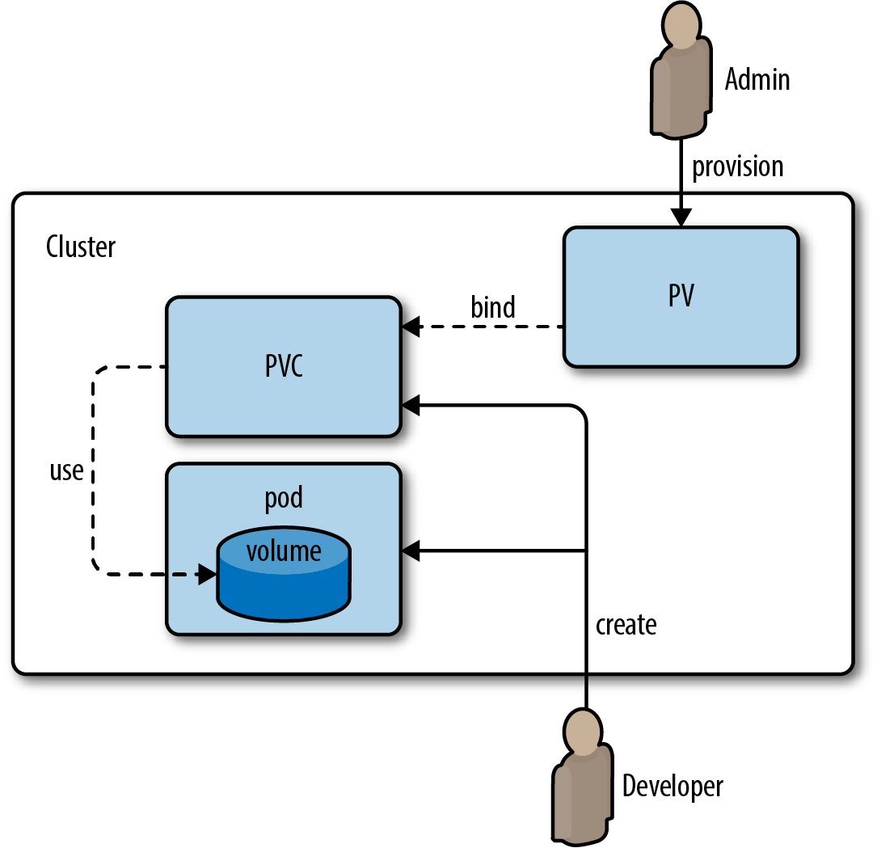
Figure 8-2. Workflow for provisioning and claiming persistent volumes

The workflow involves admins and developers coordinating available types and sizes of volumes. With dynamic provisioning, this workflow can be streamlined.

Chapter 9. Scaling
In Kubernetes, scaling can mean different things to different users. We distinguish between two cases:
- Cluster scaling, sometimes called infrastructure-level scaling, refers to the (automated) process of adding or removing worker nodes based on cluster utilization.
- Application-level scaling, sometimes called pod scaling, refers to the (automated) process of manipulating pod characteristics based on a variety of metrics, from low-level signals such as CPU utilization to higher-level ones, such as HTTP requests served per second, for a given pod. Two kinds of pod-level scalers exist:
Horizontal Pod Autoscalers (HPAs), which increase or decrease the number of pod replicas depending on certain metrics.
Vertical Pod Autoscalers (VPAs), which increase or decrease the resource requirements of containers running in a pod. Since VPAs are still under development as of January 2018, we will not discuss them here. If you’re interested in this topic, you can read about them in Michael’s blog post “Container resource consumption—too important to ignore”.
In the chapter, we first examine cluster-level scaling for AWS and GKE, then discuss app-level scaling with HPAs.

9.1 Scaling a Deployment

Problem
You have a deployment and want to scale it horizontally.

Solution
Use the kubectl scale command to scale out a deployment.
Let’s reuse the fancyapp deployment from Recipe 4.4, with five replicas. If it’s not running yet, create it with kubectl create -f fancyapp.yaml.
Now suppose that the load has decreased and you don’t need five replicas anymore; three is enough. To scale the deployment down to three replicas, do this:
$
kubectl get deploy fancyapp
NAME DESIRED CURRENT UP-TO-DATE AVAILABLE AGE
fancyapp 5 5 5 5 9m
$
kubectl scale deployment fancyapp --replicas=3
deployment "fancyapp" scaled
$
kubectl get deploy fancyapp
NAME DESIRED CURRENT UP-TO-DATE AVAILABLE AGE
fancyapp 3 3 3 3 10m
Rather than manually scaling a deployment, you can automate this process; see Recipe 9.4 for an example.

9.2 Automatically Resizing a Cluster in GKE

Problem
You want your GKE cluster to automatically grow or shrink in terms of the number of nodes, depending on the utilization.

Solution
Use the GKE Cluster Autoscaler. This recipe assumes you’ve got the gcloud command installed and the environment set up (i.e., you’ve created a project and enabled billing).
First, create a cluster with one worker node and make sure you can access it with kubectl:
$
gcloud container clusters create --num-nodes=1 supersizeme
Creating cluster supersizeme...done.
Created [https://container.googleapis.com/v1/projects/k8s-cookbook/zones/...].
kubeconfig entry generated for supersizeme.
NAME ZONE MASTER_VERSION MASTER_IP ... STATUS
supersizeme europe-west2-b 1.7.8-gke.0 35.189.116.207 ... RUNNING
$
gcloud container clusters get-credentials supersizeme --zone europe-west2-b \
--project k8s-cookbook
Next, enable cluster autoscaling:
$
gcloud beta container clusters update supersizeme --enable-autoscaling \
--min-nodes=1 --max-nodes=3 \
--zone=europe-west2-b \
--node-pool=default-pool
Note that if you haven’t enabled the beta command group you will be prompted in this step for permission to install it.
At this point in time, when looking at the Google Cloud console you should see something like what is shown in Figure 9-1.
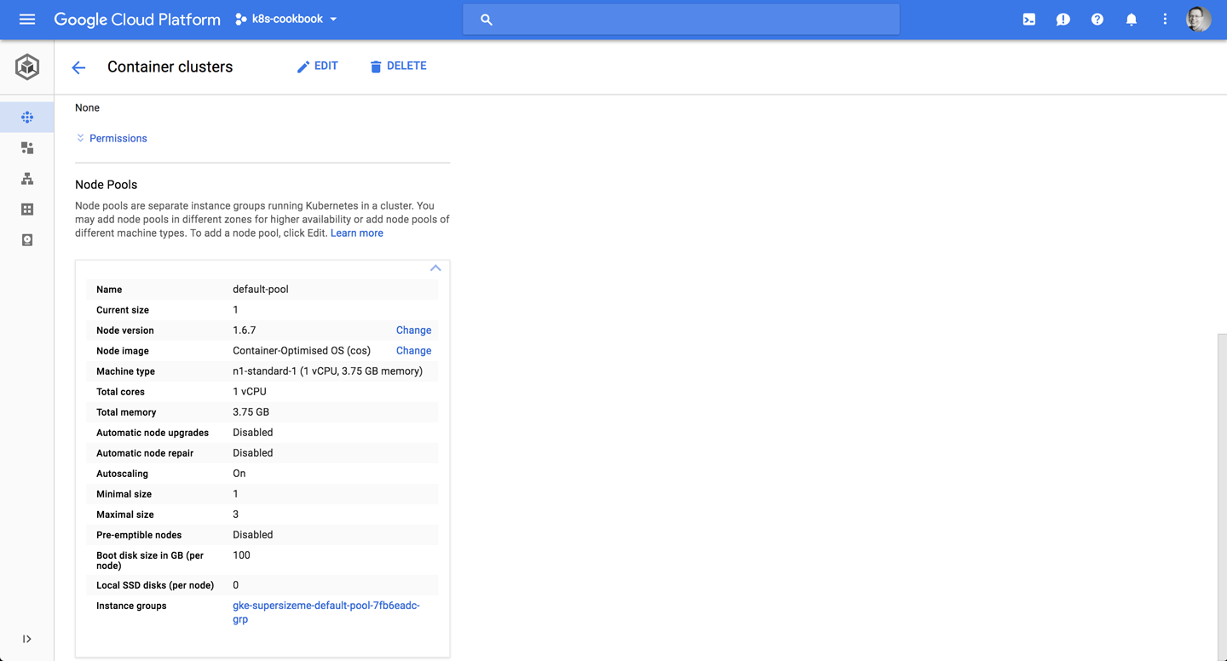
Figure 9-1. Screenshot of the Google Cloud console, showing the initial cluster size of one node

Now, launch 15 pods using a deployment. This will generate enough load to trigger the cluster autoscaling:
$
kubectl run ghost --image=ghost:0.9 --replicas=15
You should now have a cluster of three nodes, as depicted in Figure 9-2.
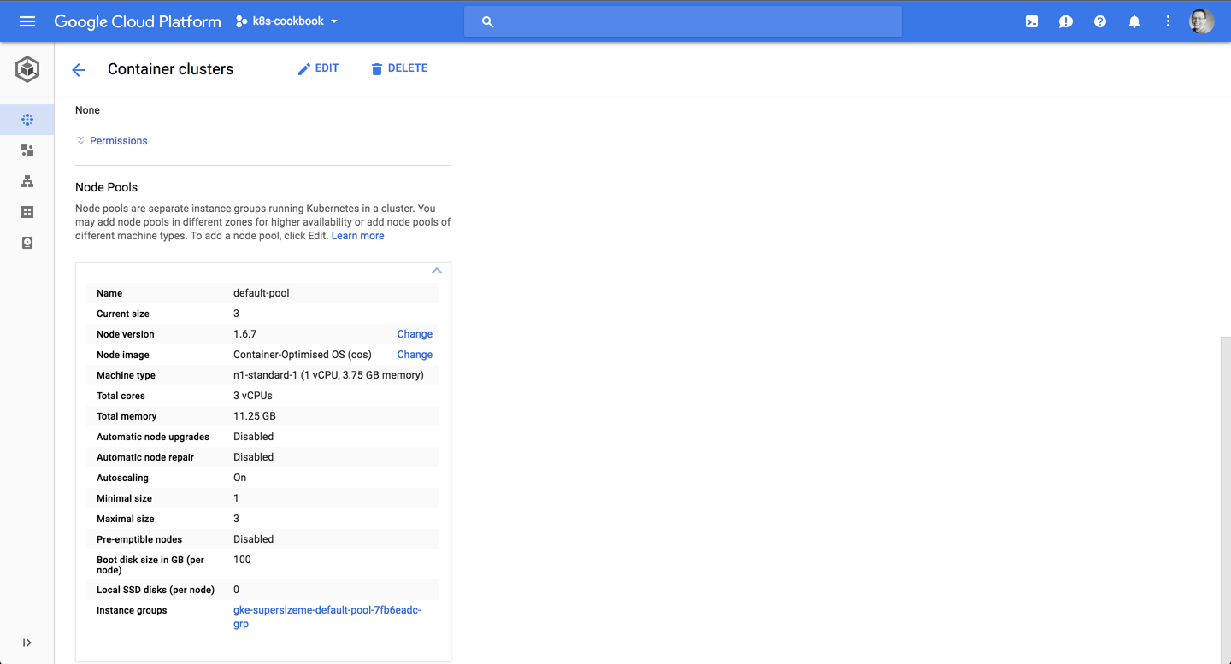
Figure 9-2. Screenshot of the Google Cloud console, showing the resulting cluster scaled to three nodes

Figure 9-3 shows you see the entire interaction:
- In the upper-left session you see the load (the 15 pods created, triggering the cluster scaling event).
- In the upper-right session you see the gcloud command, enabling the cluster autoscaling.
- In the bottom session you see the output of the kubectl get nodes --watch command, showing the current nodes available.
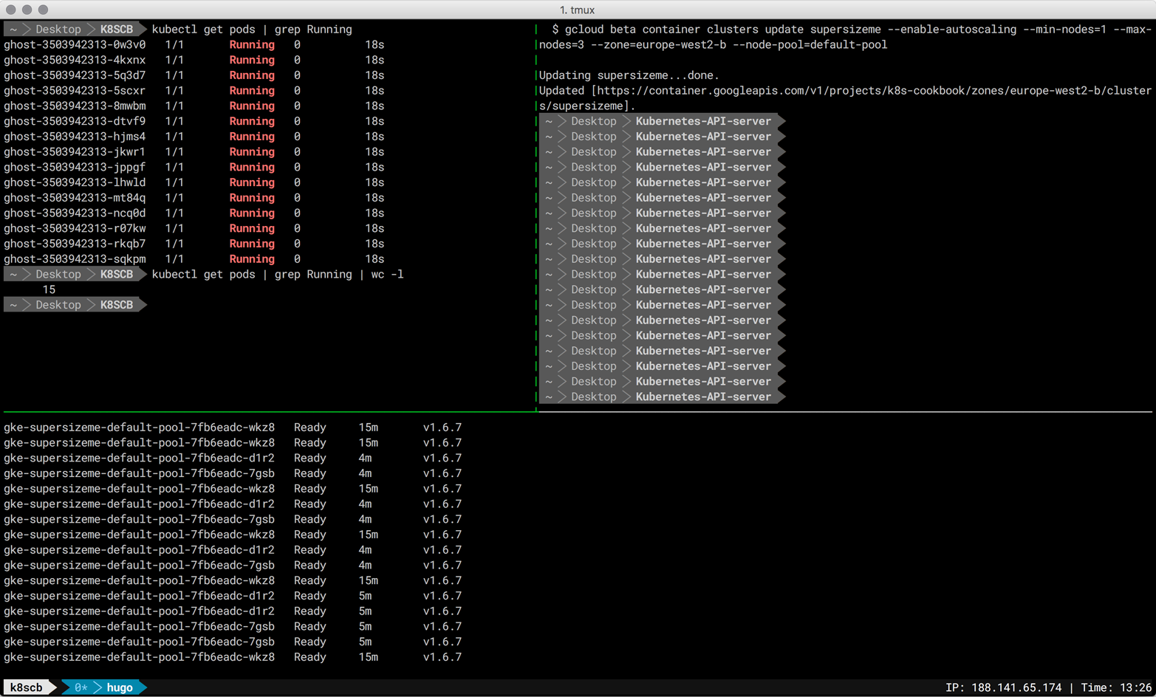
Figure 9-3. Screenshot of the terminal sessions, showing the cluster autoscaling in action

Note that all nodes in the node pool should have the same capacity, labels, and system pods running on them. Also, check that your quota is big enough when specifying the maximum settings for the node pool.
Don’t forget to do gcloud container clusters delete supersizeme when you’re done; otherwise, you’ll keep paying for the cluster resources.

See Also
- Cluster Autoscaler in the kubernetes/autoscaler repo
- Cluster Autoscaler in the GKE docs

9.3 Automatically Resizing a Cluster in AWS

Problem
You want your Kubernetes cluster running in AWS EC2 to automatically grow or shrink in terms of the number of nodes, depending on the utilization.

Solution
Use the AWS Cluster Autoscaler, a Helm package leveraging AWS autoscaling groups. If you haven’t installed Helm yet, then check out Recipe 14.1 first.

9.4 Using Horizontal Pod Autoscaling on GKE

Problem
You want to automatically increase or decrease the number of pods in a deployment, depending on the load present.

Solution
Use a Horizontal Pod Autoscaler, as described here.
First, create an app—a PHP environment and server—that you can use as the target of the HPA:
$
kubectl run appserver --image=gcr.io/google_containers/hpa-example \
--requests=cpu=200m --expose --port=80
service "appserver" created
│NAME ZONE MASTER_VERSION
deployment "appserver" created
Next, create an HPA and define the trigger parameter --cpu-percent=40, which means that the CPU utilization should not go over 40%:
$
kubectl autoscale deployment appserver --cpu-percent=40 --min=1 --max=5
deployment "appserver" autoscaled
$
kubectl get hpa --watch
NAME REFERENCE TARGETS MINPODS MAXPODS REPLICAS AGE
appserver Deployment/appserver <unknown> / 40% 1 5 0 14s
In a second terminal session, keep an eye on the deployment:
$
kubectl get deploy appserver --watch
And finally, in a third terminal session, launch the load generator:
$
kubectl run -i -t loadgen --image=busybox /bin/sh
If you don't see a command prompt, try pressing enter.
/ # while true; do wget -q -O- http://appserver.default.svc.cluster.local; done
Since there are three terminal sessions involved in parallel, an overview of the whole situation is provided in Figure 9-4.
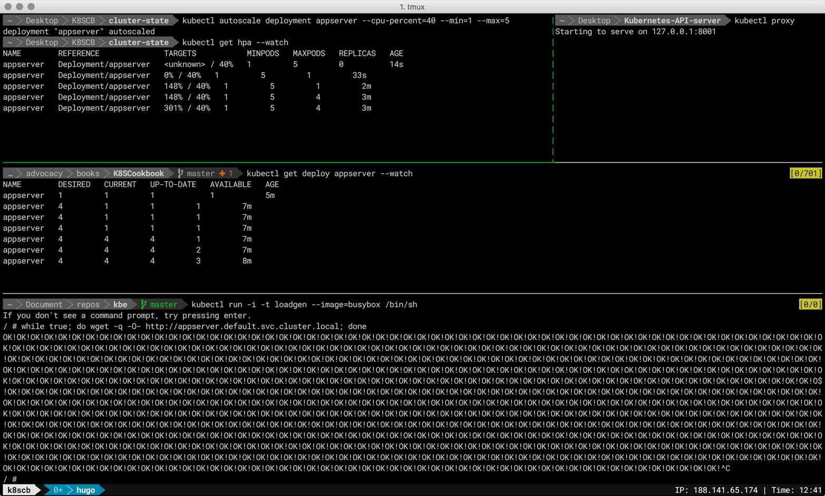
Figure 9-4. Screenshot of the terminal sessions for setting up an HPA

In Figure 9-5 you can see the effect of the HPA on the appserver deployment, this time showing the Kubernetes dashboard.
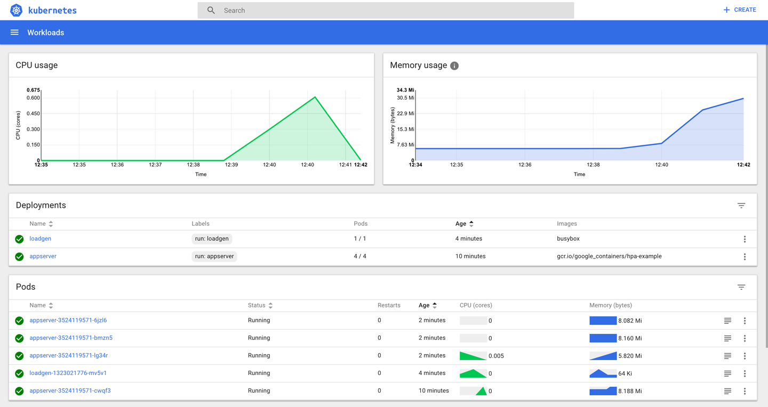
Figure 9-5. Screenshot of the Kubernetes dashboard, showing the effect of an HPA

Discussion
The autoscaling described here is the automatic increase or decrease of the number of replicas through the HPA controller, which can be influenced through an HPA resource. The controller, part of the Kubernetes controller manager in the control plane, checks pod metrics via cAdvisor instances running on each node in the cluster, which then get aggregated by Heapster. The HPA controller calculates the number of replicas required to meet the target metric defined in the HPA resource.1 Based on this calculation, the HPA controller then adapts the replicas on the target resource (e.g., deployment).
Note that autoscaling can be tricky, and adjusting low-level metrics such as CPU or RAM utilization might not have the expected impact. If you can, try using application-level custom metrics.

See Also
- Horizontal Pod Autoscaler Walkthrough
- Jerzy Szczepkowski and Marcin Wielgus’s blog post “Autoscaling in Kubernetes”
- Autoscaling demo in GKE

1
Kubernetes community on GitHub, “Autoscaling Algorithm”.
Chapter 10. Security
Running applications in Kubernetes comes with a shared responsibility between developers and ops folks to ensure that attack vectors are minimized, least-privileges principles are followed, and access to resources is clearly defined. In this chapter, we will present recipes that you can, and should, use to make sure your cluster and apps run securely. The recipes in this chapter cover:
- The role and usage of service accounts
- Role-Based Access Control (RBAC)
- Defining a pod’s security context

10.1 Providing a Unique Identity for an Application

Problem
You want to provide an application with a unique identity in order to control access to resources on a fine-grained level.

Solution
Create a service account and use it in a pod specification.
To begin, create a new service account called myappsa and have a closer look at it:
$
kubectl create serviceaccount myappsa
serviceaccount "myappsa" created
$
kubectl describe sa myappsa
Name: myappsa
Namespace: default
Labels: <none>
Annotations: <none>
Image pull secrets: <none>
Mountable secrets: myappsa-token-rr6jc
Tokens: myappsa-token-rr6jc
$
kubectl describe secret myappsa-token-rr6jc
Name: myappsa-token-rr6jc
Namespace: default
Labels: <none>
Annotations: kubernetes.io/service-account.name=myappsa
kubernetes.io/service-account.uid=0baa3df5-c474-11e7-8f08...
Type: kubernetes.io/service-account-token
Data
====
ca.crt: 1066 bytes
namespace: 7 bytes
token: eyJhbGciOiJSUzI1NiIsInR5cCI6IkpXVCJ9 ...
You can use this service account in a pod, like so:
kind
:
Pod
apiVersion
:
v1
metadata
:
name
:
myapp
spec
:
serviceAccountName
:
myappsa
containers
:
-
name
:
main
image
:
centos:7
command
:
-
"bin/bash"
-
"-c"
-
"sleep
10000"
You can then verify whether the service account myappsa has been properly used by your pod by running:
$
kubectl exec myapp -c main \
cat /var/run/secrets/kubernetes.io/serviceaccount/token \
eyJhbGciOiJSUzI1NiIsInR5cCI6IkpXVCJ9 ...
Indeed, the myappsa service account token has been mounted in the expected place in the pod and can be used going forward.
While a service account on its own is not super useful, it forms the basis for fine-grained access control; see Recipe 10.2 for more on this.

Discussion
Being able to identify an entity is the prerequisite for authentication and authorization. From the API server’s point of view, there are two sorts of entities: human users and applications. While user identity (management) is outside of the scope of Kubernetes, there is a first-class resource representing the identity of an app: the service account.
Technically, the authentication of an app is captured by the token available in a file at the location /var/run/secrets/kubernetes.io/serviceaccount/token, which is mounted automatically through a secret. The service accounts are namespaced resources and are represented as follows:
system:serviceaccount:
$NAMESPACE
:
$SERVICEACCOUNT
Listing the service accounts in a certain namespace gives you something like the following:
$
kubectl get sa
NAME SECRETS AGE
default 1 90d
myappsa 1 19m
prometheus 1 89d
Notice the service account called default here. This is created automatically; if you don’t set the service account for a pod explicitly, as was done in the Solution, it will be assigned the default service account in its namespace.

See Also
- Managing Service Accounts
- Configure Service Accounts for Pods
- Pull an Image from a Private Registry

10.2 Listing and Viewing Access Control Information

Problem
You want to learn what actions you’re allowed to do—for example, updating a deployment or listing secrets.

Solution
The following solution assumes you’re using Role-Based Access Control as the authorization method.
To check if a certain action on a resource is allowed for a specific user, use kubectl auth can-i. For example, you can execute this command to check if the service account system:serviceaccount:sec:myappsa is allowed to list pods in the namespace sec:
$
kubectl auth can-i list pods --as=system:serviceaccount:sec:myappsa -n=sec
yes

Note
If you want to try out this recipe in Minikube, you’ll need to add --extra-config=apiserver.Authorization.Mode=RBAC when executing the binary.
To list the roles available in a namespace, do this:
$
kubectl get roles -n=kube-system
NAME AGE
extension-apiserver-authentication-reader 1d
system::leader-locking-kube-controller-manager 1d
system::leader-locking-kube-scheduler 1d
system:controller:bootstrap-signer 1d
system:controller:cloud-provider 1d
system:controller:token-cleaner 1d
$
kubectl get clusterroles -n=kube-system
NAME AGE
admin 1d
cluster-admin 1d
edit 1d
system:auth-delegator 1d
system:basic-user 1d
system:controller:attachdetach-controller 1d
system:controller:certificate-controller 1d
system:controller:cronjob-controller 1d
system:controller:daemon-set-controller 1d
system:controller:deployment-controller 1d
system:controller:disruption-controller 1d
system:controller:endpoint-controller 1d
system:controller:generic-garbage-collector 1d
system:controller:horizontal-pod-autoscaler 1d
system:controller:job-controller 1d
system:controller:namespace-controller 1d
system:controller:node-controller 1d
system:controller:persistent-volume-binder 1d
system:controller:pod-garbage-collector 1d
system:controller:replicaset-controller 1d
system:controller:replication-controller 1d
system:controller:resourcequota-controller 1d
system:controller:route-controller 1d
system:controller:service-account-controller 1d
system:controller:service-controller 1d
system:controller:statefulset-controller 1d
system:controller:ttl-controller 1d
system:discovery 1d
system:heapster 1d
system:kube-aggregator 1d
system:kube-controller-manager 1d
system:kube-dns 1d
system:kube-scheduler 1d
system:node 1d
system:node-bootstrapper 1d
system:node-problem-detector 1d
system:node-proxier 1d
system:persistent-volume-provisioner 1d
view 1d
The output shows the predefined roles, which you can use directly for users and service accounts.
To further explore a certain role and understand what actions are allowed, use:
$
kubectl describe clusterroles/view -n=kube-system
Name: view
Labels: kubernetes.io/bootstrapping=rbac-defaults
Annotations: rbac.authorization.kubernetes.io/autoupdate=true
PolicyRule:
Resources Non-Resource URLs ... ...
--------- ----------------- --- ---
bindings [] ... ...
configmaps [] ... ...
cronjobs.batch [] ... ...
daemonsets.extensions [] ... ...
deployments.apps [] ... ...
deployments.extensions [] ... ...
deployments.apps/scale [] ... ...
deployments.extensions/scale [] ... ...
endpoints [] ... ...
events [] ... ...
horizontalpodautoscalers.autoscaling [] ... ...
ingresses.extensions [] ... ...
jobs.batch [] ... ...
limitranges [] ... ...
namespaces [] ... ...
namespaces/status [] ... ...
persistentvolumeclaims [] ... ...
pods [] ... ...
pods/log [] ... ...
pods/status [] ... ...
replicasets.extensions [] ... ...
replicasets.extensions/scale [] ... ...
replicationcontrollers [] ... ...
replicationcontrollers/scale [] ... ...
replicationcontrollers.extensions/scale [] ... ...
replicationcontrollers/status [] ... ...
resourcequotas [] ... ...
resourcequotas/status [] ... ...
scheduledjobs.batch [] ... ...
serviceaccounts [] ... ...
services [] ... ...
statefulsets.apps [] ... ...
In addition to the default roles defined in the kube-system namespace, you can define your own; see Recipe 10.3.

Tip
When RBAC is enabled, in many environments (including Minikube and GKE) you might see a Forbidden (403) status code and an error message as shown below when you try to access the Kubernetes dashboard:
User “system:serviceaccount:kube-system:default” cannot list pods in the namespace “sec”. (get pods)
To access the dashboard, you’ll need to give the kube-system:default service account the necessary rights:
$
kubectl create clusterrolebinding admin4kubesystem \
--clusterrole=cluster-admin \
--serviceaccount=kube-system:default
Note that this command gives the service account a lot of rights and might not be advisable in a production environment.

Discussion
As you can see in Figure 10-1, there are a couple of moving parts when dealing with RBAC authorization:
- An entity—that is, a group, user, or service account
- A resource, such as a pod, service, or secret
- A role, which defines rules for actions on a resource
- A role binding, which applies a role to an entity
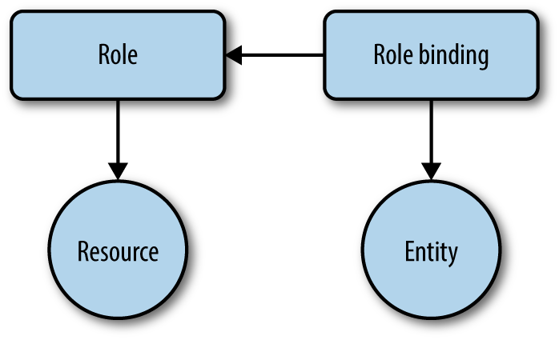
Figure 10-1. The RBAC concept

The actions on a resource that a role uses in its rules are the so-called verbs:
- get, list, watch
- create
- update/patch
- delete
Concerning the roles, we differentiate between two types:
- Cluster-wide: cluster roles and their respective cluster role bindings
- Namespace-wide: roles and role bindings
In Recipe 10.3, we will further discuss how you can create your own rules and apply them to users and resources.

See Also
- Kubernetes Authorization Overview
- Using RBAC Authorization

10.3 Controlling Access to Resources

Problem
For a given user or application, you want to allow or deny a certain action, such as viewing secrets or updating a deployment.

Solution
Let’s assume you want to restrict an app to only be able to view pods—that is, list pods and get details about pods.
You’d start off with a pod definition in a YAML manifest, pod-with-sa.yaml, using a dedicated service account, myappsa (see Recipe 10.1):
kind
:
Pod
apiVersion
:
v1
metadata
:
name
:
myapp
namespace
:
sec
spec
:
serviceAccountName
:
myappsa
containers
:
-
name
:
main
image
:
centos:7
command
:
-
"bin/bash"
-
"-c"
-
"sleep
10000"
Next, you’d define a role—let’s call it podreader in the manifest pod-reader.yaml—that defines the allowed actions on resources:
kind
:
Role
apiVersion
:
rbac.authorization.k8s.io/v1beta1
metadata
:
name
:
podreader
namespace
:
sec
rules
:
-
apiGroups
:
[
""
]
resources
:
[
"pods"
]
verbs
:
[
"get"
,
"list"
]
Last but not least you need to apply the role podreader to the service account myappsa, using a role binding in pod-reader-binding.yaml:
kind
:
RoleBinding
apiVersion
:
rbac.authorization.k8s.io/v1beta1
metadata
:
name
:
podreaderbinding
namespace
:
sec
roleRef
:
apiGroup
:
rbac.authorization.k8s.io
kind
:
Role
name
:
podreader
subjects
:
-
kind
:
ServiceAccount
name
:
myappsa
namespace
:
sec
When creating the respective resources, you can use the YAML manifests directly (assuming the service account has already been created):
$
kubectl create -f pod-reader.yaml
$
kubectl create -f pod-reader-binding.yaml
$
kubectl create -f pod-with-sa.yaml
Rather than creating manifests for the role and the role binding, you can use the following commands:
$
kubectl create role podreader \
--verb=get --verb=list \
--resource=pods -n=sec
$
kubectl create rolebinding podreaderbinding \
--role=sec:podreader \
--serviceaccount=sec:myappsa \
--namespace=sec -n=sec
Note that this is a case of namespaced access control setup, since you’re using roles and role bindings. For cluster-wide access control, you’d use the corresponding create clusterrole and create clusterrolebinding commands.

Tip
Sometimes it’s not obvious if you should use a role or a cluster role and/or role binding, so here are a few rules of thumb you might find useful:
- If you want to restrict access to a namespaced resource (like a service or pod) in a certain namespace, use a role and a role binding (as we did in this recipe).
- If you want to reuse a role in a couple of namespaces, use a cluster role with a role binding.
- If you want to restrict access to cluster-wide resources such as nodes or to namespaced resources across all namespaces, use a cluster role with a cluster role binding.

See Also
- Configure RBAC in Your Kubernetes Cluster
- Antoine Cotten’s blog post “Kubernetes v1.7 Security in Practice”

10.4 Securing Pods

Problem
You want to define the security context for an app on the pod level. For example, you want to run the app as a nonprivileged process or restrict the types of volumes the app can access.

Solution
To enforce policies on the pod level in Kubernetes, use the securityContext field in a pod specification.
Let’s assume you want an app running as a nonroot user. For this, you’d use the security context on the container level as shown in the following manifest, securedpod.yaml:
kind
:
Pod
apiVersion
:
v1
metadata
:
name
:
secpod
spec
:
containers
:
-
name
:
shell
image
:
centos:7
command
:
-
"bin/bash"
-
"-c"
-
"sleep
10000"
securityContext
:
runAsUser
:
5000
Now create the pod and check the user under which the container runs:
$
kubectl create -f securedpod.yaml
pod "secpod" created
$
kubectl exec secpod ps aux
USER PID %CPU %MEM VSZ RSS TTY STAT START TIME COMMAND
5000 1 0.0 0.0 4328 672 ? Ss 12:39 0:00 sleep 10000
5000 8 0.0 0.1 47460 3108 ? Rs 12:40 0:00 ps aux
As expected, it’s running as the user with ID 5000. Note that you can also use the securityContext field on the pod level rather than on specific containers.
A more powerful method to enforce policies on the pod level is to use pod security policies (PSP). These are cluster-wide resources that allows you to define a range of policies, including some similar to what you’ve seen here but also restrictions around storage and networking. For a walk-through on how to use PSPs, see “Secure a Kubernetes Cluster with Pod Security Policies” in the Bitnami docs for Kubernetes.

See Also
- Pod Security Policies documentation
- Configure a Security Context for a Pod or Container

Chapter 11. Monitoring and Logging
In this chapter, we focus on recipes around monitoring and logging, both on the infrastructure and on the application level. In the context of Kubernetes, different roles typically have different scopes:
- Administrator roles, such as cluster admins, networking operations folks, or namespace-level admins, focus on infrastructure aspects. Exemplary questions might be: Are nodes healthy? Shall we add a worker node? What is the cluster-wide utilization? Are users close to their usage quotas?
- Developer roles mainly think and act in the context of their applications, which may well be—in the age of microservices—a handful to a dozen. For example, a person in a developer role might ask: Do I have enough resources allocated to run my app? How many replicas should I scale my app to? Do I have access to the right volumes, and how full are they? Is one of my apps failing and, if so, why?
We will first discuss recipes around cluster-internal monitoring leveraging Kubernetes liveness and readiness probes, then focus on monitoring with Heapster and Prometheus, and finally cover logging-related recipes.

11.1 Accessing the Logs of a Container

Problem
You want to access the logs of the application running inside a container that is running in a specific pod.

Solution
Use the kubectl logs command. To see the various options, check the usage, like so:
$
kubectl logs --help | more
Print the logs for a container in a pod or specified resource. If the pod has only
one container, the container name is optional.
Aliases:
logs, log
Examples:
# Return snapshot logs from pod nginx with only one container
kubectl logs nginx
...
For example, given a pod started by a deployment (see Recipe 4.1), you can check the logs like so:
$
kubectl get pods
NAME READY STATUS RESTARTS AGE
ghost-8449997474-kn86m 1/1 Running 0 1m
$
kubectl logs ghost-8449997474-kn86m
[2017-12-16 18:44:18] INFO Creating table: posts
[2017-12-16 18:44:18] INFO Creating table: users
[2017-12-16 18:44:18] INFO Creating table: roles
[2017-12-16 18:44:18] INFO Creating table: roles_users
...

Tip
If a pod has multiple containers, you can get the logs of any of them by specifying the name of the container using the -c option of kubectl logs.

11.2 Recover from a Broken State with a Liveness Probe

Problem
You want to make sure that if the applications running inside some of your pods get into a broken state, Kubernetes restarts the pods automatically.

Solution
Use a liveness probe.1 If the probe fails, the kubelet will restart the pod automatically. The probe is part of the pod specification and is added to the containers section. Each container in a pod can have a liveness probe.
A probe can be of three different types: it can be a command that is executed inside the container, an HTTP request to a specific route served by a web server inside the container, or a more generic TCP probe.
In the following example, we show a basic HTTP probe:
apiVersion
:
v1
kind
:
Pod
metadata
:
name
:
liveness-nginx
spec
:
containers
:
-
name
:
liveness
image
:
nginx
livenessProbe
:
httpGet
:
path
:
/
port
:
80
See Recipe 11.4 for a complete example.

See Also
- Kubernetes Container probes documentation.

11.3 Controlling Traffic Flow to a Pod Using a Readiness Probe

Problem
Your pods are up and running according to the liveness probes (see Recipe 11.2), but you only want to send traffic to them if the application is ready to serve the requests.

Solution
Add readiness probes to your pod specifications.2 Similar to liveness probes, readiness probes can be of three types (see the documentation for details). The following is a straightforward example of running a single pod with the nginx Docker image. The readiness probe makes an HTTP request to port 80:
apiVersion
:
v1
kind
:
Pod
metadata
:
name
:
readiness-nginx
spec
:
containers
:
-
name
:
readiness
image
:
nginx
readinessProbe
:
httpGet
:
path
:
/
port
:
80

Discussion
While the readiness probe shown in this recipe is the same as the liveness probe in Recipe 11.2, they typically should be different as the two probes aim to give information about different aspects of the application. The liveness probe checks to see that the application process is alive, but it may not be ready to accept requests. The readiness probe checks that the application is serving requests properly. As such, only when a readiness probe passes does the pod become part of a service (see Recipe 5.1).

See Also
- Kubernetes Container probes documentation

11.4 Adding Liveness and Readiness Probes to Your Deployments

Problem
You want to be able to automatically check if your app is healthy and let Kubernetes take action if this is not the case.

Solution
To signal to Kubernetes how your app is doing, add liveness and readiness probes as described here.
The starting point is a deployment manifest, webserver.yaml:
apiVersion
:
extensions/v1beta1
kind
:
Deployment
metadata
:
name
:
webserver
spec
:
replicas
:
1
template
:
metadata
:
labels
:
app
:
nginx
spec
:
containers
:
-
name
:
nginx
image
:
nginx:stable
ports
:
-
containerPort
:
80
Liveness and readiness probes are defined in the containers section of the pod specification. See the introductory examples (Recipe 11.2 and Recipe 11.3) and add the following to your container spec in your deployment’s pod template:
...
livenessProbe
:
initialDelaySecond
:
2
periodSeconds
:
10
httpGet
:
path
:
/
port
:
80
readinessProbe
:
initialDelaySecond
:
2
periodSeconds
:
10
httpGet
:
path
:
/
port
:
80
...
And now you can launch it and check the probes:
$
kubectl create -f webserver.yaml
$
kubectl get pods
NAME READY STATUS RESTARTS AGE
webserver-4288715076-dk9c7 1/1 Running 0 2m
$
kubectl describe pod/webserver-4288715076-dk9c7
Name: webserver-4288715076-dk9c7
Namespace: default
Node: node/172.17.0.128
...
Status: Running
IP: 10.32.0.2
Controllers: ReplicaSet/webserver-4288715076
Containers:
nginx:
...
Ready: True
Restart Count: 0
Liveness: http-get http://:80/ delay=2s timeout=1s period=10s #...
...
Note that the output of the kubectl describe command has been edited down to the important bits; there’s much more information available but it’s not pertinent to our problem here.

Discussion
In order to verify if a container in a pod is healthy and ready to serve traffic, Kubernetes provides a range of health-checking mechanisms. Health checks, or probes as they are called in Kubernetes, are defined on the container level, not on the pod level, and are carried out by two different components:
- The kubelet on each worker node uses the livenessProbe directive in the spec to determine when to restart a container. These liveness probes can help overcome ramp-up issues or deadlocks.
- A service load balancing a set of pods uses the readinessProbe directive to determine if a pod is ready and hence should receive traffic. If this is not the case, it is excluded from the service’s pool of endpoints. Note that a pod is considered ready when all of its containers are ready.
When should you use which probe? That depends on the behavior of the container, really. Use a liveness probe and a restartPolicy of either Always or OnFailure if your container can and should be killed and restarted if the probe fails. If you want to send traffic to a pod only when it’s ready, use a readiness probe. Note that in this latter case, the readiness probe can be the same as the liveness probe.

See Also
- Configure Liveness and Readiness Probes
- Pod Lifecycle documentation
- Init Containers documentation (stable in v1.6 and above)

11.5 Enabling Heapster on Minikube to Monitor Resources

Problem
You want to use the kubectl top command in Minikube to monitor resource usage, but it appears that the Heapster add-on is not running:
$
kubectl top pods
Error from server (NotFound): the server could not find the requested resource
(get services http:heapster:)

Solution
The latest versions of the minikube command include an add-on manager, which lets you enable Heapster—as well as a few other add-ons, such as an ingress controller—with a single command:
$
minikube addons enable heapster
Enabling the Heapster add-on triggers the creation of two pods in the kube-system namespace: one pod running Heapster and another pod running an InfluxDB time-series database along with a Grafana dashboard.
After some minutes, once the first metrics have been collected, the kubectl top command will return resource metrics as expected:
$
kubectl top node
NAME CPU(cores) CPU% MEMORY(bytes) MEMORY%
minikube 187m 9% 1154Mi 60%
$
kubectl top pods --all-namespaces
NAMESPACE NAME CPU(cores) MEMORY(bytes)
default ghost-2663835528-fb044 0m 140Mi
kube-system kube-dns-v20-4bkhn 3m 12Mi
kube-system heapster-6j5m8 0m 21Mi
kube-system influxdb-grafana-vw9x1 23m 37Mi
kube-system kube-addon-manager-minikube 47m 3Mi
kube-system kubernetes-dashboard-scsnx 0m 14Mi
kube-system default-http-backend-75m71 0m 1Mi
kube-system nginx-ingress-controller-p8fmd 4m 51Mi
Now you will also be able to access the Grafana dashboard and customize it to your liking:
$
minikube service monitoring-grafana -n kube-system
Waiting, endpoint for service is not ready yet...
Waiting, endpoint for service is not ready yet...
Waiting, endpoint for service is not ready yet...
Waiting, endpoint for service is not ready yet...
Opening kubernetes service kube-system/monitoring-grafana in default browser...
As a result of this command, your default browser should automagically open and you should see something like Figure 11-1.
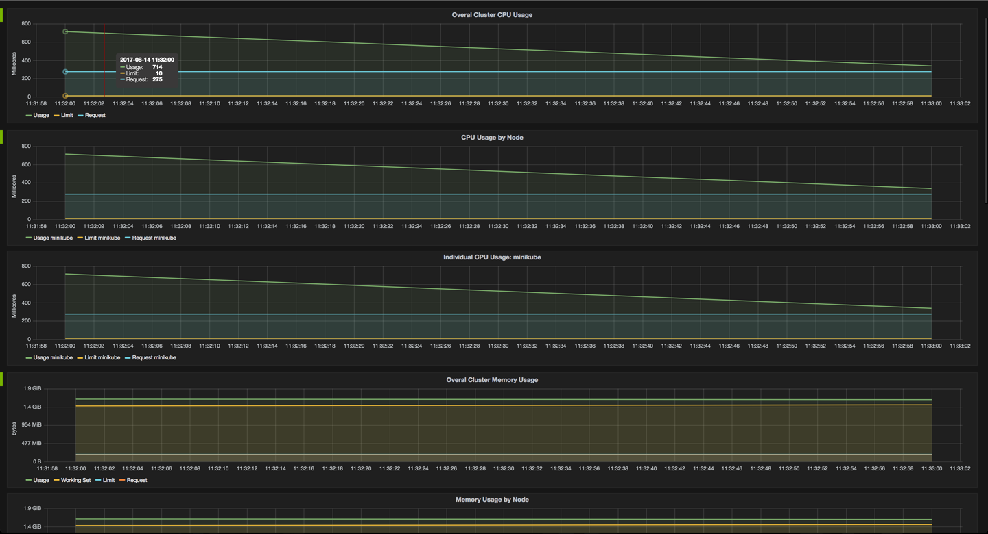
Figure 11-1. Screenshot of the Grafana dashboard, showing Minikube metrics

Note that you can drill into the metrics in Grafana at this point.

11.6 Using Prometheus on Minikube

Problem
You want to view and query the system and application metrics of your cluster in a central place.

Solution
Use Prometheus as follows:
- Create a config map holding the Prometheus configuration.
- Set up a service account for Prometheus and assign permissions via RBAC (see Recipe 10.3) to the service account (see Recipe 10.1) allowing access to all metrics.
- Create an app consisting of a deployment, a service, and an Ingress resource for Prometheus so that you can access it via a browser from outside the cluster.
First, you need to set up the Prometheus configuration via a ConfigMap object (see Recipe 8.3 for an introduction to config maps). You will be using this later in the Prometheus app. Create a file called prometheus.yml, holding the Prometheus configuration, with the following content:
global
:
scrape_interval
:
5s
evaluation_interval
:
5s
scrape_configs
:
-
job_name
:
'kubernetes-nodes'
scheme
:
https
tls_config
:
ca_file
:
/var/run/secrets/kubernetes.io/serviceaccount/ca.crt
server_name
:
'gke-k8scb-default-pool-be16f9ee-522p'
insecure_skip_verify
:
true
bearer_token_file
:
/var/run/secrets/kubernetes.io/serviceaccount/token
kubernetes_sd_configs
:
-
role
:
node
relabel_configs
:
-
action
:
labelmap
regex
:
__meta_kubernetes_node_label_(.+)
-
job_name
:
'kubernetes-cadvisor'
scheme
:
https
tls_config
:
ca_file
:
/var/run/secrets/kubernetes.io/serviceaccount/ca.crt
bearer_token_file
:
/var/run/secrets/kubernetes.io/serviceaccount/token
kubernetes_sd_configs
:
-
role
:
node
relabel_configs
:
-
action
:
labelmap
regex
:
__meta_kubernetes_node_label_(.+)
-
target_label
:
__address__
replacement
:
kubernetes.default.svc:443
-
source_labels
:
[
__meta_kubernetes_node_name
]
regex
:
(.+)
target_label
:
__metrics_path__
replacement
:
/api/v1/nodes/${1}:4194/proxy/metrics
We can use this to create a config map, like so:
$
kubectl create configmap prom-config-cm --from-file=prometheus.yml
Next, set up the Prometheus service account and role binding (permissions) in a manifest file called prometheus-rbac.yaml, as follows:
apiVersion
:
v1
kind
:
ServiceAccount
metadata
:
name
:
prometheus
namespace
:
default
---
apiVersion
:
rbac.authorization.k8s.io/v1beta1
kind
:
ClusterRoleBinding
metadata
:
name
:
prometheus
roleRef
:
apiGroup
:
rbac.authorization.k8s.io
kind
:
ClusterRole
name
:
cluster-admin
subjects
:
-
kind
:
ServiceAccount
name
:
prometheus
namespace
:
default
Using this manifest, you can now create the service account and role binding:
$
kubectl create -f prometheus-rbac.yaml
Now that you have all the prerequisites sorted (configuration and access permissions), you can move on to the Prometheus app itself. Remember, the app consists of a deployment, a service, and an Ingress resource and uses the config map and service account you created in the previous steps.
Next, define the Prometheus app manifest in prometheus-app.yaml:
kind
:
Deployment
apiVersion
:
extensions/v1beta1
metadata
:
name
:
prom
namespace
:
default
labels
:
app
:
prom
spec
:
replicas
:
1
selector
:
matchLabels
:
app
:
prom
template
:
metadata
:
name
:
prom
labels
:
app
:
prom
spec
:
serviceAccount
:
prometheus
containers
:
-
name
:
prom
image
:
prom/prometheus
imagePullPolicy
:
Always
volumeMounts
:
-
name
:
prometheus-volume-1
mountPath
:
"/prometheus"
-
name
:
prom-config-volume
mountPath
:
"/etc/prometheus/"
volumes
:
-
name
:
prometheus-volume-1
emptyDir
:
{}
-
name
:
prom-config-volume
configMap
:
name
:
prom-config-cm
defaultMode
:
420
---
kind
:
Service
apiVersion
:
v1
metadata
:
name
:
prom-svc
labels
:
app
:
prom
spec
:
ports
:
-
port
:
80
targetPort
:
9090
selector
:
app
:
prom
type
:
LoadBalancer
externalTrafficPolicy
:
Cluster
---
kind
:
Ingress
apiVersion
:
extensions/v1beta1
metadata
:
name
:
prom-public
annotations
:
ingress.kubernetes.io/rewrite-target
:
/
spec
:
rules
:
-
host
:
http
:
paths
:
-
path
:
/
backend
:
serviceName
:
prom-svc
servicePort
:
80
And now create the app from the manifest:
$
kubectl create -f prometheus-app.yaml
Congratulations—you just created a full-fledged app! Now you can access Prometheus via $MINISHIFT_IP/graph (for example, https://192.168.99.100/graph), and you should see something like in Figure 11-2.
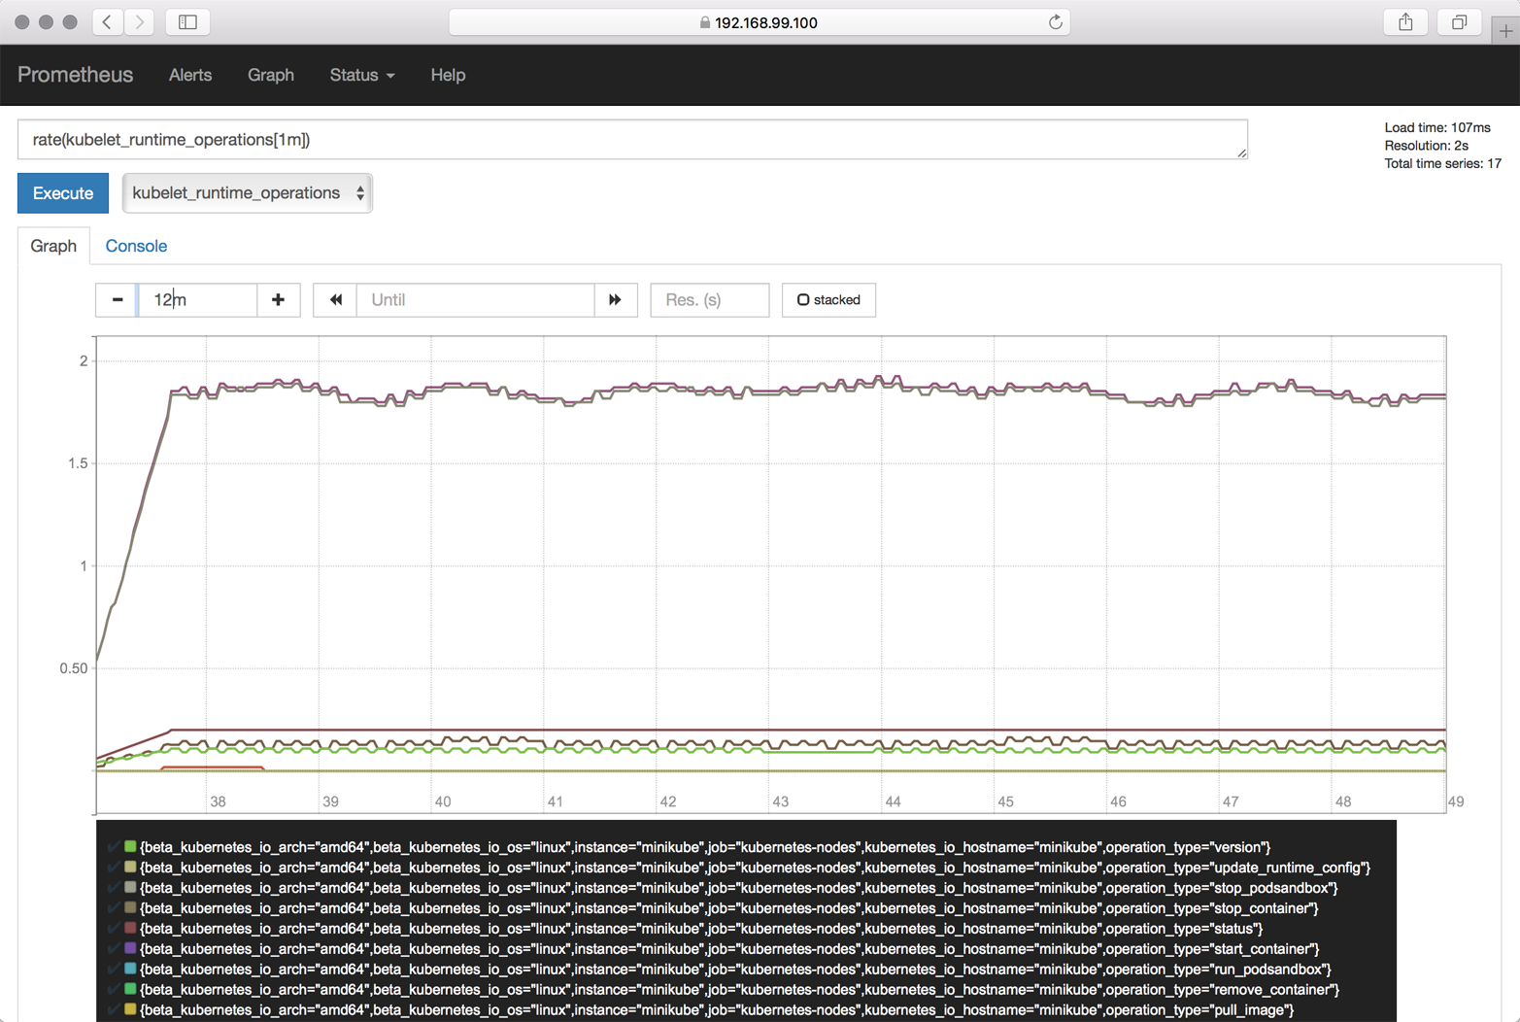
Figure 11-2. Prometheus screenshot

Discussion
Prometheus is a powerful and flexible monitoring and alerting system. You can use it—or better, one of the many instrumentation libraries—to make your own app report higher-level metrics such as, the number of transactions performed, just like the way, say, a kubelet reports the CPU usage.
While Prometheus is fast and scalable, you probable want to use something else to visualize the metrics. The canonical way to do this is to connect it with Grafana.
Warning
There is a known issue with using Prometheus with Kubernetes versions 1.7.0 through 1.7.2, as the kubelet’s behavior concerning exposing container metrics changed in v1.7.0.
Note that the Prometheus config shown in the Solution is valid for v1.7.0 to v1.7.2; if you’re using v1.7.3 or later, you want to check out the example Prometheus configuration file for details on what you need to change.
Note that the solution described here is not limited to Minikube. In fact, as long as you can create the service account (that is, you have sufficient rights to give Prometheus the necessary permissions), you can apply the same solution to environments such as GKE, ACS, or OpenShift.

See Also
- Instrumentation in the Prometheus docs
- Grafana with Prometheus in the Prometheus docs

11.7 Using Elasticsearch–Fluentd–Kibana (EFK) on Minikube

Problem
You want to view and query the logs of all of the apps in your cluster in a central place.

Solution
Use Elasticsearch, Fluentd, and Kibana as described here.
As preparation, make sure Minikube has enough resources assigned. For example, use --cpus=4 --memory=4000 and make sure the ingress add-on is enabled, like so:
$
minikube start
Starting local Kubernetes v1.7.0 cluster...
Starting VM...
Getting VM IP address...
Moving files into cluster...
Setting up certs...
Starting cluster components...
Connecting to cluster...
Setting up kubeconfig...
Kubectl is now configured to use the cluster.
$
minikube addons list | grep ingress
- ingress: enabled
If the add-on is not enabled, enable it:
$
minikube addons enable ingress
Next, create a manifest file called efk-logging.yaml with the following content:
kind
:
Ingress
apiVersion
:
extensions/v1beta1
metadata
:
name
:
kibana-public
annotations
:
ingress.kubernetes.io/rewrite-target
:
/
spec
:
rules
:
-
host
:
http
:
paths
:
-
path
:
/
backend
:
serviceName
:
kibana
servicePort
:
5601
---
kind
:
Service
apiVersion
:
v1
metadata
:
labels
:
app
:
efk
name
:
kibana
spec
:
ports
:
-
port
:
5601
selector
:
app
:
efk
---
kind
:
Deployment
apiVersion
:
extensions/v1beta1
metadata
:
name
:
kibana
spec
:
replicas
:
1
template
:
metadata
:
labels
:
app
:
efk
spec
:
containers
:
-
env
:
-
name
:
ELASTICSEARCH_URL
value
:
http://elasticsearch:9200
name
:
kibana
image
:
docker.elastic.co/kibana/kibana:5.5.1
ports
:
-
containerPort
:
5601
---
kind
:
Service
apiVersion
:
v1
metadata
:
labels
:
app
:
efk
name
:
elasticsearch
spec
:
ports
:
-
port
:
9200
selector
:
app
:
efk
---
kind
:
Deployment
apiVersion
:
extensions/v1beta1
metadata
:
name
:
es
spec
:
replicas
:
1
template
:
metadata
:
labels
:
app
:
efk
spec
:
containers
:
-
name
:
es
image
:
docker.elastic.co/elasticsearch/
elasticsearch:5.5.1
ports
:
-
containerPort
:
9200
env
:
-
name
:
ES_JAVA_OPTS
value
:
"-Xms256m
-Xmx256m"
---
kind
:
DaemonSet
apiVersion
:
extensions/v1beta1
metadata
:
name
:
fluentd
spec
:
template
:
metadata
:
labels
:
app
:
efk
name
:
fluentd
spec
:
containers
:
-
name
:
fluentd
image
:
gcr.io/google_containers/fluentd-
elasticsearch:1.3
env
:
-
name
:
FLUENTD_ARGS
value
:
-qq
volumeMounts
:
-
name
:
varlog
mountPath
:
/varlog
-
name
:
containers
mountPath
:
/var/lib/docker/containers
volumes
:
-
hostPath
:
path
:
/var/log
name
:
varlog
-
hostPath
:
path
:
/var/lib/docker/containers
name
:
containers
Now you can launch the EFK stack:
$
kubectl create -f efk-logging.yaml
Once everything has started up, log in to Kibana with the following credentials:
- Username: kibana
- Password: changeme
Visit the Discover tab at https://$IP/app/kibana#/discover?_g=() and start exploring the logs from there.
If you want to clean up and/or restart the EFK stack, use the following:
$
kubectl delete deploy/es && \
kubectl delete deploy/kibana && \
kubectl delete svc/elasticsearch && \
kubectl delete svc/kibana && \
kubectl delete ingress/kibana-public && \
kubectl delete daemonset/fluentd

Discussion
The log shipping can also be done using Logstash. We chose to use Fluentd in the Solution because it’s a CNCF project and is gaining a lot of traction.
Note that Kibana can take some time to come up, and you might need to reload the web app a couple of times before you get to the configuration bits.

See Also
- Manoj Bhagwat’s blog post “To Centralize Your Docker Logs with Fluentd and ElasticSearch on Kubernetes”
- Kubernetes EFK Stack for AWS
- elk-kubernetes

1
Kubernetes, “Configure Liveness and Readiness Probes”.
2
Kubernetes, “Define readiness probes”.
Chapter 12. Maintenance and Troubleshooting
In this chapter, you will find recipes that deal with both app-level and cluster-level maintenance. We cover various aspects of troubleshooting, from debugging pods and containers, to testing service connectivity, interpreting a resource’s status, and node maintenance. Last but not least, we look at how to deal with etcd, the Kubernetes control plane storage component. This chapter is relevant for both cluster admins and app developers.

12.1 Enabling Autocomplete for kubectl

Problem
It is cumbersome to type full commands and arguments for the kubectl command, so you want an autocomplete function for it.

Solution
Enable autocompletion for kubectl.
For Linux and the bash shell, you can enable kubectl autocompletion in your current shell using the following command:
$
source <(kubectl completion bash)
For other operating systems and shells, please check the documentation.

See Also
- Overview of kubectl
- kubectl Cheat Sheet

12.2 Removing a Pod from a Service

Problem
You have a well-defined service (see Recipe 5.1) backed by several pods. But one of the pods is misbehaving, and you would like to take it out of the list of endpoints to examine it at a later time.

Solution
Relabel the pod using the --overwrite option—this will allow you to change the value of the run label on the pod. By overwriting this label, you can ensure that it will not be selected by the service selector (Recipe 5.1) and will be removed from the list of endpoints. At the same time, the replica set watching over your pods will see that a pod has disappeared and will start a new replica.
To see this in action, start with a straightforward deployment generated with kubectl run (see Recipe 4.4):
$
kubectl run nginx --image nginx --replicas 4
When you list the pods and show the label with key run, you’ll see four pods with the value nginx (run=nginx is the label that is automatically generated by the kubectl run command):
$
kubectl get pods -Lrun
NAME READY STATUS RESTARTS AGE RUN
nginx-d5dc44cf7-5g45r 1/1 Running 0 1h nginx
nginx-d5dc44cf7-l429b 1/1 Running 0 1h nginx
nginx-d5dc44cf7-pvrfh 1/1 Running 0 1h nginx
nginx-d5dc44cf7-vm764 1/1 Running 0 1h nginx
You can then expose this deployment with a service and check the endpoints, which correspond to the IP addresses of each pod:
$
kubectl expose deployments nginx --port 80
$
kubectl get endpoints
NAME ENDPOINTS AGE
nginx 172.17.0.11:80,172.17.0.14:80,172.17.0.3:80 + 1 more... 1h
Moving the first pod out of the service traffic via relabeling is done with a single command:
$
kubectl label pods nginx-d5dc44cf7-5g45r run=notworking --overwrite

Tip
To find the IP address of a pod, you can list the pod’s manifest in JSON and run a JQuery query:
$
kubectl get pods nginx-d5dc44cf7-5g45r -o json | \
jq -r .status.podIP172.17.0.3
You will see a brand new pod appear with the label run=nginx, and you will see that your nonworking pod still exists but no longer appears in the list of service endpoints:
$
kubectl get pods -Lrun
NAME READY STATUS RESTARTS AGE RUN
nginx-d5dc44cf7-5g45r 1/1 Running 0 21h notworking
nginx-d5dc44cf7-hztlw 1/1 Running 0 21s nginx
nginx-d5dc44cf7-l429b 1/1 Running 0 5m nginx
nginx-d5dc44cf7-pvrfh 1/1 Running 0 5m nginx
nginx-d5dc44cf7-vm764 1/1 Running 0 5m nginx
$
kubectl describe endpoints nginx
Name: nginx
Namespace: default
Labels: run=nginx
Annotations: <none>
Subsets:
Addresses: 172.17.0.11,172.17.0.14,172.17.0.19,172.17.0.7
...

12.3 Accessing a ClusterIP Service Outside the Cluster

Problem
You have an internal service that is causing you trouble and you want to test that it is working well locally without exposing the service externally.

Solution
Use a local proxy to the Kubernetes API server with kubectl proxy.
Let’s assume that you have created a deployment and a service as described in Recipe 12.2. You should see an nginx service when you list the services:
$
kubectl get svc
NAME TYPE CLUSTER-IP EXTERNAL-IP PORT(S) AGE
nginx ClusterIP 10.109.24.56 <none> 80/TCP 22h
This service is not reachable outside the Kubernetes cluster. However, you can run a proxy in a separate terminal and then reach it on localhost.
Start by running the proxy in a separate terminal:
$
kubectl proxy
Starting to serve on 127.0.0.1:8001

Tip
You can specify the port that you want the proxy to run on with the --port option.
In your original terminal, you can then use your browser or curl to access the application exposed by your service. Note the specific path to the service; it contains a /proxy part. Without this, you get the JSON object representing the service:
$
curl http://localhost:8001/api/v1/proxy/namespaces/default/services/nginx/
<!DOCTYPE html>
<html>
<head>
<title>Welcome to nginx!</title>
...

Note
Note that you can now also access the entire Kubernetes API over localhost using curl.

12.4 Understanding and Parsing Resource Statuses

Problem
You want to react based on the status of a resource—say, a pod—in a script or in another automated environment like a CI/CD pipeline.

Solution
Use kubectl get $KIND/$NAME -o json and parse the JSON output using one of the two methods described here.
If you have the JSON query utility jq installed, you can use it to parse the resource status. Let’s assume you have a pod called jump and want to know what Quality of Service (QoS) class1 the pod is in:
$
kubectl get po/jump -o json | jq --raw-output .status.qosClass
BestEffort
Note that the --raw-output argument for jq will show the raw value and that .status.qosClass is the expression that matches the respective subfield.
Another status query could be around the events or state transitions:
$
kubectl get po/jump -o json | jq .status.conditions
[
{
"lastProbeTime": null,
"lastTransitionTime": "2017-08-28T08:06:19Z",
"status": "True",
"type": "Initialized"
},
{
"lastProbeTime": null,
"lastTransitionTime": "2017-08-31T08:21:29Z",
"status": "True",
"type": "Ready"
},
{
"lastProbeTime": null,
"lastTransitionTime": "2017-08-28T08:06:19Z",
"status": "True",
"type": "PodScheduled"
}
]
Of course, these queries are not limited to pods—you can apply this technique to any resource. For example, you can query the revisions of a deployment:
$
kubectl get deploy/prom -o json | jq .metadata.annotations
{
"deployment.kubernetes.io/revision": "1"
}
Or you can list all the endpoints that make up a service:
$
kubectl get ep/prom-svc -o json | jq '.subsets'
[
{
"addresses": [
{
"ip": "172.17.0.4",
"nodeName": "minikube",
"targetRef": {
"kind": "Pod",
"name": "prom-2436944326-pr60g",
"namespace": "default",
"resourceVersion": "686093",
"uid": "eee59623-7f2f-11e7-b58a-080027390640"
}
}
],
"ports": [
{
"port": 9090,
"protocol": "TCP"
}
]
}
]
Now that you’ve seen jq in action, let’s move on to a method that doesn’t require external tooling—that is, the built-in feature of using Go templates.
The Go programming language defines templates in a package called text/template that can be used for any kind of text or data transformation, and kubectl has built-in support for it. For example, to list all the container images used in the current namespace, do this:
$
kubectl get pods -o go-template \
--template="{{range .items}}{{range .spec.containers}}{{.image}} \
{{end}}{{end}}"
busybox prom/prometheus

See Also
- jq Manual
- jq playground to try out queries without installing jq
- Package Template in the Go docs

12.5 Debugging Pods

Problem
You have a situation where a pod is either not starting up as expected or fails after some time.

Solution
To systematically discover and fix the cause of the problem, enter an OODA loop:
- Observe. What do you see in the container logs? What events have occurred? How is the network connectivity?
- Orient. Formulate a set of plausible hypotheses—stay as open-minded as possible and don’t jump to conclusions.
- Decide. Pick one of the hypotheses.
- Act. Test the hypothesis. If it’s confirmed, you’re done; otherwise, go back to step 1 and continue.
Let’s have a look at a concrete example where a pod fails. Create a manifest called unhappy-pod.yaml with this content:
apiVersion
:
extensions/v1beta1
kind
:
Deployment
metadata
:
name
:
unhappy
spec
:
replicas
:
1
template
:
metadata
:
labels
:
app
:
nevermind
spec
:
containers
:
-
name
:
shell
image
:
busybox
command
:
-
"sh"
-
"-c"
-
"echo
I
will
just
print
something
here
and
then
exit"
Now when you launch that deployment and look at the pod it creates, you’ll see it’s unhappy:
$
kubectl create -f unhappy-pod.yaml
deployment "unhappy" created
$
kubectl get po
NAME READY STATUS RESTARTS AGE
unhappy-3626010456-4j251 0/1 CrashLoopBackOff 1 7s
$
kubectl describe po/unhappy-3626010456-4j251
Name: unhappy-3626010456-4j251
Namespace: default
Node: minikube/192.168.99.100
Start Time: Sat, 12 Aug 2017 17:02:37 +0100
Labels: app=nevermind
pod-template-hash=3626010456
Annotations: kubernetes.io/created-by={"kind":"SerializedReference","apiVersion":
"v1","reference":{"kind":"ReplicaSet","namespace":"default","name":
"unhappy-3626010456","uid":
"a9368a97-7f77-11e7-b58a-080027390640"...
Status: Running
IP: 172.17.0.13
Created By: ReplicaSet/unhappy-3626010456
Controlled By: ReplicaSet/unhappy-3626010456
...
Conditions:
Type Status
Initialized True
Ready False
PodScheduled True
Volumes:
default-token-rlm2s:
Type: Secret (a volume populated by a Secret)
SecretName: default-token-rlm2s
Optional: false
QoS Class: BestEffort
Node-Selectors: <none>
Tolerations: <none>
Events:
FirstSeen ... Reason Message
--------- ... ------ -------
25s ... Scheduled Successfully assigned
unhappy-3626010456-4j251 to minikube
25s ... SuccessfulMountVolume MountVolume.SetUp succeeded for
volume "default-token-rlm2s"
24s ... Pulling pulling image "busybox"
22s ... Pulled Successfully pulled image "busybox"
22s ... Created Created container
22s ... Started Started container
19s ... BackOff Back-off restarting failed container
19s ... FailedSync Error syncing pod
As you can see, Kubernetes considers this pod as not ready to serve traffic as it encountered an “error syncing pod.”
Another way to observe this is using the Kubernetes dashboard to view the deployment (Figure 12-1), as well as the supervised replica set and the pod (Figure 12-2).
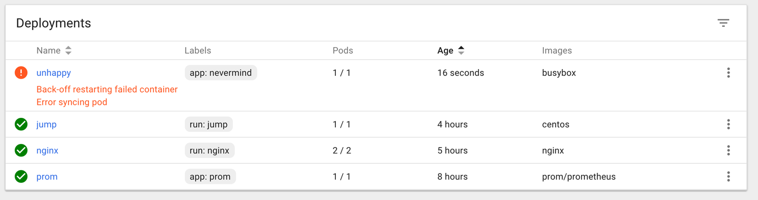
Figure 12-1. Screenshot of deployment in error state

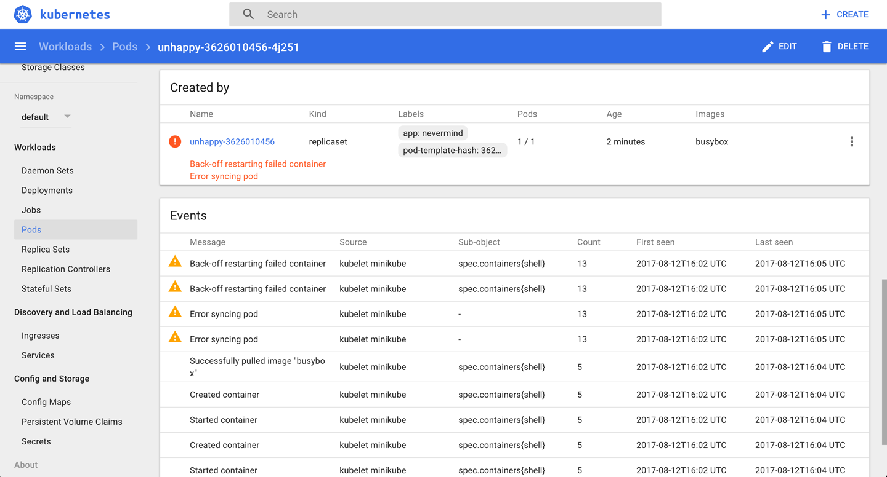
Figure 12-2. Screenshot of pod in error state

Discussion
An issue, be it a pod failing or a node behaving strangely, can have many different causes. Here are some things you’ll want to check before suspecting software bugs:
- Is the manifest correct? Check with the Kubernetes JSON schema.
- Does the container run standalone, locally (that is, outside of Kubernetes)?
- Can Kubernetes reach the container registry and actually pull the container image?
- Can the nodes talk to each other?
- Can the nodes reach the master?
- Is DNS available in the cluster?
- Are there sufficient resources available on the nodes?
- Did you restrict the container’s resource usage?

See Also
- Kubernetes Troubleshoot Applications documentation
- Application Introspection and Debugging
- Debug Pods and Replication Controllers
- Debug Services
- Troubleshoot Clusters

12.6 Getting a Detailed Snapshot of the Cluster State

Problem
You want to get a detailed snapshot of the overall cluster state for orientation, auditing, or troubleshooting purposes.

Solution
Use the kubectl cluster-info dump command. For example, to create a dump of the cluster state in a subdirectory cluster-state-2017-08-13, do this:
$
kubectl cluster-info dump --all-namespaces \
--output-directory=$PWD/cluster-state-2017-08-13
$
tree ./cluster-state-2017-08-13
.
├── default
│ ├── cockroachdb-0
│ │ └── logs.txt
│ ├── cockroachdb-1
│ │ └── logs.txt
│ ├── cockroachdb-2
│ │ └── logs.txt
│ ├── daemonsets.json
│ ├── deployments.json
│ ├── events.json
│ ├── jump-1247516000-sz87w
│ │ └── logs.txt
│ ├── nginx-4217019353-462mb
│ │ └── logs.txt
│ ├── nginx-4217019353-z3g8d
│ │ └── logs.txt
│ ├── pods.json
│ ├── prom-2436944326-pr60g
│ │ └── logs.txt
│ ├── replicasets.json
│ ├── replication-controllers.json
│ └── services.json
├── kube-public
│ ├── daemonsets.json
│ ├── deployments.json
│ ├── events.json
│ ├── pods.json
│ ├── replicasets.json
│ ├── replication-controllers.json
│ └── services.json
├── kube-system
│ ├── daemonsets.json
│ ├── default-http-backend-wdfwc
│ │ └── logs.txt
│ ├── deployments.json
│ ├── events.json
│ ├── kube-addon-manager-minikube
│ │ └── logs.txt
│ ├── kube-dns-910330662-dvr9f
│ │ └── logs.txt
│ ├── kubernetes-dashboard-5pqmk
│ │ └── logs.txt
│ ├── nginx-ingress-controller-d2f2z
│ │ └── logs.txt
│ ├── pods.json
│ ├── replicasets.json
│ ├── replication-controllers.json
│ └── services.json
└── nodes.json

12.7 Adding Kubernetes Worker Nodes

Problem
You need to add a worker node to your Kubernetes cluster.

Solution
Provision a new machine in whatever way your environment requires (for example, in a bare-metal environment you might need to physically install a new server in a rack, in a public cloud setting you need to create a new VM, etc.), and then install the three components that make up a Kubernetes worker node:
kubelet
This is the node manager and supervisor for all pods, no matter if they’re controlled by the API server or running locally, such as static pods. Note that the kubelet is the final arbiter of what pods can or cannot run on a given node, and takes care of:
- Reporting node and pod statuses to the API server.
- Periodically executing liveness probes.
- Mounting the pod volumes and downloading secrets.
- Controlling the container runtime (see the following).
Container runtime
This is responsible for downloading container images and running the containers. Initially, this was hardwired to the Docker engine, but nowadays it is a pluggable system based on the Container Runtime Interface (CRI), so you can, for example, use CRI-O rather than Docker.
kube-proxy
This process dynamically configures iptables rules on the node to enable the Kubernetes service abstraction (redirecting the VIP to the endpoints, one or more pods representing the service).
The actual installation of the components depends heavily on your environment and the installation method used (cloud, kubeadm, etc.). For a list of available options, see the kubelet reference and kube-proxy reference.

Discussion
Worker nodes, unlike other Kubernetes resources such as a deployments or services, are not directly created by the Kubernetes control plane but only managed by it. That means when Kubernetes creates a node, it actually only creates an object that represents the worker node. It validates the node by health checks based on the node’s metadata.name field, and if the node is valid—that is, all necessary components are running—it is considered part of the cluster; otherwise, it will be ignored for any cluster activity until it becomes valid.

See Also
- “The Kubernetes Node” in the Kubernetes Architecture design document
- Master-Node communication
- Static Pods

12.8 Draining Kubernetes Nodes for Maintenance

Problem
You need to carry out maintenance on a node—for example, to apply a security patch or upgrade the operating system.

Solution
Use the kubectl drain command. For example, to do maintenance on node 123-worker:
$
kubectl drain 123-worker
When you are ready to put the node back into service, use kubectl uncordon 123-worker, which will make the node schedulable again.

Discussion
What the kubectl drain command does is to first mark the specified node un-schedulable to prevent new pods from arriving (essentially a kubectl cordon). Then it evicts the pods if the API server supports eviction. Otherwise, it will use normal kubectl delete to delete the pods. The Kubernetes docs have a concise sequence diagram of the steps, reproduced in Figure 12-3.
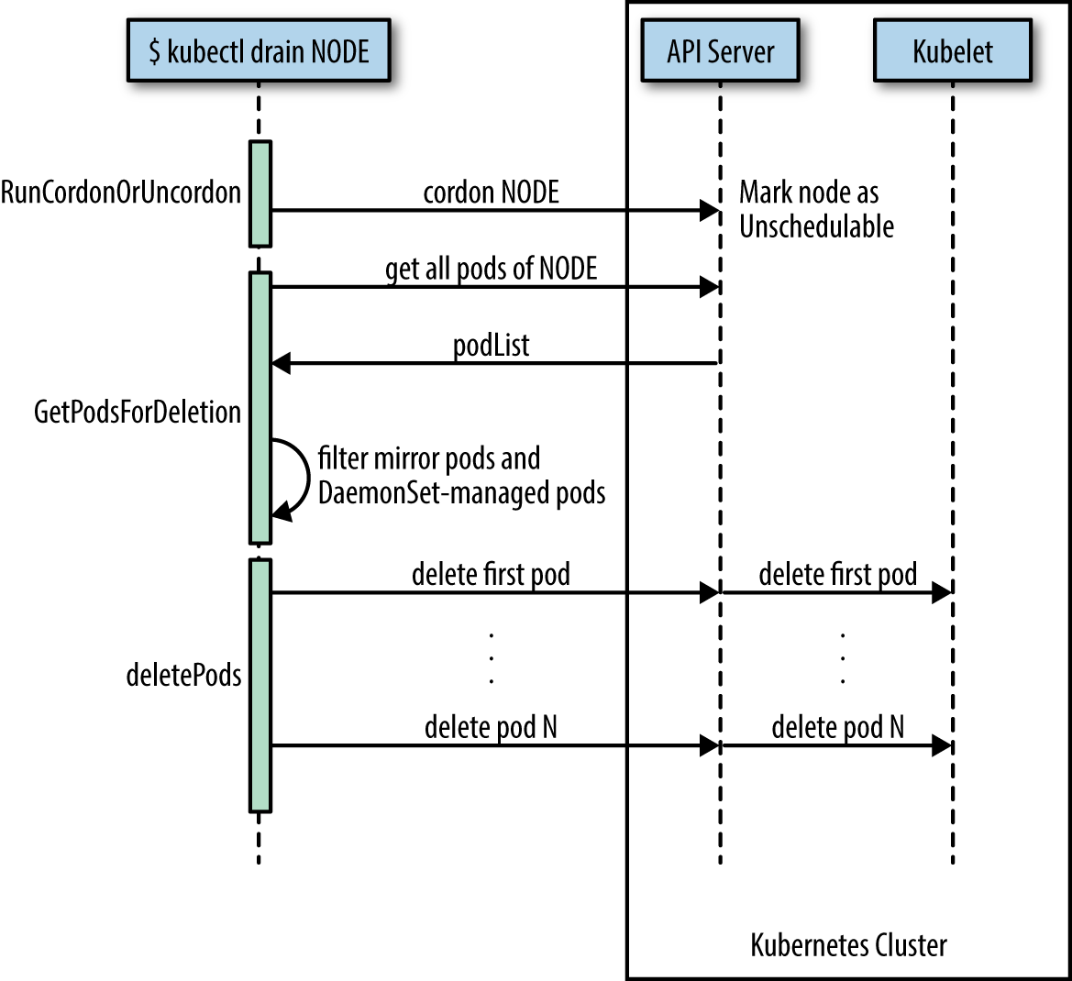
Figure 12-3. Node drain sequence diagram

The kubectl drain command evicts or deletes all pods except mirror pods (which cannot be deleted through the API server). For pods supervised by a DaemonSet, drain will not proceed without using --ignore-daemonsets, and regardless it will not delete any DaemonSet-managed pods—those pods would be immediately replaced by the DaemonSet controller, which ignores unschedulable markings.
Warning
drain waits for graceful termination, so you should not operate on this node until the kubectl drain command has completed. Note that kubectl drain $NODE --force will also evict pods not managed by an RC, RS, job, DaemonSet, or StatefulSet.

See Also
- Safely Drain a Node while Respecting Application SLOs
- The kubectl reference docs

12.9 Managing etcd

Problem
You need to access etcd to back it up or verify the cluster state directly.

Solution
Get access to etcd and query it, either using curl or etcdctl. For example, in the context of Minikube (with jq installed):
$
minikube ssh
$
curl 127.0.0.1:2379/v2/keys/registry | jq .
{
"action": "get",
"node": {
"key": "/registry",
"dir": true,
"nodes": [
{
"key": "/registry/persistentvolumeclaims",
"dir": true,
"modifiedIndex": 241330,
"createdIndex": 241330
},
{
"key": "/registry/apiextensions.k8s.io",
"dir": true,
"modifiedIndex": 641,
"createdIndex": 641
},
...
This technique can be used in environments where etcd is used with the v2 API.

Discussion
In Kubernetes, etcd is a component of the control plane. The API server (see Recipe 6.1) is stateless and the only Kubernetes component that directly communicates with etcd, the distributed storage component that manages the cluster state. Essentially, etcd is a key/value store; in etcd2 the keys formed a hierarchy, but with the introduction of etcd3 this was replaced with a flat model (while maintaining backwards compatibility concerning hierarchical keys).

Note
Up until Kubernetes 1.5.2 we used etcd2, and from then on we switched to etcd3. In Kubernetes 1.5.x, etcd3 is still used in v2 API mode and going forward this is changing to the etcd v3 API with v2 being deprecated soon. Though from a developer’s point of view this doesn’t have any implications, because the API server takes care of abstracting the interactions away, as an admin you want to pay attention to which etcd version is used in which API mode.
In general, it’s the responsibility of the cluster admin to manage etcd—that is, to upgrade it and make sure the data is backed up. In certain environments where the control plane is managed for you, such as in Google Kubernetes Engine, you cannot access etcd directly. This is by design, and there’s no workaround for it.

See Also
- etcd v2 Cluster Administration guide
- etcd v3 Disaster Recovery guide
- Operating etcd clusters for Kubernetes
- “Accessing Localkube Resources from Inside a Pod: Example etcd” in the Minikube docs
- Stefan Schimanski and Michael Hausenblas’s blog post “Kubernetes Deep Dive: API Server – Part 2”
- Michael Hausenblas’s blog post “Notes on Moving from etcd2 to etcd3”

1
Medium, “What are Quality of Service (QoS) Classes in Kubernetes”.
Chapter 13. Developing Kubernetes
Now that you’ve seen how to install, interact with, and use Kubernetes to deploy and manage applications, we focus in this chapter on adapting Kubernetes to your needs as well as fixing bugs in Kubernetes. For this, you will need Go installed and access to the Kubernetes source code hosted on GitHub. We show how to compile Kubernetes (as a whole) and also show how to compile specific components like the client kubectl. We also demonstrate how to use Python to talk to the Kubernetes API server and show how to extend Kubernetes with a custom resource definition.

13.1 Compiling from Source

Problem
You want to package your own Kubernetes binaries from source instead of downloading the official release binaries (see Recipe 2.4) or third-party artifacts.

Solution
Clone the Kubernetes Git repository and build from source.
If you are on a Docker host, you can use the quick-release target of the root Makefile as shown here:
$
git clone https://github.com/kubernetes/kubernetes
$
cd kubernetes
$
make quick-release

Tip
This Docker-based build requires at least 4 GB of RAM to complete. Ensure that your Docker daemon has access to that much memory. On macOS, access the Docker for Mac preferences and increase the allocated RAM.
The binaries will be located in the _output/release-stage directory and a complete bundle will be in the _output/release-tars directory.
Or, if you have a Golang environment properly set up, use the release target of the root Makefile:
$
git clone https://github.com/kubernetes/Kubernetes
$
cd kubernetes
$
make
The binaries will be located in the _output/bin directory.

See Also
- Detailed Kubernetes developer guides

13.2 Compiling a Specific Component

Problem
You want to build a specific component of Kubernetes from source, not all the components—for example, you only want to build the client kubectl.

Solution
Instead of using make quick-release or simply make, as shown in Recipe 13.1, do make kubectl.
There are targets in the root Makefile to build individual components. For example to compile kubectl, kubeadm, and hyperkube, do this:
$
make kubectl
$
make kubeadm
$
make hyperkube
The binaries will be located in the _output/bin directory.

13.3 Using a Python Client to Interact with the Kubernetes API

Problem
You want to use Python to write scripts that use the Kubernetes API.

Solution
Install the Python kubernetes module. This module is currently being developed in the Kubernetes incubator. You can install the module from source or from the Python Package Index (PyPi) site:
$
pip install kubernetes
With a Kubernetes cluster reachable using your default kubectl context, you are now ready to use this Python module to talk to the Kubernetes API. For example, the following Python script lists all the pods and prints their names:
from
kubernetes
import
client
,
config
config
.
load_kube_config
()
v1
=
client
.
CoreV1Api
()
res
=
v1
.
list_pod_for_all_namespaces
(
watch
=
False
)
for
pod
in
res
.
items
:
print
(
pod
.
metadata
.
name
)
The config.load_kube_config() call in this script will load your Kubernetes credentials and endpoint from your kubectl config file. By default, it will load the cluster endpoint and credentials for your current context.

Discussion
The Python client is built using the OpenAPI specification of the Kubernetes API. It is up to date and autogenerated. All APIs are available through this client.
Each API group corresponds to a specific class, so to call a method on an API object that is part of the /api/v1 API group, you need to instantiate the CoreV1Api class. To use deployments, you will need to instantiate the extensionsV1beta1Api class. All methods and corresponding API group instances can be found in the autogenerated README.

See Also
- Examples in the project’s repository

13.4 Extending the API Using Custom Resource Definitions (CRDs)

Problem
You have a custom workload and none of the existing resources, such as Deployment, a Job, or a StatefulSet, is a good fit. So, you want to extend the Kubernetes API with a new resource that represents your workload while continuing to use kubectl in the usual way.

Solution
Use a CustomResourceDefinition (CRD) as described [here].
Let’s say you want to define a custom resource of kind Function. This represents a short-running Job-like kind of resource, akin to what AWS Lambda offers, that is a Function-as-a-Service (FaaS, or sometimes misleadingly called “serverless”).

Note
For a production-ready FaaS solution running on Kubernetes, see Recipe 14.7.
First, define the CRD in a manifest file called functions-crd.yaml:
apiVersion
:
apiextensions.k8s.io/v1beta1
kind
:
CustomResourceDefinition
metadata
:
name
:
function.example.com
spec
:
group
:
example.com
version
:
v1
names
:
kind
:
Function
plural
:
functions
scope
:
Namespaced
Then let the API server know about your new CRD (it can take several minutes to register):
$
kubectl create -f functions-crd.yaml
customresourcedefinition "functions.example.com" created
Now that you have the custom resource Function defined and the API server knows about it, you can instantiate it using a manifest called myfaas.yaml with the following content:
apiVersion
:
example.com/v1
kind
:
Function
metadata
:
name
:
myfaas
spec
:
code
:
"http://src.example.com/myfaas.js"
ram
:
100Mi
And create the myfaas resource of kind Function as per usual:
$
kubectl create -f myfaas.yaml
function "myfaas" created
$
kubectl get crd functions.example.com -o yaml
apiVersion: apiextensions.k8s.io/v1beta1
kind: CustomResourceDefinition
metadata:
creationTimestamp: 2017-08-13T10:11:50Z
name: functions.example.com
resourceVersion: "458065"
selfLink: /apis/apiextensions.k8s.io/v1beta1/customresourcedefinitions
/functions.example.com
uid: 278016fe-81a2-11e7-b58a-080027390640
spec:
group: example.com
names:
kind: Function
listKind: FunctionList
plural: functions
singular: function
scope: Namespaced
version: v1
status:
acceptedNames:
kind: Function
listKind: FunctionList
plural: functions
singular: function
conditions:
- lastTransitionTime: null
message: no conflicts found
reason: NoConflicts
status: "True"
type: NamesAccepted
- lastTransitionTime: 2017-08-13T10:11:50Z
message: the initial names have been accepted
reason: InitialNamesAccepted
status: "True"
type: Established
$
kubectl describe functions.example.com/myfaas
Name: myfaas
Namespace: default
Labels: <none>
Annotations: <none>
API Version: example.com/v1
Kind: Function
Metadata:
Cluster Name:
Creation Timestamp: 2017-08-13T10:12:07Z
Deletion Grace Period Seconds: <nil>
Deletion Timestamp: <nil>
Resource Version: 458086
Self Link: /apis/example.com/v1/namespaces/default
/functions/myfaas
UID: 316f3e99-81a2-11e7-b58a-080027390640
Spec:
Code: http://src.example.com/myfaas.js
Ram: 100Mi
Events: <none>
To discover CRDs, simply access the API server. For example, using kubectl proxy, you can access the API server locally and query the key space (example.com/v1 in our case):
$
curl 127.0.0.1:8001/apis/example.com/v1/ | jq .
{
"kind": "APIResourceList",
"apiVersion": "v1",
"groupVersion": "example.com/v1",
"resources": [
{
"name": "functions",
"singularName": "function",
"namespaced": true,
"kind": "Function",
"verbs": [
"delete",
"deletecollection",
"get",
"list",
"patch",
"create",
"update",
"watch"
]
}
]
}
Here you can see the resource along with the allowed verbs.
When you want to get rid of your custom resource instance myfaas, simply delete it:
$
kubectl delete functions.example.com/myfaas
function "myfaas" deleted

Discussion
As you’ve seen, it is straightforward to create a CRD. From an end user’s point of view, CRDs present a consistent API and are more or less indistinguishable from native resources such as pods or jobs. All the usual commands, such as kubectl get and kubectl delete, work as expected.
Creating a CRD is, however, really less than half of the work necessary to fully extend the Kubernetes API. On their own, CRDs only let you store and retrieve custom data via the API server in etcd. You need to also write a custom controller that interprets the custom data expressing the user’s intent and establishes a control loop comparing the current state with the declared state, and tries to reconcile both.

Tip
Up until v1.7, what are now known as CRDs were called third-party resources (TPRs). If you happen to have a TPR, strongly consider migrating it now.
The main limitations of CRDs (and hence the reasons you might want to use a user API server in certain cases) are:
- Only a single version per CRD is supported, though it is possible to have multiple versions per API group (that means you can’t convert between different representations of your CRD).
- CRDS don’t support assigning default values to fields in v1.7 or earlier.
- Validation of the fields defined in a CRD specification is possible only from v1.8.
- It’s not possible to define subresources, such as status resources.

See Also
- Extend the Kubernetes API with CustomResourceDefinitions
- Stefan Schimanski and Michael Hausenblas’s blog post “Kubernetes Deep Dive: API Server – Part 3a”
- Aaron Levy, “Writing a Custom Controller: Extending the Functionality of Your Cluster”, KubeCon 2017
- Tu Nguyen’s article “A Deep Dive into Kubernetes Controllers”
- Yaron Haviv’s article “Extend Kubernetes 1.7 with Custom Resources”

Chapter 14. The Ecosystem
In this chapter, we take a look at the wider Kubernetes ecosystem; that is, software in the Kubernetes incubator and related projects such as Helm and kompose.

14.1 Installing Helm, the Kubernetes Package Manager

Problem
You do not want to write all the Kubernetes manifests by hand. Instead, you would like to be able to search for a package in a repository and download and install it with a command-line interface.

Solution
Use Helm. Helm is the Kubernetes package manager; it defines a Kubernetes package as a set of manifests and some metadata. The manifests are actually templates. The values in the templates are filled when the package is instantiated by Helm. A Helm package is called a chart.
Helm has a client-side CLI called helm and a server called tiller. You interact with charts using helm, and tiller runs within your Kubernetes cluster as a regular Kubernetes deployment.
You can build Helm from source or download it from the GitHub release page, extract the archive, and move the helm binary into your $PATH. For example, on macOS, for the v2.7.2 release of Helm, do this:
$
wget https://storage.googleapis.com/kubernetes-helm/ \
helm-v2.7.2-darwin-amd64.tar.gz
$
tar -xvf helm-v2.7.2-darwin-amd64.tar.gz
$
sudo mv darwin-amd64/64 /usr/local/bin
$
helm version
Now that the helm command is in your $PATH, you can use it to start the server-side component, tiller, on your Kubernetes cluster. Here we use Minikube as an example:
$
kubectl get nodes
NAME STATUS AGE VERSION
minikube Ready 4m v1.7.8
$
helm init
$HELM_HOME has been configured at /Users/sebgoa/.helm.
Tiller (the helm server side component) has been installed into your Kubernetes
Cluster. Happy Helming!
$
kubectl get pods --all-namespaces | grep tiller
kube-system tiller-deploy-1491950541-4kqxx 0/1 ContainerCreating 0 1s
You’re all set now and can install one of the over 100 packages available.

14.2 Using Helm to Install Applications

Problem
You’ve installed the helm command (see Recipe 14.1), and now you would like to search for charts and deploy them.

Solution
By default, Helm comes with some chart repositories configured. These repositories are maintained by the community; you can read more about them on GitHub. There are over 100 charts available.
For example, let’s assume you would like to deploy Redis. You can search for redis in the Helm repositories and then install it. Helm will take the chart and create an instance of it called a release.
First, verify that tiller is running and that you have the default repositories configured:
$
kubectl get pods --all-namespaces | grep tiller
kube-system tiller-deploy-1491950541-4kqxx 1/1 Running 0 3m
$
helm repo list
NAME URL
stable http://storage.googleapis.com/kubernetes-charts
You can now search for a Redis package:
$
helm search redis
NAME VERSION DESCRIPTION
stable/redis 0.5.1 Open source, advanced key-value store. It ...
testing/redis-cluster 0.0.5 Highly available Redis cluster with multiple...
testing/redis-standalone 0.0.1 Standalone Redis Master
stable/sensu 0.1.2 Sensu monitoring framework backed by the ...
testing/example-todo 0.0.6 Example Todo application backed by Redis
And use helm install to create a release like so:
$
helm install stable/redis
Helm will create all the Kubernetes objects defined in the chart; for example, a secret (see Recipe 8.2), a PVC (see Recipe 8.5), a service (see Recipe 5.1), and/or a deployment. Together, these objects make up a Helm release that you can manage as a single unit.
The end result is that you will have a redis pod running:
$
helm ls
NAME REVISION UPDATED STATUS CHART ...
broken-badger 1 Fri May 12 11:50:43 2017 DEPLOYED redis-0.5.1 ...
$
kubectl get pods
NAME READY STATUS RESTARTS AGE
broken-badger-redis-4040604371-tcn14 1/1 Running 0 3m
To learn more about Helm charts and how to create your own charts, see Recipe 14.3.

14.3 Creating Your Own Chart to Package Your Application with Helm

Problem
You have written an application with multiple Kubernetes manifests and would like to package it as a Helm chart.

Solution
Use the helm create and helm package commands.
With helm create, you can generate the skeleton of your chart. Issue the command in your terminal, specifying the name of your chart. For example, to create an oreilly chart:
$
helm create oreilly
Creating oreilly
$
tree oreilly/
oreilly/
├── Chart.yaml
├── charts
├── templates
│ ├── NOTES.txt
│ ├── _helpers.tpl
│ ├── deployment.yaml
│ ├── ingress.yaml
│ └── service.yaml
└── values.yaml
2 directories, 7 files
If you have all your manifests already written, you can copy them into the /templates directory and delete what the scaffolding created. If you want to templatize your manifests, then write the values that need to be substituted in the manifests in the values.yaml file. Edit the metadata file Chart.yaml, and if you have any dependent charts put them in the /charts directory.
You can test your chart locally by running:
$
helm install ./oreilly
Finally, you can package it with helm package oreilly/. This will generate a tarball of your chart, copy it to a local chart repository, and generate a new index.yaml file for your local repository. Look into the ~/.helm directory and you should see something similar to the following:
$
ls -l ~/.helm/repository/local/
total 16
-rw-r--r-- 1 sebgoa staff 379 Dec 16 21:25 index.yaml
-rw-r--r-- 1 sebgoa staff 1321 Dec 16 21:25 oreilly-0.1.0.tgz
A helm search oreilly should now return your local chart:
$
helm search oreilly
NAME VERSION DESCRIPTION
local/oreilly 0.1.0 A Helm chart for Kubernetes

See Also
- “How to Create Your First Helm Chart” in the Bitnami docs for Kubernetes
- “The Chart Best Practices Guide” in the Helm docs

14.4 Converting Your Docker Compose Files to Kubernetes Manifests

Problem
You’ve started using containers with Docker and written some Docker compose files to define your multicontainer application. Now you would like to start using Kubernetes, and wonder if and how you can reuse your Docker compose files.

Solution
Use kompose, a CLI tool that converts your Docker compose files into Kubernetes manifests.
To start, download kompose from the GitHub release page and move it to your $PATH, for convenience.
For example, on macOS, do the following:
$
wget https://github.com/kubernetes-incubator/kompose/releases/download/ \
v1.6.0/kompose-darwin-amd64
$
sudo mv kompose-darwin-amd64 /usr/local/bin/kompose
$
sudo chmod +x /usr/local/bin/kompose
$
kompose version
1.6.0 (ae4ef9e)
Given the following Docker compose file that starts a redis container:
version
:
'2'
services
:
redis
:
image
:
redis
ports
:
-
"6379:6379"
You can automatically convert this into Kubernetes manifests with the following command:
$
kompose convert --stdout
The manifests will be printed to stdout and you will see a Kubernetes service and a deployment as a result. To create these objects automatically, you can use the Docker compose-compliant command up like so:
$
kompose up
Warning
Some Docker compose directives are not converted to Kubernetes. In this case, kompose prints out a warning informing you that the conversion did not happen.
While in general it doesn’t cause problems, it is possible that the conversion may not result in a working manifest in Kubernetes. This is expected as this type of transformation cannot be perfect. However, it gets you close to a working Kubernetes manifest. Most notably, handling volumes and network isolation will typically require manual, custom work from your side.

Discussion
The main kompose commands are convert, up, and down. You can view detailed help for each command in the CLI using the --help option.
By default, kompose converts your Docker services into a Kubernetes deployment and associated service. You can also specify the use of a DaemonSet (see Recipe 7.3), or you can use OpenShift-specific objects such as a DeploymentConfiguration.

14.5 Creating a Kubernetes Cluster with kubicorn

Problem
You want to create a Kubernetes cluster on AWS.

Solution
Use kubicorn to create and manage Kubernetes clusters on AWS. Since kubicorn currently doesn’t provide for binary releases, you need to have Go installed for the following to work.
First, install kubicorn and make sure that Go (version 1.8 or later) is available. Here, we’re using a CentOS environment.
$
go version
go version go1.8 linux/amd64
$
yum group install "Development Tools" \
yum install ncurses-devel
$
go get github.com/kris-nova/kubicorn
...
Create, Manage, Image, and Scale Kubernetes infrastructure in the cloud.
Usage:
kubicorn [flags]
kubicorn [command]
Available Commands:
adopt Adopt a Kubernetes cluster into a Kubicorn state store
apply Apply a cluster resource to a cloud
completion Generate completion code for bash and zsh shells.
create Create a Kubicorn API model from a profile
delete Delete a Kubernetes cluster
getconfig Manage Kubernetes configuration
help Help about any command
image Take an image of a Kubernetes cluster
list List available states
version Verify Kubicorn version
Flags:
-C, --color Toggle colorized logs (default true)
-f, --fab Toggle colorized logs
-h, --help help for kubicorn
-v, --verbose int Log level (default 3)
Use "kubicorn [command] --help" for more information about a command.
Once you have the kubicorn command installed, you can create the cluster resources by selecting a profile and verifying whether the resources are properly defined:
$
kubicorn create --name k8scb --profile aws
2017-08-14T05:18:24Z [✔] Selected [fs] state store
2017-08-14T05:18:24Z [✿] The state [./_state/k8scb/cluster.yaml] has been...
$
cat _state/k8scb/cluster.yaml
SSH:
Identifier: ""
metadata:
creationTimestamp: null
publicKeyPath: ~/.ssh/id_rsa.pub
user: ubuntu
cloud: amazon
kubernetesAPI:
metadata:
creationTimestamp: null
port: "443"
location: us-west-2
...

Note
The default resource profile we’re using assumes you have a key pair in ~/.ssh named id_rsa (private key) and id_rsa.pub (public key). If this is not the case, you might want to change this. Also, note that the default region used is Oregon, us-west-2.
To continue, you need to have an AWS Identity and Access Management (IAM) user with the following permissions available: AmazonEC2FullAccess, AutoScalingFullAccess, and AmazonVPCFullAccess. If you don’t have such an IAM user, now is a good time to create one.1
One last thing you need to do for kubicorn to work is set the credentials of the IAM user you’re using (see previous step) as environment variables, as follows:
$
export AWS_ACCESS_KEY_ID=***************************
$
export AWS_SECRET_ACCESS_KEY=*****************************************
Now you’re in a position to create the cluster, based on the resource definitions above as well as the AWS access you provided:
$
kubicorn apply --name k8scb
2017-08-14T05:45:04Z [✔] Selected [fs] state store
2017-08-14T05:45:04Z [✔] Loaded cluster: k8scb
2017-08-14T05:45:04Z [✔] Init Cluster
2017-08-14T05:45:04Z [✔] Query existing resources
2017-08-14T05:45:04Z [✔] Resolving expected resources
2017-08-14T05:45:04Z [✔] Reconciling
2017-08-14T05:45:07Z [✔] Created KeyPair [k8scb]
2017-08-14T05:45:08Z [✔] Created VPC [vpc-7116a317]
2017-08-14T05:45:09Z [✔] Created Internet Gateway [igw-e88c148f]
2017-08-14T05:45:09Z [✔] Attaching Internet Gateway [igw-e88c148f] to VPC ...
2017-08-14T05:45:10Z [✔] Created Security Group [sg-11dba36b]
2017-08-14T05:45:11Z [✔] Created Subnet [subnet-50c0d919]
2017-08-14T05:45:11Z [✔] Created Route Table [rtb-8fd9dae9]
2017-08-14T05:45:11Z [✔] Mapping route table [rtb-8fd9dae9] to internet gate...
2017-08-14T05:45:12Z [✔] Associated route table [rtb-8fd9dae9] to subnet ...
2017-08-14T05:45:15Z [✔] Created Launch Configuration [k8scb.master]
2017-08-14T05:45:16Z [✔] Created Asg [k8scb.master]
2017-08-14T05:45:16Z [✔] Created Security Group [sg-e8dca492]
2017-08-14T05:45:17Z [✔] Created Subnet [subnet-cccfd685]
2017-08-14T05:45:17Z [✔] Created Route Table [rtb-76dcdf10]
2017-08-14T05:45:18Z [✔] Mapping route table [rtb-76dcdf10] to internet gate...
2017-08-14T05:45:19Z [✔] Associated route table [rtb-76dcdf10] to subnet ...
2017-08-14T05:45:54Z [✔] Found public IP for master: [34.213.102.27]
2017-08-14T05:45:58Z [✔] Created Launch Configuration [k8scb.node]
2017-08-14T05:45:58Z [✔] Created Asg [k8scb.node]
2017-08-14T05:45:59Z [✔] Updating state store for cluster [k8scb]
2017-08-14T05:47:13Z [✿] Wrote kubeconfig to [/root/.kube/config]
2017-08-14T05:47:14Z [✿] The [k8scb] cluster has applied successfully!
2017-08-14T05:47:14Z [✿] You can now `kubectl get nodes`
2017-08-14T05:47:14Z [✿] You can SSH into your cluster ssh -i ~/.ssh/id_rsa ...
Although you don’t see the beautiful coloring here, the last four lines of output are green and tell you that everything has been successfully set up. You can also verify this by visiting the Amazon EC2 console in a browser, as shown in Figure 14-1.
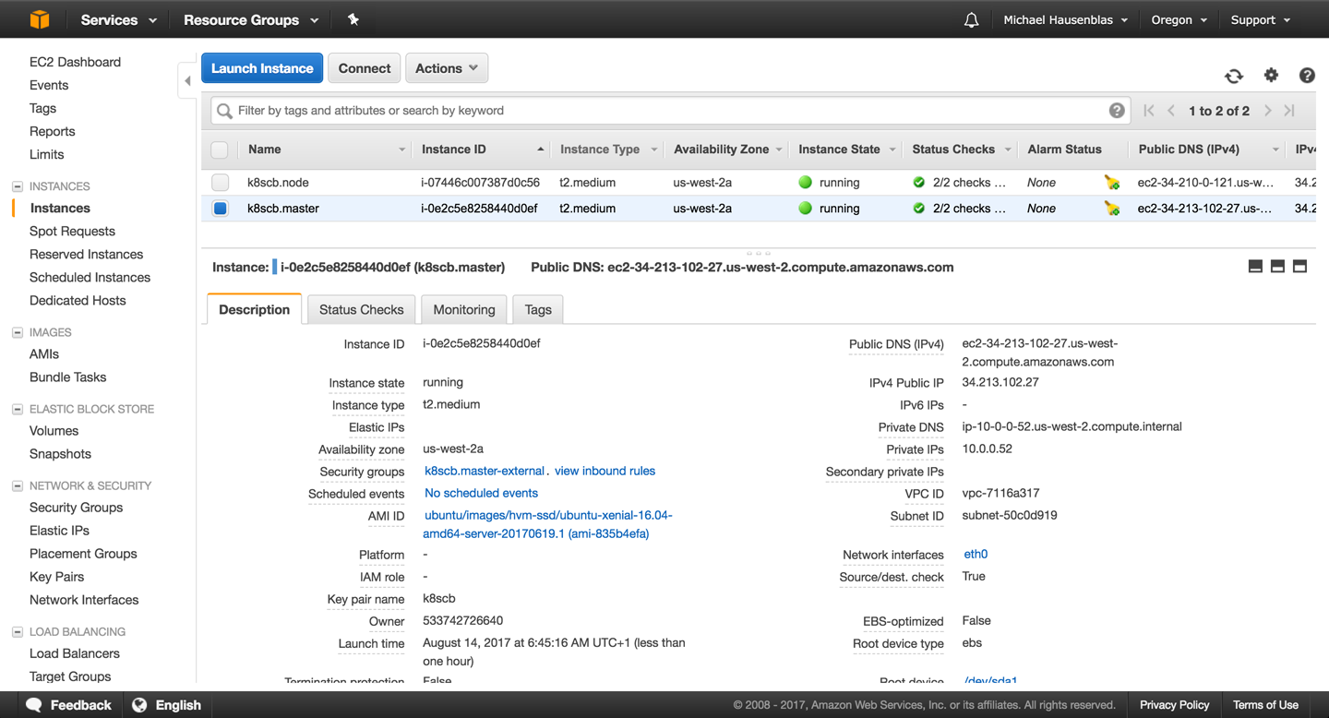
Figure 14-1. Screenshot of Amazon EC2 console, showing two nodes created by kubicorn

Now, do as instructed in the last output line of the kubicorn apply command and ssh into the cluster:
$
ssh -i ~/.ssh/id_rsa ubuntu@34.213.102.27
The authenticity of host '34.213.102.27 (34.213.102.27)' can't be established.
ECDSA key fingerprint is ed:89:6b:86:d9:f0:2e:3e:50:2a:d4:09:62:f6:70:bc.
Are you sure you want to continue connecting (yes/no)? yes
Warning: Permanently added '34.213.102.27' (ECDSA) to the list of known hosts.
Welcome to Ubuntu 16.04.2 LTS (GNU/Linux 4.4.0-1020-aws x86_64)
* Documentation: https://help.ubuntu.com
* Management: https://landscape.canonical.com
* Support: https://ubuntu.com/advantage
Get cloud support with Ubuntu Advantage Cloud Guest:
http://www.ubuntu.com/business/services/cloud
75 packages can be updated.
32 updates are security updates.
To run a command as administrator (user "root"), use "sudo <command>".
See "man sudo_root" for details.
ubuntu@ip-10-0-0-52:~$
kubectl get all -n kube-system
NAME READY STATUS
po/calico-etcd-qr3f1 1/1 Running
po/calico-node-9t472 2/2 Running
po/calico-node-qlpp6 2/2 Running
po/calico-policy-controller-1727037546-f152z 1/1 Running
po/etcd-ip-10-0-0-52 1/1 Running
po/kube-apiserver-ip-10-0-0-52 1/1 Running
po/kube-controller-manager-ip-10-0-0-52 1/1 Running
po/kube-dns-2425271678-zcfdd 0/3 ContainerCreating
po/kube-proxy-3s2c0 1/1 Running
po/kube-proxy-t10ck 1/1 Running
po/kube-scheduler-ip-10-0-0-52 1/1 Running
NAME CLUSTER-IP EXTERNAL-IP PORT(S) AGE
svc/calico-etcd 10.96.232.136 <none> 6666/TCP 4m
svc/kube-dns 10.96.0.10 <none> 53/UDP,53/TCP 4m
NAME DESIRED CURRENT UP-TO-DATE AVAILABLE AGE
deploy/calico-policy-controller 1 1 1 1 4m
deploy/kube-dns 1 1 1 0 4m
NAME DESIRED CURRENT READY AGE
rs/calico-policy-controller-1727037546 1 1 1 4m
rs/kube-dns-2425271678 1 1 0 4m
When you’re done, tear down the Kubernetes cluster like so (note that this may take a couple of minutes):
$
kubicorn delete --name k8scb
2017-08-14T05:53:38Z [✔] Selected [fs] state store
Destroying resources for cluster [k8scb]:
2017-08-14T05:53:41Z [✔] Deleted ASG [k8scb.node]
...
2017-08-14T05:55:42Z [✔] Deleted VPC [vpc-7116a317]

Discussion
While kubicorn is a rather young project, it is fully functional, and you can also create clusters on Azure and Digital Ocean with it.
It does require you to have Go installed as it doesn’t ship binaries (yet), but it’s very flexible in terms of configuration and also rather intuitive to handle, especially if you have an admin background.

See Also
- Setting up Kubernetes in AWS in the kubicorn docs
- Lachlan Evenson’s video walk-through “Building a Kubernetes Cluster on Digital Ocean Using Kubicorn”

14.6 Storing Encrypted Secrets in Version Control

Problem
You want to store all your Kubernetes manifests in version control and safely share them (even publicly), including secrets.

Solution
Use sealed-secrets. Sealed-secrets is a Kubernetes controller that decrypts one-way encrypted secrets and creates in-cluster Secret objects (see Recipe 8.2).
Your sensitive information is encrypted into a SealedSecret object, which is a custom CRD resource (see Recipe 13.4). The SealedSecret is safe to store under version control and share even publicly. Once a SealedSecret is created on the Kubernetes API server, the controller decrypts it and creates the corresponding Secret object (which is only base64-encoded).
To get started, download the latest release of the kubeseal binary. This will allow you to encrypt your secrets:
$
GOOS=$(go env GOOS)
$
GOARCH=$(go env GOARCH)
$
wget https://github.com/bitnami/sealed-secrets/releases/download/v0.5.1/
kubeseal-$GOOS-$GOARCH
$
sudo install -m 755 kubeseal-$GOOS-$GOARCH /usr/local/bin/kubeseal
Then create the SealedSecret CRD and launch the controller:
$
kubectl create -f https://github.com/bitnami/sealed-secrets/releases/
download/v0.5.1/sealedsecret-crd.yaml
$
kubectl create -f https://github.com/bitnami/sealed-secrets/releases/
download/v0.5.1/controller.yaml
The result will be that you have a new custom resource and a new pod running in the kube-system namespace:
$
kubectl get customresourcedefinitions
NAME AGE
sealedsecrets.bitnami.com 34s
$
kubectl get pods -n kube-system | grep sealed
sealed-secrets-controller-867944df58-l74nk 1/1 Running 0 38s
You are now ready to start using sealed-secrets. First, generate a generic secret manifest:
$
kubectl create secret generic oreilly --from-literal=password=root -o json
--dry-run > secret.json
$
cat secret.json
{
"kind": "Secret",
"apiVersion": "v1",
"metadata": {
"name": "oreilly",
"creationTimestamp": null
},
"data": {
"password": "cm9vdA=="
}
}

Tip
To create a manifest but not create the object on the API server, use the --dry-run option. This will print your manifest to stdout. If you want YAML, use the -o yaml option; and if you want JSON, use -o json.
Then use the kubeseal command to generate the new custom SealedSecret object:
$
kubeseal < secret.json > sealedsecret.json
$
cat sealedsecret.json
{
"kind": "SealedSecret",
"apiVersion": "bitnami.com/v1alpha1",
"metadata": {
"name": "oreilly",
"namespace": "default",
"creationTimestamp": null
},
"spec": {
"data": "AgDXiFG0V6NKF8e9k1NeBMc5t4QmfZh3QKuDORAsFNCt50wTwRhRLRAQOnz0sDk..."
}
}
You can now store sealedsecret.json safely in version control. Only the private key stored in the sealed-secret controller can decrypt it. Once you create the SealedSecret object, the controller will detect it, decrypt it, and generate the corresponding secret:
$
kubectl create -f sealedsecret.json
sealedsecret "oreilly" created
$
kubectl get sealedsecret
NAME AGE
oreilly 5s
$
kubectl get secrets
NAME TYPE DATA AGE
...
oreilly Opaque 1 5s

See Also
- The sealed-secrets repository
- Angus Lees’s article “Sealed Secrets: Protecting Your Passwords Before They Reach Kubernetes”

14.7 Deploying Functions with kubeless

Problem
You want to deploy Python, Node.js, Ruby, or PowerShell functions to Kubernetes without having to build a Docker container. You also want to be able to call those functions via HTTP or by sending events to a message bus.

Solution
Use the Kubernetes-native serverless solution kubeless.
kubeless uses a CustomResourceDefinition (see Recipe 13.4) to define Function objects and a controller to deploy these functions inside pods within a Kubernetes cluster.
While the possibilities are quite advanced, in this recipe we will show a basic example of deploying a Python function that returns the JSON payload you send it.
First, create a kubeless namespace and launch the controller. To do so, you can get the manifest that is released with every version on the GitHub release page. From that same release page, also download the kubeless binary:
$
kubectl create ns kubeless
$
curl -sL https://github.com/kubeless/kubeless/releases/download/v0.3.1/ \
kubeless-rbac-v0.3.1.yaml | kubectl create -f -
$
wget https://github.com/kubeless/kubeless/releases/download/v0.3.1/ \
kubeless_darwin-amd64.zip
$
sudo cp bundles/kubeless_darwin-amd64/kubeless /usr/local/bin
Within the kubeless namespace, you will see three pods: the controller that watches the Function custom endpoints, and the Kafka and Zookeeper pods. The latter two pods are only needed for functions that are triggered by events. For HTTP-triggered functions, you only need the controller to be in the running state:
$
kubectl get pods -n kubeless
NAME READY STATUS RESTARTS AGE
kafka-0 1/1 Running 0 6m
kubeless-controller-9bff848c4-gnl7d 1/1 Running 0 6m
zoo-0 1/1 Running 0 6m
To try kubeless, write the following Python function in a file called post.py:
def
handler
(
context
):
print
context
.
json
return
context
.
json
You can then deploy this function in Kubernetes using the kubeless CLI. The function deploy command takes several optional arguments. The --runtime option specifies what language the function is written in; the --http-trigger option specifies that the function will be triggered via HTTP(S) calls; and the --handler option specifies the name of the function, with the prefix being the basename of the file the function is stored in. Finally, the --from-file option specifies the file in which the function is written:
$
kubeless function deploy post-python --trigger-http \
--runtime python2.7 \
--handler post.handler \
--from-file post.py
INFO[0000] Deploying function...
INFO[0000] Function post-python submitted for deployment
INFO[0000] Check the deployment status executing 'kubeless function ls post-python'
$
kubeless function ls
NAME NAMESPACE HANDLER RUNTIME TYPE TOPIC
post-python default hellowithdata.handler python 2.7 HTTP
$
kubectl get pods
NAME READY STATUS RESTARTS AGE
post-python-5bcb9f7d86-d7nbt 1/1 Running 0 6s
The kubeless controller detected the new Function object and created a deployment for it. The function code is stored in a config map (see Recipe 8.3) and injected into the running pod at runtime. Then the function is callable via HTTP. The following shows these few objects:
$
kubectl get functions
NAME AGE
post-python 2m
$
kubectl get cm
NAME DATA AGE
post-python 3 2m
$
kubectl get deployments
NAME DESIRED CURRENT UP-TO-DATE AVAILABLE AGE
post-python 1 1 1 1 2m
To call the function you can use the kubeless function call command, like so:
$
kubeless function call post-python --data '{"oreilly":"function"}'
{"oreilly": "function"}

Note
kubeless can be used for much more than basic HTTP-triggered functions. Use the --help option to explore the CLI: kubeless --help.

See Also
- The kubeless repository
- kubeless examples
- Kubeless on Azure Container Services

1
AWS Identity and Access Management User Guide, “Creating an IAM User in Your AWS Account”.
Appendix A. Resources

General
- Kubernetes Documentation
- Kubernetes GitHub repository
- The Kubernetes community on GitHub

Tutorials and Examples
- Kubernetes by Example
- The Katacoda Kubernetes playground
- Kubernetes: Up and Running, by Brendan Burns, Kelsey Hightower, and Joe Beda (O’Reilly)

Index

A
access control
for resources, Problem-Solution
listing and viewing information on, Problem-Discussion
administrator roles, Monitoring and Logging
annotations (resource), Problem
API groups, Discussion, Discussion
API server, Solution, Discussion
apiVersion field, Discussion
application-level scaling, Scaling
applications, installing with Helm, Problem
authorization
role-based access control, Problem-Discussion
autocompletion for kubectl, Problem
autoscalers, Scaling
AWS Cluster, Problem
GKE Cluster, Problem-See Also
Horizontal Pod Autoscaler, Solution-Discussion
AWS
automatically resizing cluster in, Problem
creating Kubernetes cluster with kubicorn, Solution-Discussion
az CLI, Solution
Azure Cloud Shell, Solution
Azure Container Service (ACS)
creating a Kubernetes cluster on, Problem

B
bash, Technology You Need to Understand, Solution
batch jobs, Problem-Solution

C
cascading versus direct deletion, Discussion
client and server binaries, downloading, Problem
cluster scaling, Scaling
automatically resizing a cluster in GKE, Problem-See Also
ClusterIP type, Solution
accessing ClusterIP service outside the cluster, Problem
clusters
adding worker node to, Problem
creating with kubicorn, Solution-See Also
exploring roles in, Solution
getting detailed snapshot of state, Problem
code examples from this book, Online Resources
command-line interface (kubectl) (see kubectl)
command-line interface (minikube), Solution
config maps, Problem-Solution
creating for Prometheus, Solution
containers
accessing logs, Problem
exchanging data between, via local volume, Problem
in pod manifest, Solution
installing container runtime, Solution
liveness and readiness probes defined in, Solution
CPU utilization, Scaling
CronJob object, Solution
custom resource definition (CRD), Problem-Discussion, Solution
deletion with kubectl, Discussion

D
DaemonSet object, Solution, Discussion
dashboard (Kubernetes), accessing from Minikube, Problem
default namespace, Solution
default service account, Discussion
delete command (kubectl), Solution
deployments
adding liveness and readiness probes to, Problem-Discussion
changes in, recording with annotations, Discussion
changing image version with kubectl, Discussion
creating using kubectl run command, Creating and Modifying Fundamental Workloads
deleting with kubectl, Solution
Deployment object to supervise pods, Discussion
launching using a manifest, Problem-Problem
listing with kubectl, Solution
querying revisions with jq, Solution
scaling horizontally, Problem
updating, Solution-Solution
developer roles, Monitoring and Logging
DNS entry for a service, verifying, Problem
Docker
compose files, converting to manifests, Problem
using hypercube image to run Kubernetes master node with, Solution
using with Minikube, Solution
draining nodes, Problem-Problem

E
ecosystem (Kubernetes), The Ecosystem
edit command (kubectl), Solution, Solution
editors
KUBE_EDITOR environment variable, Solution
using EDITOR=vi, Discussion
Elastic Block Store (EBS), Discussion
Elasticsearch, Fluentd, and Kibana, using on Minikube, Solution-Discussion
entities, Discussion
environment variables
editing for a deployment, Solution
setting with kubectl run --env, Discussion
etcd, Solution
managing, Problem-See Also
using etcdctrl to get /registry directory contents, Solution
explain command (kubectl), Solution

F
fields (in manifests)
explaining with kubectl, Problem
pod manifest fields, Solution
file manifests (see manifests)
Fluentd, Solution-Discussion
fully qualified domain name (FQDN), accessing services by, Solution
functions
defining with custom resource definition, Problem-Discussion
deploying with kubeless, Problem-Solution

G
Garbage Collection doc, Discussion
gcloud CLI, Solution
creating Kubernetes cluster, Solution
resizing, updating, and upgrading a Kubernetes cluster, Discussion
generators, Discussion
get command (kubectl), Solution
get-kube-binaries.sh script, Solution
Git, Technology You Need to Understand
GitHub, downloading Kubernetes release from, Problem
Go (build system), Technology You Need to Understand, Solution, Solution
Google Cloud Shell, Discussion
(see also gcloud CLI)
Google Container Registry (GCR), hypercube image, Solution
Google Kubernetes Engine (GKE)
creating a cluster on, Problem
dynamically provisioning persistent storage on, Problem
GKE Cluster Autoscaler, Problem-See Also
kubectl in gcloud, Solution
using horizontal pod autoscaling in, Problem-Discussion
Grafana, Solution

H
health checks, Discussion
(see also liveness probes; readiness probes)
Heapster, Problem-Solution
Helm
creating your own chart to package applications, Problem-Problem
installing, Problem
using to install applications, Problem
Horizontal Pod Autoscalers (HPAs), Scaling
hyperkube, Problem

I
ingress
deploying ingress controller on Minikube, Problem
making services accessible from outside the cluster, Problem-Discussion
setting up an ingress controller, Discussion
init containers, Solution-Solution

J
jobs, Solution
CronJob, Solution
JSON query utility (jq), Solution
JSON, creating manifests in, Discussion

K
Kibana, Problem-Discussion
kind field, Solution
kompose, Solution
kube-proxy process, Working with Services, Solution
kubeadm CLI tool
bootstrapping Kubernetes cluster with, Problem
installing, Solution
logging into nodes on clusters created with, Solution
kubectl
annotate command, Problem
apply command
using to update a deployment, Solution
auth can-i command, Solution
create command
--dry-run option, Discussion
--record option, Solution
creating deployments with kubectl run command, Creating and Modifying Fundamental Workloads
options to configure parameters, Discussion
creating objects from file manifests, Problem
deleting resources, Problem
drain command, Solution
edit command, changing service type, Solution
editing environment variables for a deployment, Solution
editing resources with, Problem
enabling autocomplete for, Problem
explaining resources and fields, Problem
expose command, Discussion
creating a service, Solution
get --selector command, Solution
get endpoints command, Discussion
get nodes command, Discussion
installing, Problem
label command, Solution
listing a certain kind of resources, Problem
logs command, Solution
patch command
using to update a deployment, Solution
replace command
using to update a deployment, Solution
rollout undo command, Solution
run command, Discussion
scale command, Solution
top command, Solution
version command, Solution
watching resource changes with, Problem
kubeless, Problem-Solution
kubelet, Solution, Solution
running via systemd, Problem
Kubernetes
API groups, Discussion
applications, Problem
compiling from source, Developing Kubernetes
ecosystem, The Ecosystem
installing command-line interface, kubectl, Problem
Python client, Problem
releases, A Note on Kubernetes Releases
using without installing, Problem
Kubernetes cluster, creating, Creating a Kubernetes Cluster-See Also
bootstrapping cluster with kubeadm, Problem
downloading client and server binaries, Problem
downloading Kubernetes release from GitHub, Problem
installing kubeadm to create a cluster, Problem
on Azure Container Service (ACS), Problem
on Google Kubernetes Engine (GKE), Problem
using hypercube image to run Kubernetes master node with Docker, Problem
using systemd unit file to run Kubernetes components, Problem
kubernetes-cni, Solution
kubeseal, Solution
generating custom SealedSecret, Solution
kubicorn, Solution-See Also

L
labels, Problem
overwriting, Solution
using to query objects, Problem
legacy apps, Discussion
liveness probes, Problem
adding to deployments, Problem-Discussion
LoadBalancer type, Solution
logging, Monitoring and Logging
(see also monitoring and logging)
using Elasticsearch-Fluentd-Kibana (EFK), Problem-Discussion
logstash, Discussion

M
maintenance
draining Kubernetes node for, Problem-Problem
managing etcd, Problem-See Also
manifests
converting Docker compose files to, Problem
creating objects from, Problem
defining labels in, Discussion
for Prometheus app, Solution
for services, Solution
for StatefulSets, Solution
in this book, GitHub repository, Online Resources
Ingress object, Solution
launching a deployment with, Problem-Problem
structure of, Problem
writing for a batch job, Solution
writing for CronJobs, Solution
writing for DaemonSet, Solution
writing for pods, Problem
writing to create namespaces, Solution
metadata field, Solution
Minikube
accessing Kubernetes dashboard, Problem
deploying ingress controller on, Problem
enabling Heapster to monitor resources, Problem-Solution
installing to run local Kubernetes instance, Problem
kubectl installation, Solution
starting your first application on, Problem
understanding data persistency on, Solution-Discussion
using a persistent volume with, Problem-Problem
using Elasticsearch-Fluentd-Kibana (EFK) on, Problem-Discussion
using locally for Kubernetes development, Problem
using Prometheus on, Problem-See Also
minikube version command, Discussion
monitoring and logging, Monitoring and Logging-Discussion
accessing logs of a container, Problem
adding liveness and readiness probes to deployments, Problem-Discussion
controlling traffic flow to pods using readiness probes, Problem
enabling Heapster on Minikube to monitor resources, Problem-Solution
recovery using liveness probes, Problem
using Elasticsearch-Fluentd-Kibana (EFK) on Minikube, Solution-Discussion
using Prometheus on Minikube, Problem-See Also

N
namespace
creating using a YAML manifest, Solution
namespaces
creating to avoid name collisions, Problem
deleting all pods in, using kubectl, Solution
deleting all resources in, using kubectl, Solution
listing roles available in, Solution
persistent volume claims in, Discussion
secrets in, Discussion
setting quotas in, Problem
Network File System (NFS), Discussion
network, creating for Kubernetes cluster, Discussion
nodes
adding worker node, Problem
draining for maintenance, Problem-Problem
running infrastructure daemons per node, Problem
non-cloud native apps, Discussion

O
OODA loop, Solution

P
package management, Technology You Need to Understand
package manager (Kubernetes) (see Helm)
passphrase, Solution
persistent volume claim, Solution, Solution-Discussion
persistent volumes, Problem-Problem
dynamically provisioning on GKE, Problem
PetSet, Discussion
PHP app, Solution
playground (Kubernetes), Solution
pod security policies, Solution
pods
controlling traffic flow using readiness probes, Problem
debugging, Problem-Problem
deleting using kubectl, Solution
influencing startup behavior, Problem
removing from a service, Problem
running a scheduled job in, Problem
scaling, Scaling
(see also scaling)
securing, Problem
service account in, Solution
supervision by deployment, Discussion
watching with kubectl, Solution
writing a manifest from scratch, Problem
probes, Discussion
(see also liveness probes; readiness probes)
Prometheus, Problem-See Also
proxies
running with kubectrl, Discussion
Python, Technology You Need to Understand
client for Kubernetes, Problem

Q
quality of service (QoS) class, Solution
queries, using labels for, Problem
quotas for resources in a namespace, Problem

R
readiness probes, Problem
adding to deployments, Problem-Discussion
Redis, Solution
dashboard view of application, Discussion
regions (Azure), Solution
replica sets (RSs), Discussion
ReplicaSet object, Discussion
resourcces
custom resource definition, Solution
resource groups (Azure), Solution
deleting, Solution
ResourceQuota object, Solution
resources
access control for, Problem-See Also
annotating, Problem
changes in, watching with kubectl, Problem
custom resource definition, Problem-Discussion
deleting with kubectl, Problem
editing with kubectl, Problem
explaining using kubectl, Problem
listing, Problem
short names for, Solution
understanding and parsing statuses, Problem-Problem
restart policy, Discussion
role-based access control (RBAC), Solution-Discussion
setting up for Prometheus, Solution

S
scaling, Scaling-See Also
a deployment, Problem
automatically resizing AWS cluster, Problem
automatically resizing GKE cluster, Problem-See Also
using horizontal pod autoscaling in GKE, Problem-See Also
schedule section (manifests), Solution
SealedSecret object, Solution-Problem
secrets
encrypted, storing in version control, Problem-Problem
passing API access key to a pod via, Problem-Problem
security, Security-Solution
access control for resources, Problem-Solution
access control information, listing and viewing, Problem-Discussion
defining security context for pods, Problem
unique identity for an application, Problem-Discussion
selector, Discussion
using to query objects, Solution
service accounts, Solution
creating for Prometheus, Solution
Service object, creating, Solution
writing YAML file for, Discussion
services, Working with Services-Discussion
changing service type, Problem-Solution
concept of, Working with Services
creating to expose your application, Problem-See Also
deleting with kubectl, Solution
deploying ingress controller on Minikube, Problem
listing endpoints, Solution
listing services and deployments with kubectl, Solution
making accessible from outside the cluster, Problem-Discussion
verifying DNS entry for, Problem
SHA256 hash, verifying for Kubernetes release on GitHub, Solution
spec field, Solution
StatefulSet object, Solution
status field, Solution
storage classes (Minikube), Discussion
systemd, writing unit file to run Kubernetes components, Problem

T
template section (manifests), Solution
third-party resources, Discussion
troubleshooting
accessing ClusterIP service outside the cluster, Problem
debugging pods, Problem-Problem
getting detailed snapshot of cluster state, Problem
removing a pod from service, Problem
resource statuses, Problem-Problem

U
utilization, Discussion

V
Vertical Pod Autoscalers (VPAs), Scaling
volumes
about, Volumes and Configuration Data
exchanging data between containers via local volume, Problem
passing API access key to a pod via local volume, Solution
persistent, using with Minikube, Problem-Problem

W
watch command (Linux), Discussion
--watch option (kubectl), Solution

Y
YAML, creating manifests in, Discussion
About the Authors
Sébastien Goasguen built his first compute cluster in the late ’90s and takes pride in having completed his PhD thanks to Fortran 77 and partial differential equations. His struggles with parallel computers led him to work on making computing a utility and to focus on grids and, later, clouds. Fifteen years later, he secretly hopes that containers and Kubernetes will let him get back to writing applications.
He is currently the senior director of cloud technologies at Bitnami, where he leads the Kubernetes efforts. He founded Skippbox, a Kubernetes startup, in late 2015. While at Skippbox, he created several open source software applications and tools to enhance the user experience of Kubernetes. He is a member of the Apache Software Foundation and a former vice president of Apache CloudStack. Sébastien focuses on the cloud ecosystem and has contributed to dozens of open source projects. He is the author of the Docker Cookbook, an avid blogger, and an online instructor of Kubernetes concepts for Safari subscribers.
Michael Hausenblas is a developer advocate for Go, Kubernetes, and OpenShift at Red Hat, where he helps AppOps to build and operate distributed services. His background is in large-scale data processing and container orchestration and he’s experienced in advocacy and standardization at W3C and IETF. Before Red Hat, Michael worked at Mesosphere, MapR, and two research institutions in Ireland and Austria. He contributes to open source software (mainly using Go), blogs, and hangs out on Twitter too much.
Colophon
The animal on the cover of Kubernetes Cookbook is a Bengal eagle owl (Bubo bengalensis). These large horned owls are usually seen in pairs and can be found in hilly and rocky scrub forests throughout South Asia.
The Bengal eagle owl measures 19–22 inches tall and weighs between 39–70 ounces. Its feathers are brownish-gray or beige and its ears have brown tufts. In contrast to the neutral color of its body, its eye color is strikingly orange. Owls with orange eyes hunt during the day. It prefers a meaty diet and mostly feasts on rodents such as mice or rats but will also resort to eating other birds during the winter. This owl produces a deep, resonant, booming, two-note “whooo” call that can be heard at dusk and dawn.
Females build nests in shallow recesses in the ground, rock ledges, and river banks, and lay 2–5 cream colored eggs. The eggs hatch after 33 days. By the time the chicks are around 10 weeks of age, they are adult-sized, though not mature yet, and they depend on their parents for nearly six months. To distract predators from their offspring, the parents will pretend to have a wing injury or fly in a zigzag manner.
Many of the animals on O’Reilly covers are endangered; all of them are important to the world. To learn more about how you can help, go to animals.oreilly.com.
The cover image is from Meyers Kleines Lexicon. The cover fonts are URW Typewriter and Guardian Sans. The text font is Adobe Minion Pro; the heading font is Adobe Myriad Condensed; and the code font is Dalton Maag’s Ubuntu Mono.

